Outdoor Classroom Project Plan:
Materials List & Budget for
Sensory Garden

A sensory garden includes plants that help teach students how to use all five senses (sight, touch, taste, smell, touch) as they explore the outdoor classroom. Some plants have bright flowers or leaves to trigger a visual response, while other plants feel, taste, or smell unique. Wind chimes make a great, simple addition to the garden, but expanded sound gardens can be incorporated into the outdoor classroom as well. Each garden should incorporate elements that engage the students with all five of their senses.
- Habitat Requirements:
- Full sun for 6-8 hours per day for optimal plant growth
- Near the entrance of the outdoor classroom if possible

- Example Sensory Garden Pictures & Educational Sign:
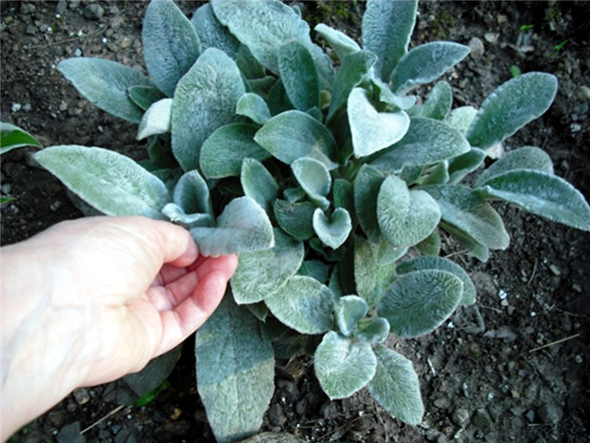

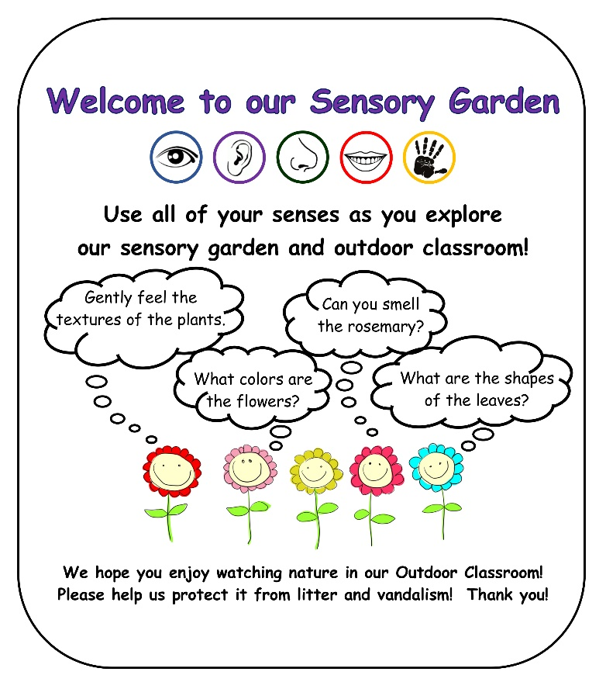
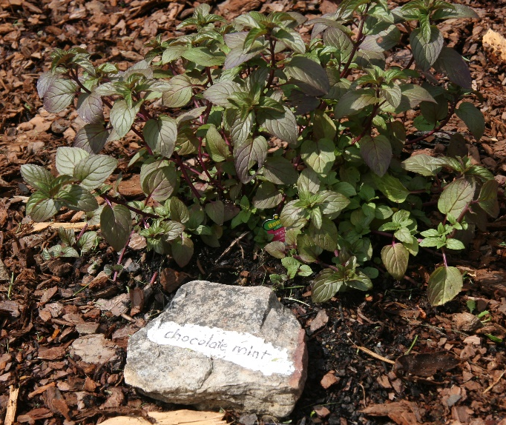
Lamb’s Ear is very soft to the touch. (above)
Chocolate Mint tastes and smells yummy. (below)
OC Project Plan: Example Sensory Garden Materials List & Budget

- Estimated Cost:
- Example 4 ft x 13 ft Sensory Garden: 3-sided garden against the school building: $570-$575
- Example 5 ft x 14 ft Sensory Garden: 4-sided garden away from school building: $690-$695

- Materials & Supplies Lists with Estimated Budgets:
Example 3-sided Sensory Garden
(Actual Size: 3 ft 8 in (W) x 13 ft 8 in (L) x 6 in (D) 3-sided raised bed garden against school building ~19 CF)
Station | Materials & Supplies | Estimated Cost | Source of Materials | Final Cost
3-Sensory | (1) Can of Rust-Oleum Professional White Water-based Marking paint (for laying out garden) @~$9.98 ea | $10 | Lowe’s Item #429750
3-Sensory | (40) Old Manor 12-in L x 4-in H x 8-in D Concrete Retaining Wall Blocks (to create three sides of raised bed against school building) @~$2.88 ea | $115 total | Lowe’s Item #477088
3-Sensory | (1) 6’x50’ Sta-Green Professional Landscape Fabric (weed barrier) (16’ used for this garden) @~$33.98 ea | $35 | Lowe’s Item #510606
3-Sensory | (4) 32-Quart (1CF) Bags of Evergreen Organic Potting Soil Mix @~$6.38 ea | $25 total | Lowe’s Item #380608
3-Sensory | (7) 1 CF/32 Qt Bags of Evergreen Organic Top Soil @~$2.18 each | $15 total | Lowe’s Item #648834
3-Sensory | (2) 1 CF Bags of Evergreen Organic Compost and Manure @~$3.68 ea | $10 total | Lowe’s Item #380606
3-Sensory | (3) 2 CF Bags of Evergreen Organic Drainage and Aeration Soil Conditioner @~$4.58 ea | $15 total | Lowe’s Item #648829
3-Sensory | (16) Sensory Plants (4 different species (one per sense), 4 plants per species – see list below) @~$7 ea | $110 total | Nursery via OC Consultant
3-Sensory | (2) Hanging Baskets with Flowers @~$15 ea | $30 total | Nursery via OC Consultant
3-Sensory | (1) Style Selections 30-in Black Metal Shepherd’s Hook (set of 2) (for hanging flower baskets) @~$13.98 ea | $15 total | Lowe’s Item #2675239
3-Sensory | (1) Package of 40 6” Black Plastic Landscape Edging Pieces (18 to create (3) 3 ft dividers between the four plant species to make plant ID & weeding easier) @~$21.98 ea | $20 | Lowe’s Item #379805
3-Sensory | (3) 2 CF Bags of Natural Dark Brown Pine Bark Mulch @~3.48 ea **do NOTget black mulch as it gets hot and kills plants** | $10 total | Lowe’s Item #92118

OC Project Plan: Example Sensory Garden Materials List & Budget

- Materials & Supplies with Estimated Budget (cont.)
3-Sensory | (1) Set of Grayson Lane 36-in Brass Sun Metal Wind Chime @~$17.29 ea  OR  (1) Set of Zingz & Thingz 34-in Metal Hummingbird Wind Chime @ 25.98 ea | $20-25 | Lowe’s Item #3602357  OR  Lowe’s Item #511650
3-Sensory | (1) Garden Accents 64-in Steel-painted Metal Traditional Shepherd’s Hook (to hang wind chimes) @~$10.98 ea | $10 | Lowe’s Item #150326
3-Sensory | (4) Plant ID Signs (one for each species) @~$6 ea | $25 total | https://www.alabamawildlife.org/oc-dig-into-plants/ for details
3-Sensory | (4) Biomarkers to hold Plant ID signs (13” stake with a 2” x 4” plate) @ ~$3 ea (includes S&H) | $15 total | AWF OC Consultant or https://mcgbiomarkers.com/shop/
3-Sensory | Educational Sign (explain how senses are engaged) | $75 | Ask OC Consultant about https://www.alabamawildlife.org/oc-signs/
3-Sensory | (1) 6 ft. U-Post for Fence (for educational sign) @~$10.69 ea | $10 | Lowe’s Item #493054
3-Sensory | (1) Hillman 1/4-in x 1-1/2 in Zinc-Plated Coarse Thread Hex Bolt (2-count) @~$0.88 ea | $5 Total | Lowe’s Item #137634
3-Sensory | (2) Hillman 1/4-in x 20 Zinc-Plated Steel Hex Nut @~$0.10 ea |  | Lowe’s Item #63301
3-Sensory | (2) Hillman 1/4-in Zinc-Plated Standard Flat Washer @~$0.15 ea |  | Lowe’s Item #63306
Total Estimated Cost: $570-$575

Example 4-sided Sensory Garden
(Actual Size: 4 ft 8 in (W) x 13 ft 8 in (L) x 6” (D) 4-sided raised bed garden ~20 CF)
Station | Materials & Supplies | Estimated Cost | Source of Materials | Final Cost
4-Sensory | (1) Can of Rust-Oleum Professional White Water-based Marking paint (for laying out garden) @~10.98 ea | $10 | Lowe’s Item #429750
4-Sensory | (70) Old Manor 12-in L x 4-in H x 8-in D Concrete Retaining Wall Blocks (to create four sides of raised bed garden) @~$2.88 ea | $200 total | Lowe’s Item #477088
4-Sensory | (1) 6’x50’ Sta-Green Professional Landscape Fabric (weed barrier) (16’ used for this garden) @~$33.98 ea | $35 | Lowe’s Item #510606
4-Sensory | (4) 32-Quart (1CF) Bags of Evergreen Organic Potting Soil Mix @~$6.38 ea | $25 total | Lowe’s Item #380608
OC Project Plan: Example Sensory Garden Materials List & Budget

- Materials & Supplies with Estimated Budget (cont.)
4-Sensory | (8) 1 CF/32 Qt Bags of Evergreen Organic Top Soil @~$2.18 each | $20 total | Lowe’s Item #648834
4-Sensory | (2) 1 CF Bags of Evergreen Organic Compost and Manure @~$3.68 ea | $10 total | Lowe’s Item #380606
4-Sensory | (3) 2 CF Bags of Evergreen Organic Drainage and Aeration Soil Conditioner @~$4.58 ea | $15 total | Lowe’s Item #648829
4-Sensory | (20) Sensory Plants (4 different species (one per sense), 4 plants per species – see list below) @~$7 ea | $140 total | Nursery via OC Consultant
4-Sensory | (2) Hanging Baskets with Flowers @~$15 ea | $30 total | Nursery via OC Consultant
4-Sensory | (1) Style Selections 30-in Black Metal Shepherd’s Hook (set of 2) (for hanging flower baskets) @~$13.98 ea | $15 total | Lowe’s Item #2675239
4-Sensory | (1) Package of 40 6” Black Plastic Landscape Edging Pieces (18 to create (3) 3 ft dividers between the four plant species to make plant ID & weeding easier) @~$21.98 ea | $20 | Lowe’s Item #379805
4-Sensory | (3) 2 CF Bags of Natural Dark Brown Pine Bark Mulch @~3.48 ea **do NOTget black mulch as it gets hot and kills plants** | $10 total | Lowe’s Item #92118
4-Sensory | (1) Set of Grayson Lane 36-in Brass Sun Metal Wind Chime @~$17.29 ea  OR  (1) Set of Zingz & Thingz 34-in Metal Hummingbird Wind Chime @ 25.98 ea | $20-25 | Lowe’s Item #3602357  OR  Lowe’s Item #511650
4-Sensory | (1) Garden Accents 64-in Steel-painted Metal Traditional Shepherd’s Hook (to hang wind chimes) @~$10.98 ea | $10 | Lowe’s Item #150326
4-Sensory | (4) Plant ID Signs (one for each species) @~$6 ea | $25 total | https://www.alabamawildlife.org/oc-dig-into-plants/ for details
4-Sensory | (4) Biomarkers to hold Plant ID signs (13” stake with a 2” x 4” plate) @ ~$3 ea (includes S&H) | $15 total | AWF OC Consultant or https://mcgbiomarkers.com/shop/
4-Sensory | Educational Sign (explain how senses are engaged) | $75 | Ask OC Consultant about https://www.alabamawildlife.org/oc-signs/
4-Sensory | (1) 6 ft. U-Post for Fence (for educational sign) @~$10.69 ea | $10 | Lowe’s Item #493054

OC Project Plan: Example Sensory Garden Materials List & Budget
- Materials & Supplies with Estimated Budget (cont.)
4-Sensory | (1) Hillman 1/4-in x 1-1/2 in Zinc-Plated Coarse Thread Hex Bolt (2-count) @~$0.88 ea | $5 total | Lowe’s Item #137634
4-Sensory | (2) Hillman 1/4-in x 20 Zinc-Plated Steel Hex Nut @~$0.10 ea |  | Lowe’s Item #63301
4-Sensory | (2) Hillman 1/4-in Zinc-Plated Standard Flat Washer @~$0.15 ea |  | Lowe’s Item #63306
Total Estimated Cost: $690-$695

OC Project Plan: Example Sensory Garden Materials List & Budget

- Sensory Plant Suggestions:
- Customized plant identification signs with unique scannable QR Codes linked to webpages on AWF's website are available for the bolded species below. The webpages provide specific information about that plant species including a description of the plant, photos of the plant, maintenance tips, and the ecological benefits that species provides. Plant species marked with an asterisk* are recommended for a sensory garden.

Sight
Clover | Bleeding Heart | Narrowleaf Sunflower | Stokes Aster
Pink Muhly Grass | Oxeye Daisy | Dense Blazing Star | Eastern Red Columbine
Taste
Chocolate cosmos | Pineapple Sage | *Spearmint | Wild Strawberry
Swiss Chard | Lettuces | Chives | Arugula
Touch
*Lamb’s Ear (*only need 1) | Feather Grass | Maidenhair Fern | Sensitive Plant
Silver Mound | Sphagnum Moss | *Autumn Joy Sedum | Fountain Grass
Smell
*Rosemary (*only need 1) | *Lavender | Lemon Balm | Orange Mint
Creeping Phlox | Patchouli | Lemon Verbena | Lilac

