Outdoor Classroom Project Plan:
Construction Instructions for
3-sided Sensory Garden (3 ft 8 in x 13 ft 8 in)
- Construction Tools:
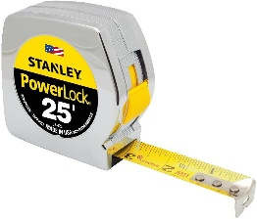
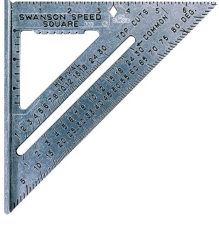
- (1) 20 ft Measuring Tape
Measuring Tape
- (1) Speed Square for measuring angles
Speed Square
- (4-6) Shovels (2-3 for adults; 2-3 for children)
- (1-2) Wheelbarrows for moving grass clumps, soil & mulch
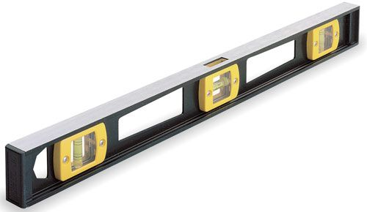
- (24-30) 1-gallon milk jugs (with tops cut off but handles remaining) for students to move dirt, sand, soil, etc.
- 24-inch I-beam Level
- (4-6) Hand-held Trowels (for stirring soil amendments together)
- Water hose for watering plants at the end of day
I-beam Level
- Saw for cutting 4” x 4” post into (4) 6” pieces for Plant ID Signs
- Drill for attaching signs to posts
- Construction Supplies:
- Twine (40 ft long)
- (4) Garden Stakes or Flags
- (1) Can of Landscape Spray Paint
- Retaining Wall Blocks (12 in Long x 8 in Wide x 4 in Tall)
- Weed Fabric (6 ft x 15 ft)
- Soil (or components to create amended soil such as soil conditioner, cow manure, potting soil, etc.)
- Instructions to Design a Perfect Rectangle:
Steps 1-5 #1

- Gather construction tools and purchase supplies to have them
on-hand for the construction day.
- To create the perimeter of your garden, begin by placing
Building Wall
Stake #1
a Stake #1 (or flag) in the ground where you want the
back left corner to be located against the building.
14 ft Twine
- Place the speed square on the ground against the wall
Speed Square
to measure the 90-degree angle needed for the inside
of the back left corner of your garden.
4 ft Twine
- Cut the twine into two pieces that are 4 ft long and two
pieces that are 14 ft long.
- Tie the end of a 4 ft piece of twine and the end of a 14 ft
piece of twine to Stake #1. (See diagram on page 3)
Example 3-sided Sensory Garden Construction Instructions

- Place the end of the measuring tape at Stake #1, and follow the edge of the building wall as you measure out 13 ft 8 in to create the first long-side of the garden. Place Stake #2 in the ground next to the wall to mark the second back corner. Pull the 14 ft long piece of twine from Stake #1 to Stake #2, and tie the end of it to Stake #2 to create a straight line.
Stake #1
Stake #2
Speed Square
13 ft 8 in of Twine
Steps 6 & 7 #1
- Place the end of the measuring tape at Stake #1 again, and then follow the edge of the speed square as you measure out 3 ft 8 in from the wall. Place Stake #3 in the ground to create the first short-side of the garden. Make sure that the measuring tape stays straight and follows the outer edge of the speed square, so that the inside of the first corner forms a 90-degree angle. Pull the 4 ft long piece of twine from Stake #1 to Stake #3, and tie the end of it to Stake #3 to create a straight line.
Stake #2
Stake #1
3 ft 8 in of Twine
Steps 8 - 10 #1
Stake #3
- Next place the speed square on the ground against the wall by Stake #2 to determine the 90-degree angle needed for the inside of the back right corner of your garden.
Speed Square
Stake #4
Stake #3
3 ft 8 in of Twine
- Place the end of the measuring tape at the second stake, and follow the opposite edge of the speed square as you measure out 3 ft 8 in. Place Stake #4 in the ground to mark the third corner. Make sure that the measuring tape stays straight, so that the second corner continues to form a 90-degree angle. Pull the 4 ft long piece of twine from Stake #2 to
3 ft 8 in
13 ft 8 in of Twine
Stake #4, and tie the end of it to Stake #4 to create a straight line.
- Next, tie one end of the remaining 14 ft piece of twine to Stake #4 and the other end Stake #3. This should create 90-degree angles in the third and fourth corners, and you can use your speed square to confirm this.
- Lastly spray paint straight lines along the ground following the OUTSIDE of the garden perimeter that was created by the twine. (See diagram on page 3)

Example 3-sided Sensory Garden Construction Instructions
Left Side
Front of Garden
Back of Garden against Building Wall
Right Side

- Construction Instructions for the Garden continued:
- Dig and remove the grass in a path that is 1 inch deep and 8 inches wide along the INSIDE of the spray-painted garden perimeter to create a base on which to place the retaining wall blocks. Use your shovel/trowel to create a flat surface for the base to keep the retaining wall blocks level.
- Place the first retaining wall block in the back left corner with the 8-inch side of the block against the building and the 12-inch side creating the left side of the garden. Use your I-beam level to make sure the block is level from side-to-side and front-to-back. Add a little dirt or sand and use your trowel to level the base surface if needed. Place the next block directly next to the first one, and use your level to make sure that the second block is level with the first block. Continue adding blocks until you have placed and leveled three blocks (3 ft) in a row. You should have 8 inches of base surface remaining without a block.
- Place a retaining wall block at the end of your first side but place it perpendicular to the other blocks so that the 8-inch width of the new block fills in the final 8 inches of the first side of the garden. Use your I-beam level to make sure the new block is level and adjust it if needed. Continue adding blocks until you have placed and leveled thirteen blocks (13 ft) in a row to create the front of the garden. You should have 8 inches remaining in the front right side of your garden without a block.
- Place a block perpendicularly at the end of the second side of your garden, so that the 8-inch width of the new block fills in the final 8 inches of the second side. Use your I-beam level to make sure the new block is level and adjust it if needed. Place and level two more blocks, leaving the remaining 8 inches of the third side of the garden without a block.

Example 3-sided Sensory Garden Construction Instructions

- Lastly, place a block perpendicularly at the end of the third side of your garden with the 12-inch side against the wall, so that the 8-inch width of the new block fills in the final 8 inches of the third side. Use your I-beam level to make sure the new block is level and adjust it if needed. The first level of your garden is completed.
- Place the landscape fabric (weed barrier) on the grass inside the garden area, push the fabric against the insides of the retaining wall blocks and up against the building wall, and lay the edges of the fabric on top of the blocks so that the fabric is sandwiched and held in place between the first and second layers of retaining wall blocks. If your fabric is not wide enough to cover the insides of the block and have the edge of the fabric lay on top of the block, then you need to make your garden a little smaller (less wide).
- Next, start laying the second layer of blocks from the back right corner that you just completed for the first layer of blocks, and then place the blocks in reverse order (counter-clockwise). Lay the 8-inch end of first block against the wall with the 12-inch side starting the right side of the second layer of blocks. Don’t forget—the second layer of retaining wall blocks should straddle the first layer to create more stable walls for your garden. (See diagram on page 3 and example drawing below.)
Building Wall

To build a stable wall, stack the second layer of blocks in reverse order so the blocks are offset and more stable.
|8 inches|
|8 inches|
|8 inches|
|8 inches|
End of Block
12 inches
12 inches

- Fill the bottom of the garden with top soil, add the compost and manure, and then add the potting soil and soil conditioner to retain moisture in the soil. Use trowels to turn and mix the soils.
- Install 3 ft dividers of the landscape edging inside the garden to create (4) 3 ft 1 in x 3 ft planting sections—each section for a different plant species. (see the lines in the diagrams below)
- Plant the flowers, grouping each of the different species of plants together within each square.
- Add 1 inch of mulch around the plantings throughout the garden, and water thoroughly.
- Create puddle stations by filling terracotta pot lids or pie plates up to ½ inch with manure (for minerals), add ¼ inch of sand over the manure, and then soak the sandy soil with water.
Example 3-sided Sensory Garden Construction Instructions

- Cut (1) 4” x 4” x 6’ into (12) 6” pieces. Use the Speed Square to cut one end of each 6” piece at a 40-50-degree angle to create a slanted top for your Plant ID signs.
- Attach each Plant ID sign to the slanted tops of the 4” x 4” x 6” pieces (using screws or adhesive). Sink the bottom of the posts a few inches into the ground in front of the appropriate plant species grouping.
- Dig a 1-ft deep hole near the garden for your education sign, place the other 4”x4”x6’ post in the hole, use concrete to secure the post in the hole and around the base of the post to prevent water from collecting and rotting post. Attach educational sign to post.
- Water all of the new plantings thoroughly.

