My Outdoor Classroom BioBlitz
Field Journal
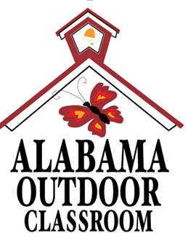

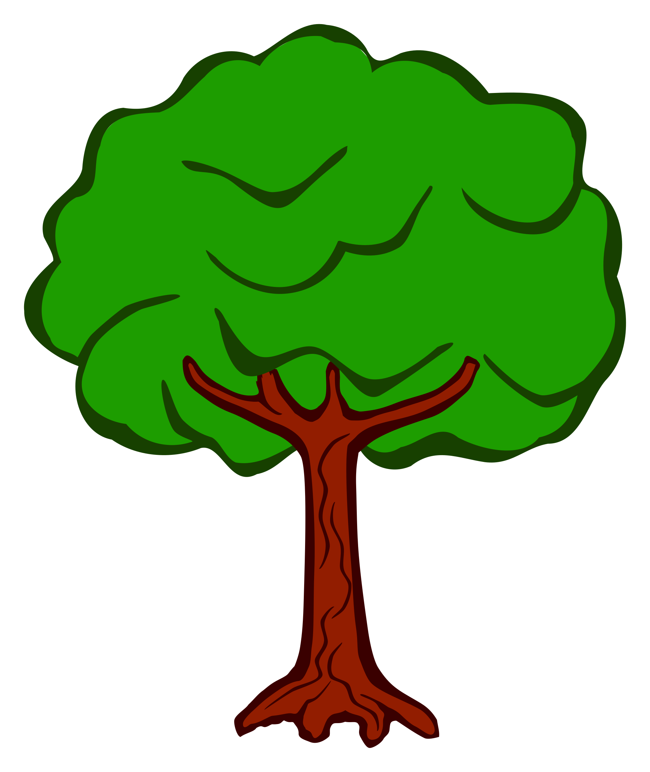
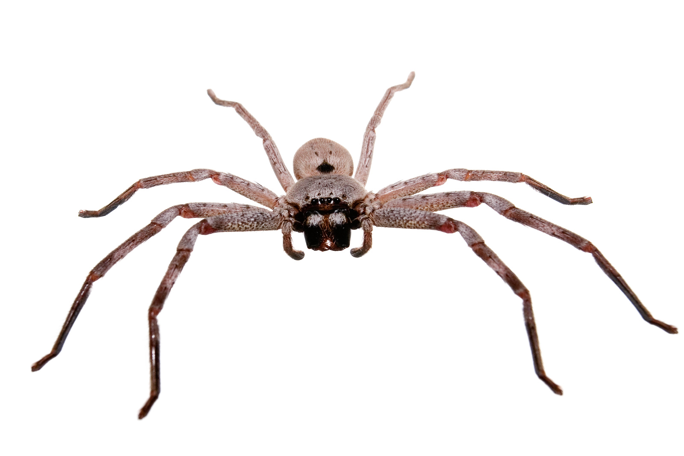
My School’s BioBlitz!

By_________________________________

Date: ___________________ Time: _____________
Location on Campus: _________________________
Which kingdom?
__ Plant __ Animal __ Fungi
Common Name: _____________________________
Scientific Name: _____________________________
Description:_________________________________
___________________________________________
___________________________________________
Color:______________________________________
Size: _______________________________________
Other Observations:

Date: ___________________ Time: _____________
Location on Campus: _________________________
Which kingdom?
__ Plant __ Animal __ Fungi
Common Name: _____________________________
Scientific Name: _____________________________
Description:_________________________________
___________________________________________
___________________________________________
Color:______________________________________
Size: _______________________________________
Other Observations:

