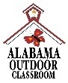
Living or Nonliving Scavenger Hunt
Look at the picture and decide if the item in your Outdoor Classroom is living or nonliving. Color in the correct circle for each item.
Alabama Wildlife Federation Outdoor Classroom Field Journal Activity: Living or Nonliving Scavenger Hunt (Kindergarten)
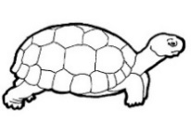 | turtle | - Living  - Nonliving
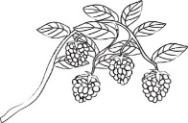 | berry bush | - Living  - Nonliving
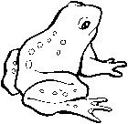 | frog | - Living  - Nonliving
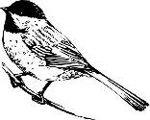 | bird | - Living  - Nonliving
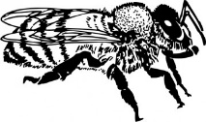 | bee | - Living  - Nonliving
 | grass | - Living  - Nonliving
 | log | - Living  - Nonliving
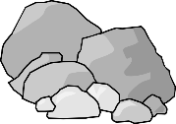 | rocks | - Living  - Nonliving
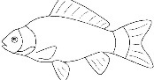 | fish | - Living  - Nonliving
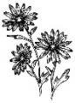 | flowers | - Living  - Nonliving

