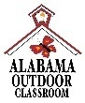**Living or Nonliving?**

**Outdoor Classroom Field Journal Activity Lesson Plans & Resources**

Online Lesson Plans & Resources: https://www.alabamawildlife.org/oc-activity-living-or-nonliving/

**Living Things Song:** Reinforce the idea of living things by singing this song together to the tune of *Freres Jacques*. *(Adapted from “Learner Classroom”)*

**Living Things Song**

*(Sing to the tune of Freres Jacques)*

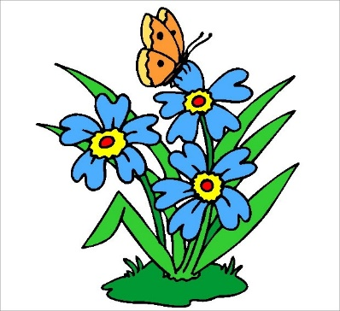**It is living!**

**It is living!**

**I know why!**

**I know why!**

**It eats and breathes and grows.**

**It eats and breathes and grows.**

**It’s alive!**

**It’s alive!**

*Alabama Wildlife Federation Outdoor Classroom Field Journal Activity: Living or Nonliving Song, pg 1 of 1*

