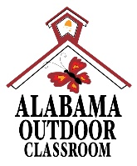
Evidence of the Water Cycle
Name:_______________________ Date:____________
Water is found throughout the world...in soil, marshes, swamps, ponds, streams, rivers, lakes, glaciers, oceans, clouds, precipitation and even underground. There is a continual movement of water as it travels from one part of the hydrosphere to another. Review “The Water Cycle” diagram (on page 2) along with the “Helpful Hints” below it to help you answer the following questions.
Look for evidence of the Water Cycle in your outdoor classroom.
Did You Know?
Seventy percent of the earth is covered with water.
Do you see any examples of condensation? yes no
If yes, what type of condensation is it? _________________
Do you see any examples of evaporation? yes no
If yes, what type of evaporation is it? __________________
Do you see any examples of precipitation? yes no
If yes, what type of precipitation is it? _________________

Water is essential to all life. When plants and animals do not have access to water, then they will not survive.
Did You Know?
Up to 60% of the human body is water, the brain is composed of 70% water, our blood is about 83% water, and the lungs are nearly 90% water.
Explore your outdoor classroom in search of plants and animals that contain water in them.
List the name of an animal that you found that has water in it:________________
How does this animal take water into its body?____________________________
How does water leave this animal and enter another phase of the water cycle?
_____________________________________________________________
List a type of plant in the outdoor classroom that has water in it: _____________
How does this plant take in water?____________________________________
How does water leave this plant and enter another phase of the water cycle?
______________________________________________________________
Alabama Wildlife Federation Outdoor Classroom Field Investigation: Evidence of the Water Cycle page 1 of 3

Draw a picture of the water cycle that is occurring in your outdoor classroom, including the following:
1. Identify at least three sources of water in the outdoor classroom area that are found during different stages of the water cycle.
2. Identify at least three of the processes that can occur such as condensation, evaporation, infiltration, sublimation, and transpiration and draw where these processes would occur as water travels through the water cycle in the outdoor classroom area.

Alabama Wildlife Federation Outdoor Classroom Field Investigation: Evidence of the Water Cycle page 2 of 3

***************************************************************************************
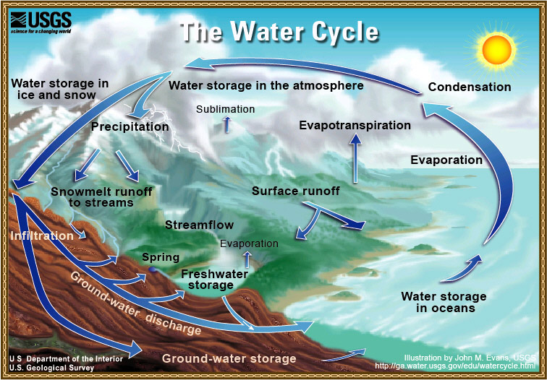
Helpful Hints:
Condensation – the process in which water vapor (a gas) changes into tiny water drops of water (a liquid), either by cooling or by being subjected to increased pressure.
Discharge – to pour forth water from one source to another.
Evaporation – the process in which water (a liquid) changes into a vapor (or gas) as the sun heats the water.
Freshwater – consisting of or living in water that is not salty.
Groundwater – water that collects or flows beneath the Earth's surface, filling the porous spaces between soil, sediment, and rocks in aquifers and springs. The upper surface of groundwater is called the water table.
Infiltration – the process in which a fluid seeps or passes into the pores or cracks of a solid such as soil or rock.
Precipitation – A form of water, such as rain, snow, or sleet, that condenses from the atmosphere, becomes too heavy to remain suspended, and falls to the Earth's surface.
Sublimation – the process of changing from a solid to a gas without passing through an intermediate liquid phase such as when ice and snow on the Earth's surface change into a gas at temperatures below the freezing point of water.
Surface Runoff - the waters that travel over the land surface and through channels to drain into a creek, stream, river, lake or ocean.
Transpiration – the process of giving off water vapor from the earth to the atmosphere by the heating of water from land and water surfaces, and by the release or emission of water vapor from the leaves of plants.
Alabama Wildlife Federation Outdoor Classroom Field Investigation: Evidence of the Water Cycle page 3 of 3

