Evidence of the Nitrogen Cycle
Name:_______________________ Date:____________
Nitrogen is used by many organisms on Earth. It is found in several different forms: N₂ (elemental nitrogen), NO₃ (nitrates), NO₂ (nitrites) and NH₄ (ammonium).
The changing of nitrogen from one form to another is aided by bacteria.
Without these bacteria there would not be a nitrogen cycle.
Look for evidence of nitrogen in your outdoor classroom. You are not going to be
able to see the bacteria, but you can see the organisms that the bacteria utilize
to change nitrogen into one of its usable forms.
- Identify a plant in your Outdoor Classroom: _________________________________
Using the nitrogen cycle diagram, what nitrogen compounds are related to plants?
(Hint: Trace the arrows from the plants to the nitrogen compound and back to the plant.)
__________________________________________________________________
- Identify an animal in your Outdoor Classroom: _______________________________
Using the nitrogen cycle diagram, what nitrogen compounds are related to animals?
(Hint: Trace the arrows.)
__________________________________________________________________
- Identify a fungus in your Outdoor Classroom: ________________________________
Using the nitrogen cycle diagram, what nitrogen compounds are related to fungi?
_________________________________________________________
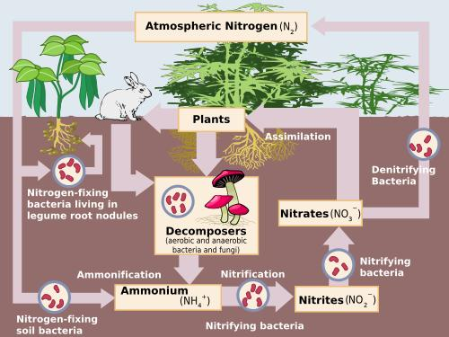
Did You Know?
- The atmosphere is 78% nitrogen.
- Most nitrogen is not usable by animals and plants.
- About 3% of your body weight is nitrogen.
- Nitrogen is used in fertilizer to promote plant growth.

Alabama Wildlife Federation Outdoor Classroom Field Investigation: Evidence of the Nitrogen Cycle page 1 of 2
Let’s learn about the processes of the nitrogen cycle. All of these processes are happening in your outdoor classroom and throughout nature. It is a never-ending circle of changes.
- Fixation – It is the first step in making nitrogen usable by plants. N₂ NH₄
- Nitrification – Ammonium gets changed into nitrates by the bacteria. NH₄NO₂NO₃
**Nitrates can be absorbed by plants.**
- Assimilation – The plants absorbs the nitrates from the soil into their roots. The nitrates are used in amino acids, nucleic acids and chlorophyll.
- Ammonification – When a plant or animal dies decomposers turn nitrogen back into ammonium and the nitrogen cycle starts again.
- Denitrification – Extra nitrogen in the soil is cycled back into the air.
Checkpoint: Thinking about the processes above, fill in the nitrogen cycle below
using chemical formulas.
_______ _______ _______ _______ _______

NO₃

N₂

Now apply the idea of the nitrogen cycle to your Outdoor Classroom. Select a garden area. Sketch the area in the box below. Draw what you see above the soil level and predict what would be below the soil level (underground). Label the nitrogen cycle steps on your sketch.
Alabama Wildlife Federation Outdoor Classroom Field Investigation: Evidence of the Nitrogen Cycle page 2 of 2

