Materials per student or group: 1- Large plastic bottle such as an apple juice bottle with a wide-mouth (1” or larger), duct tape, hand trowel or shovel, 6” square of cardboard or other stiff material, 4 - 1’ blocks or similar item to serve as spacers, insect bait (if desired), 2 - 4” x 2’ pieces of cardboard or other stiff material to act as fence.
Step 1: Take the large plastic bottle and carefully cut around the bottle where the beveled top meets the widest part of the bottle.  Cut along the shoulder of the bottle.  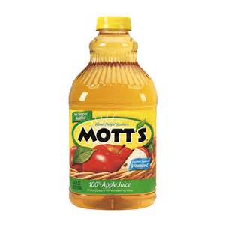 | Step 2: Turn the top over (looks like a funnel) and insert it into the bottom part of the bottle. The opening on the lid should not touch the bottom of the bottle.
Step 3: Using duct tape, tape along the edges so the top and bottom fasten together.  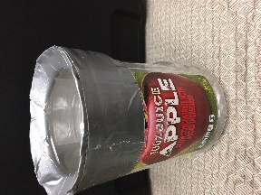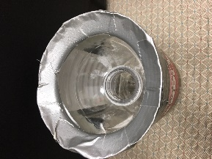 | Step 4: Dig a hole in the ground, preferably along a wall or other obstable, and place the trap in the hole so the top edge is level with the surrounding area.  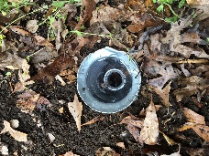
Step 5: Use 2” wide strips of cardboad or plywood to create a wall or obstable, so critters will be forced into the trap.  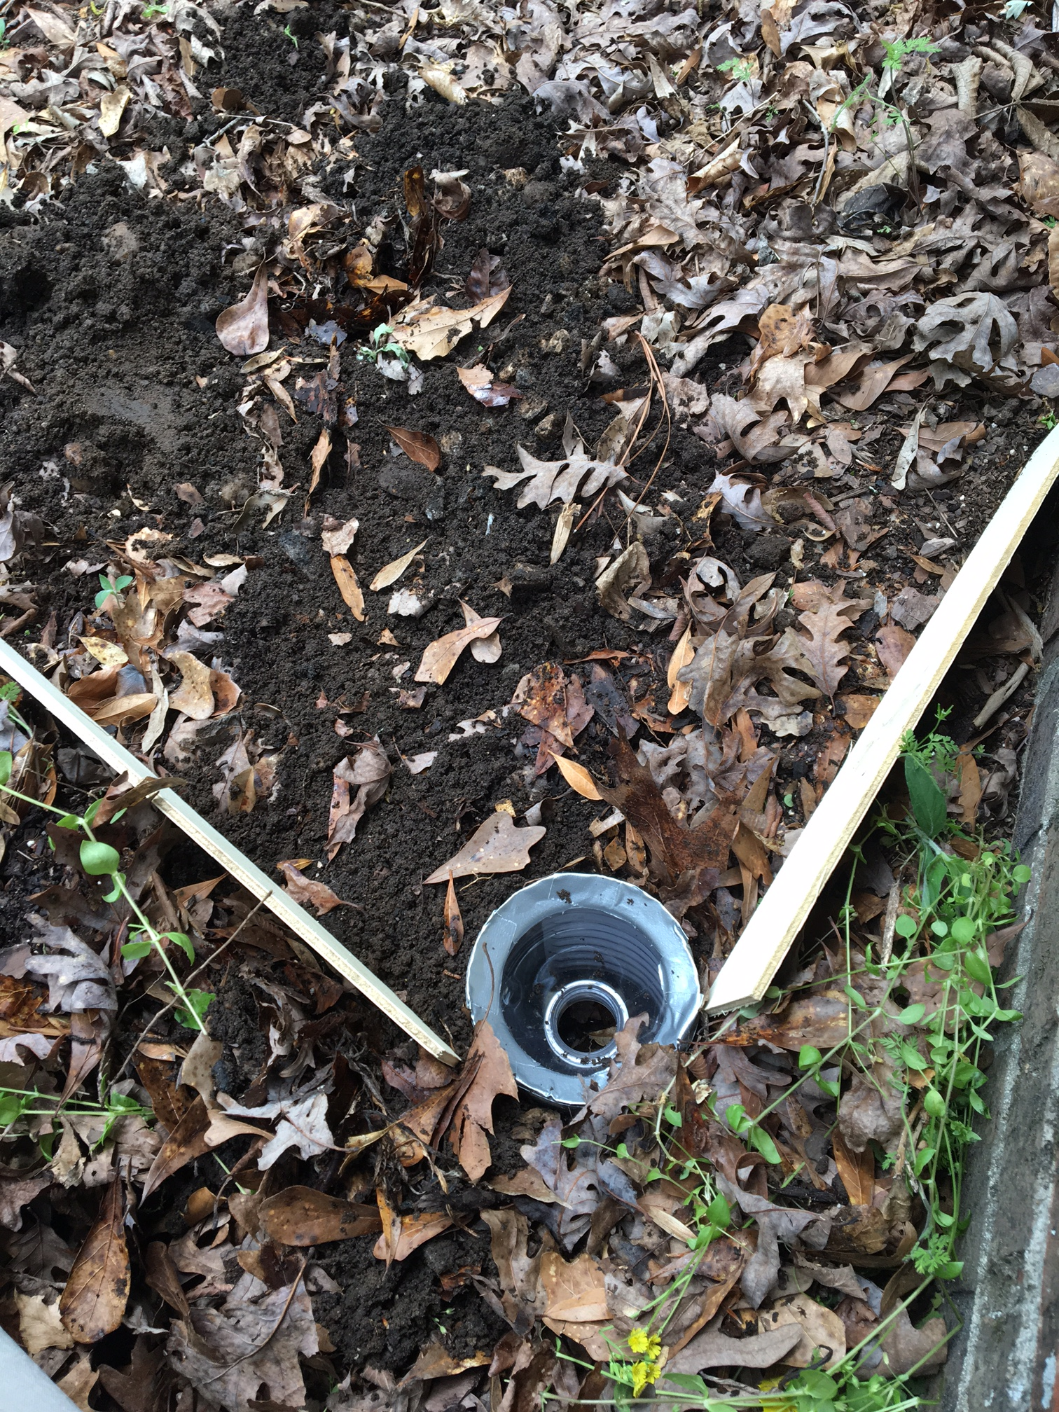 | Step 6: Place a piece of plywood or cardboard about 1” above the trap to act a a roof. Place something heavy on top so that it doesn’t blow off.  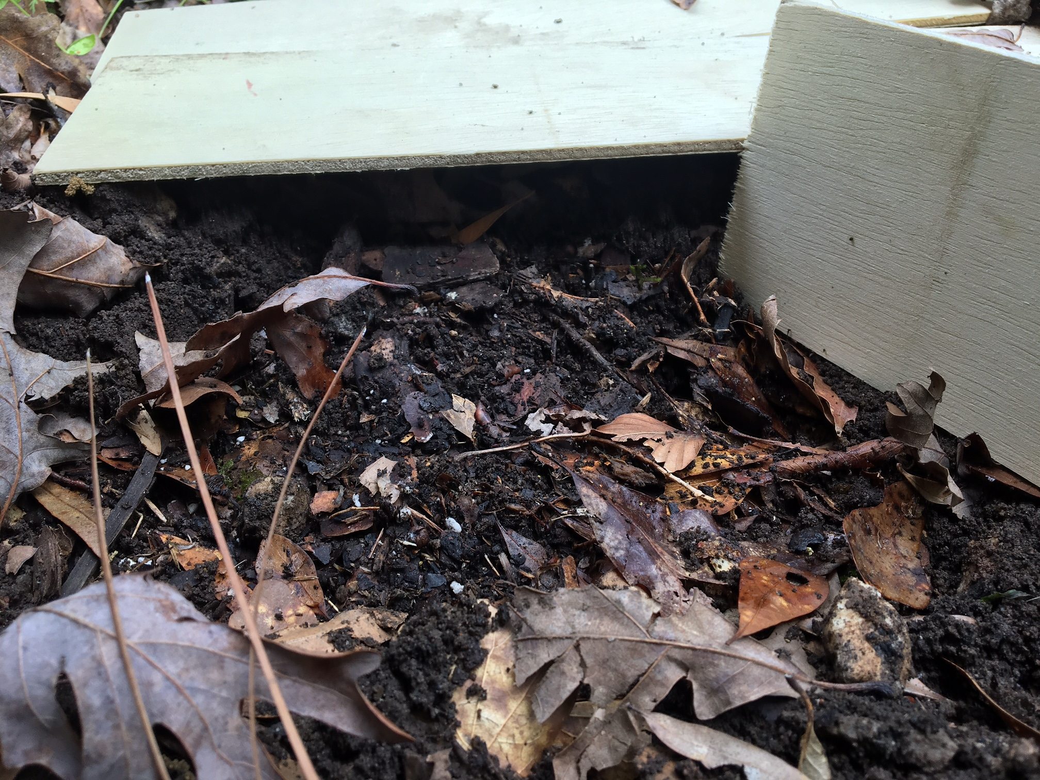

Step 7: Carefully remove the trap from the hole after a couple of days and dump it into a plastic tub to check for critters.

