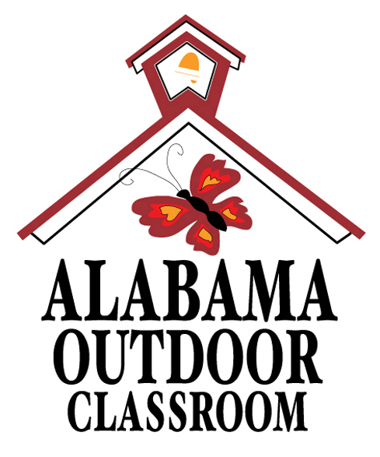

Outdoor Classroom Faculty Survey

We would like to have your feedback about the use and sustainability of our school's outdoor classroom. Please take a few quick minutes to take this survey. Our Outdoor Classroom Planning Committee will use the results of this survey to help us determine our goals for the outdoor classroom this year.

1. Please check the boxes of the outdoor learning stations that you have used with your students (you can choose more than one):
- Aquatic Study Area or Fish Pond  - Butterfly & Pollinator Garden  - Frog & Toad Habitat  - Lizard Habitat  - Songbird Habitat  - Turtle Habitat | - Raised Bed Garden (for annual Plants)  - Bog Garden or Rain Garden  - Sensory Garden  - Berry Bush Patch or Fruit Orchard  - Weather Station  - Cardinal Directions Sign | - Log Decomposition Station  - Compost Area  - Tree ID Trail  - Wildlife Tracking Station  - Other:_______________________________  - Other:_______________________________

2. Which of the following would increase your participation in the use of the outdoor classroom? (you can choose more than one)
- Amphitheater Seating or Benches  - Pavilion, Gazebo or Shade Cloth (for Shade)  - Outdoor Work Tables  - Activity Kits  - Gardening Tools | - Outdoor Classroom Rules Sign  - Educational Signage & Plant Identification Signs  - Professional Development to review Activities & Lesson Plans  - Service Learning Opportunities for students  - Outdoor Classroom Work Days

3. Which of the following educational tools or resources do you need in conjunction with your outdoor activities? (you can choose more than one)
- Magnifying Glasses  - Field Identification Guides  - Clipboards | - Insect Nets  - Aquatic Thermometers  - Water Quality Testing Kits | - Binoculars  - Activity Instructions or Lessons  - Other (please specify):______________________________

4. Please list your name and email address:_______________________________________________________________________________
Thank you for taking the time to fill out this survey!
The Alabama Outdoor Classroom Program is a partnership between:
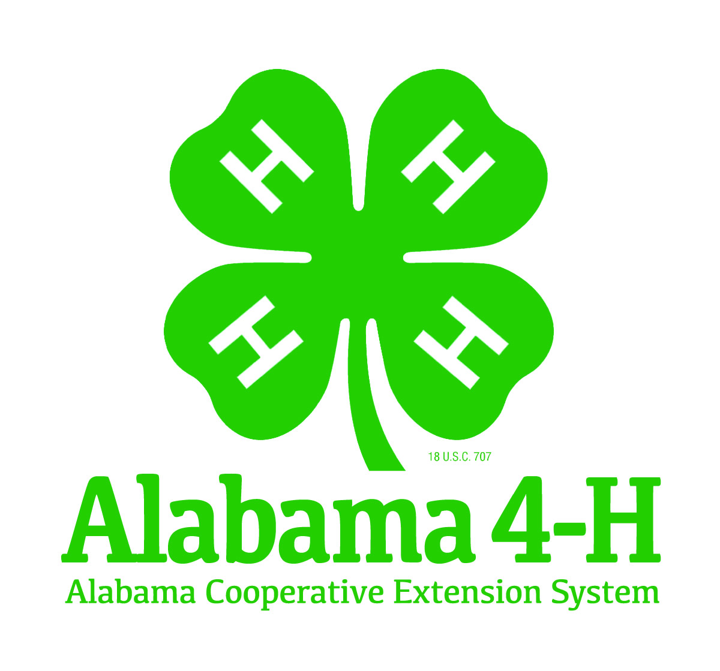   | 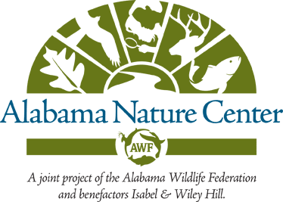    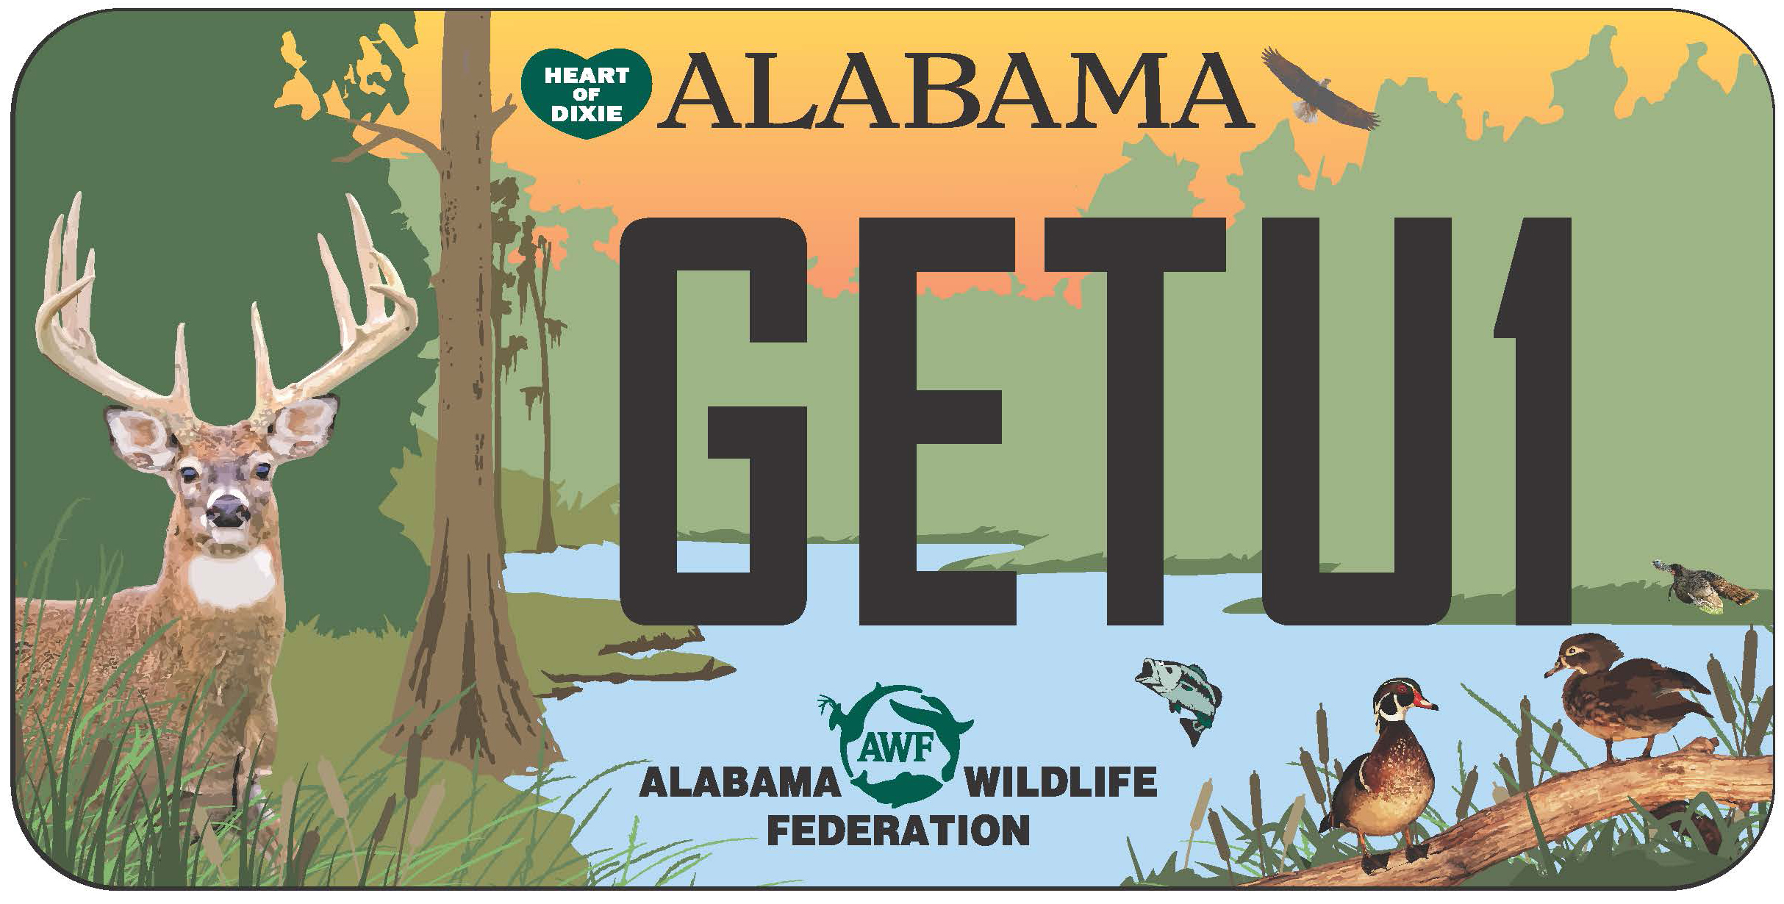 | 
Alabama Cooperative Extension System | Alabama Wildlife Federation | Alabama Department of  Conservation & Natural Resources

Outdoor Classroom Faculty Survey for Established OC Schools (example) – 80316 Alabama Outdoor Classroom Planning Guide Appendix, Document #1 (page 4 of 4)

