Welcome to our
Vermiculture Worm Bin

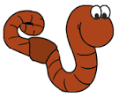
We are growing red wiggler earthworms to:
- provide food for our box turtles,
- compost our waste materials and turn
them into something useful – worm castings
(A.K.A. worm poop!) that plants use as food,
- put worms and their castings in our gardens
so they can help fertilize the plants, help
break-up the soil so that it can retain
water, and help plants grow faster & bigger!
Do Not Add:

What you can add to the Worm Bin:

- Cheese
- Fat
- Fruit Pulp
- Magazines
- Meat
- Milk

- Paper
- Sawdust
- Wood
- Leaves

- Greens like cabbage, kale, and lettuce
- Coffee grounds
- Crushed egg shells
- Fruit skin/covering
- Grass clippings

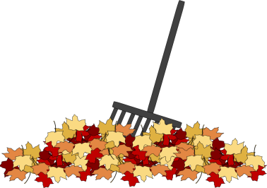

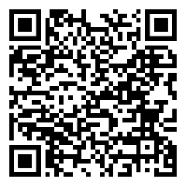
Scan this QR Code to learn more about decomposition.
Enjoy nature’s beauty!
Protect it from litter and vandalism!

