Outdoor Classroom Project Plan:
Materials List & Budget for
Weather Station
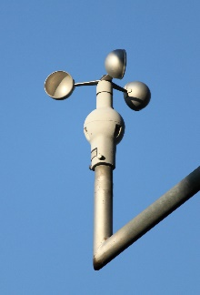
The weather station in your outdoor classroom includes various weather instruments that you can use to measure, record and track weather conditions over time.
- Thermometer measures the air temperature.
- Anemometer (pictured right) measures wind speed.
- Hygrometer measures humidity, or the amount of water vapor in the air.
- Rain gauge measures the amount of rain that has fallen over a specific time period.
- Barometer measures air pressure in the atmosphere, also called barometric pressure.
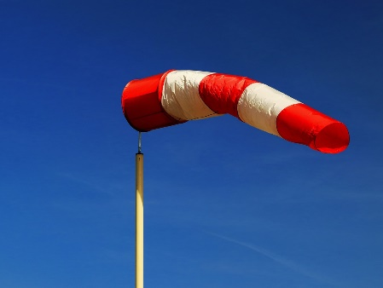
- Wind sock (pictured right) is a cone-shaped tube of fabric, which resembles a giant sock, attached to pole that rotates. It helps us determine wind direction and relative wind speed.
- Cardinal directions sign, for which we have a separate materials list and estimated budget, includes directional signs pointing North, South, East, and West attached to a 4”x4” post. Use the cardinal directions sign in your outdoor classroom along with your wind sock to determine the direction the wind is blowing.
- Location Suggestions for the Weather Station:
- Next to the Cardinal Directions Sign
- In the middle/ open area of the outdoor classroom–do not put it next to a tree or building that might block the wind or shade the thermometer
- Example Weather Stations & Educational Sign:
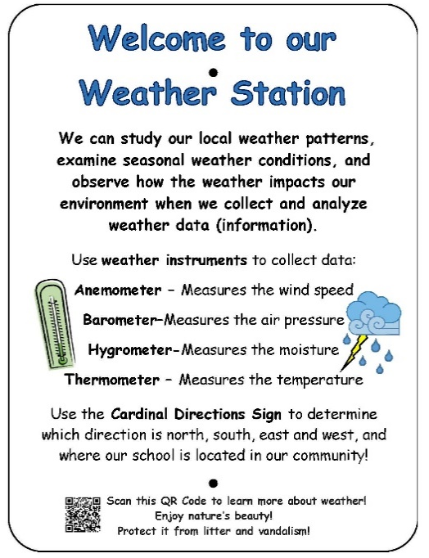
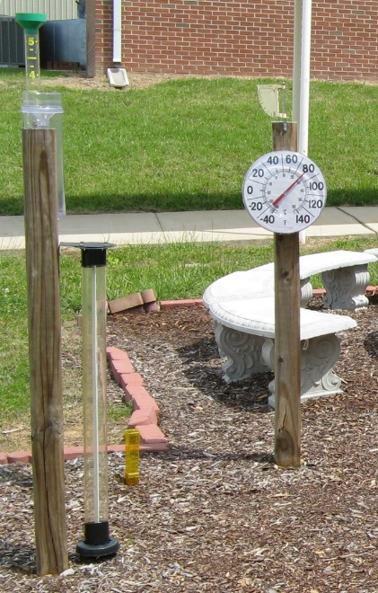

OC Project Plan: Example Weather Station Materials List & Budget

- Estimated Cost:
- Example Weather Station (analog only): $335
- Materials & Supplies with Estimated Budget:
Example Analog Weather Station
A weather station should include an analog thermometer (for air temperature) and analog rain gauge (for rain fall) so that the students can practice reading a thermometer and reading the measurements in a rain gauge, a weather sock and cardinal directions sign so that students can determine the direction of the wind, and an anemometer (for wind speed), a hygrometer (for humidity), and barometer (for air pressure).
A materials list & budget for a cardinal directions sign can be found on the AWF website.
Station | Materials & Supplies | Estimated Cost | Example Source | Final Cost
Weather | Large (~6.5”) Rain Gauge (this one is easy to read, and it is easy to empty and then put back after the students have recorded their measurements) @~$24.95 ea | $25 | https://www.weathershack.com/product/conant-65-rain-gauge.html
Weather | Large Analog Thermometer (easy to read and should be easy to mount on your weather station post) @~$3.98 ea | $5 | Lowe’s Item# 396644
Weather | Outdoor Analog Hygrometer (to measure humidity – this one is a combo with a thermometer, but we suggest you still include a traditional analog thermometer so that students can learn how to read it.) @~$9.78 ea | $10 | Lowe’s Item# 2737940
Weather | Outdoor Analog Barometer (this instrument can be used to help predict weather events hours in a advance because it measures the air pressure) @~$31.99 ea | $35 | https://www.amazon.com/AMTAST-Thermometer-Hygrometer-Barometric-Temperature/dp/B07JDLVMV6/ref=sr_1_2_sspa?keywords=outdoor+barometer&qid=1691536413&sr=8-2-spons&sp_csd=d2lkZ2V0TmFtZT1zcF9hdGY&psc=1
Weather | Anemometer (measures wind speed. This one is included in a solar powered digital weather station.) @~$113.98 ea | $115 | https://www.amazon.com/AcuRite-Wireless-Weather-Station-Sensor/dp/B00N1XCA9M/?th=1
Weather | Waterproof Connection Box 11 x 4 x 3 inches (to store and protect anemometer receiver) @~$16.99 ea | $20 | https://www.amazon.com/Waterproof-Connection-Restmo-Weatherproof-Decorations/dp/B07XL4FG71/
Weather | Wind Sock @~$11.99 ea | $10 | https://www.amazon.com/Qishi-Windsocks-Rip-Stop-Measurement-Reflective/dp/B01L138HY0/
Weather | (1) Severe Weather 4-in x 8-ft #2 Ground Contact Wood Pressure Treated Lumber (to attach instruments to) @~$10.78 ea | $10 | Lowe’s Item# 552328
Weather | (1) Box of (50) 3.5” #10 exterior deck screws (to attach the weather station instruments; not all will be used on the weather station so save remaining for use on Cardinal Directions sign) @ ~$9.98 ea | $10 | Lowe’s Item# 9479

OC Project Plan: Example Weather Station Materials List & Budget

- Materials & Supplies with Estimated Budget (cont.)

Weather | (1) 50 lb bags of Quikrete Fast Setting Concrete Mix @~$6.71 ea | $5 | Lowe’s Item# 10437
Weather | (1) 6 ft. U-Post for Fence (for educational sign) @~$10.69 ea | $10 | Lowe’s Item #493054
Weather | (1) Hillman 1/4-in x 1-1/2-in Zinc-Plated Coarse Thread Hex Bolt (2-Count) @~$.0.88 ea | $5 total | Lowe’s Item# 137634
Weather | (2) Hillman 1/4-in x 20 Zinc-Plated Steel Hex Nut @~$0.10 ea |  | Lowe’s Item# 63301
Weather | (2) Hillman 1/4-in Zinc-plated Standard Flat Washer @~$0.15 ea |  | Lowe’s Item# 63306
Weather | Educational Sign (to explain weather station) @~$75 ea | $75 | Ask OC Consultant about https://www.alabamawildlife.org/oc-signs/
Total Estimated Cost: $335

