Welcome to our
Weather Station

We can study our local weather patterns, examine seasonal weather conditions, and observe how the weather impacts our environment when we collect and analyze weather data (information).
Use weather instruments to collect data:
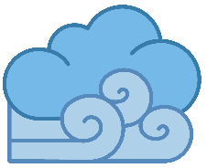
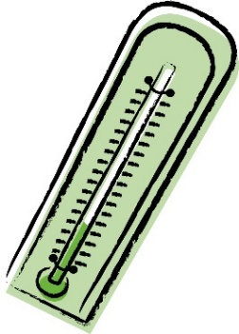
Anemometer – Measures the wind speed
Barometer–Measures the air pressure
Hygrometer-Measures the moisture
Thermometer – Measures the temperature
Use the Cardinal Directions Sign to determine which direction is north, south, east and west, and where our school is located in our community!
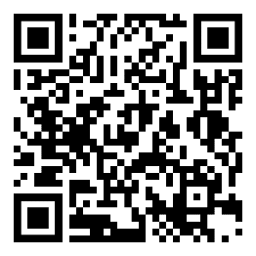
Scan this QR Code to learn more about weather!
Enjoy nature’s beauty!
Protect it from litter and vandalism!

