Outdoor Classroom Project Plan:
Materials List & Budget for
VERMICOMPOST BIN

Vermicomposting is the method of using earthworms to speed up the process of composting. The worms in the compost bin consume the compost material such as used paper or coffee grinds and turn it into something useful – worm castings (or worm poop) that can be used as fertilizer or “black gold.” This system of composting demonstrates to students how important worms are to the health of our ecosystems. Just as they do in your vermicompost bin, worms help break down organic matter into nutrients for plants. They also break up the soil with their tunnels, which helps aerate the soil and allows the soil to retain more water. Earthworms help our wildflowers, grasses, bushes and trees survive and thrive!

- Location Requirements:
  - Keep your vermicompost bin somewhere out of direct sun. Bins can be stored indoors as well.
  - It is important to keep temperatures mild inside of the bin. Use a thermometer to verify it is between 55-70ºF. Adjust the location of your bin as needed to achieve these temperatures.
  - If you have a Box Turtle Habitat, you may consider placing you vermicompost bin nearby. This will give you easy access to worms when you are feeding the turtles.

- Photos of a Completed Vermiculture Bin:
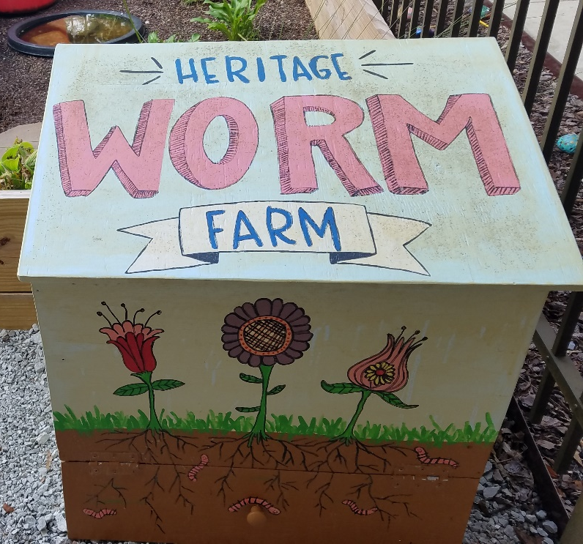
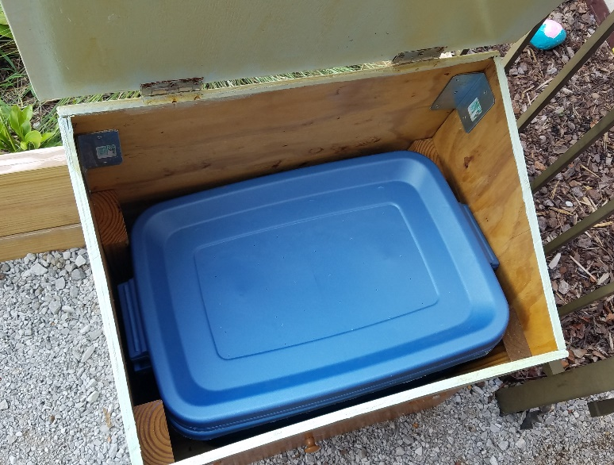

OC Project Plan: Vermicompost Bin Materials List & Budget

- Estimated Cost: $275-295
- Materials & Supplies with Estimated Budget:
Vermicompost Bin
Holds 2 worm bins & 1 liquid fertilizer collection bin
Station | Materials & Supplies | Estimated Cost | Example Source | Final Cost
Vermi | (1) ½-in x 4-ft x 8-ft Southern Yellow Pine Plywood Sheathing @~$24.80 ea | $25 | Lowe’s Item #12192
Vermi | (1) 2-in x 4-in x 8ft #2 Prime Wood Pressure Treated Lumber @~$5.38 ea | $5 | Lowe’s Item #196087
Vermi | (1) Gatehouse 3-in Zinc Mortise Door Hinge (2-Pack) (for top of box) @~$3.27 ea | $5 | Lowe’s Item #308972
Vermi | (1) Gatehouse 2-in Zinc Mortise Door Hinge (2-Pack) (for front of box) @~$2.47 ea | $5 | Lowe’s Item #308970
Vermi | (8) Simpson Strong-Tie 1.25-in x 1.25-in x 3.25 in 18-Gauge G90 Galvanized Steel Angle @~$1.28 ea | $10 | Lowe’s Item #1944409
Vermi | (1) Hillman One #8 x 2-1/2-in Bronze Expoxy Flat Exterior Multi-Material Screws (for attaching 2x4’s to sides of box to create shelf inside box) @~$3.98 ea | $5 | Lowe’s Item #875079
Vermi | (1) Amerock Everyday Heritage 1.25-in Unfinished Round Traditional Cabinet Knob (for opening the bottom front door of box) @~$2.93 ea | $5 | Lowe’s Item #4068532
Vermi | (1-2) Dark 10-Gallon (40-Quart) Centrex Rugged Tote with Standard Snap Lid (24” long x 16” wide x 8.8” deep) @~$18.98 ea | $20-40 total | Lowe’s Item #831520
Vermi | (1) Clear Storage Plastic Bin with Lid, 28 quart (2 Count) (5-7 Gallon, 22-24” long, 15-16” wide, & 5-6” deep) @~$40.72 ea | $40 | https://www.amazon.com/HOMZ-Quart-Snaplock-Container-Storage/dp/B07STLHLCZ/
Vermi | (1) Gallon of Exterior Stain/Paint (pick a light color that will help reflect sunlight) @~$38.98 ea | $40 | Lowe’s Item #147475
Vermi | (1) Valspar 4-Piece Paint Roller Kit @~$15.48 ea | $15 | Lowe’s Item #1617024
Vermi | Shredded Newspaper or fallen leaves, lightly moistened (for bedding) | FREE | Donated or On Campus
Vermi | Handful of sand or crushed egg shell (for grit) | FREE | From School
Vermi | ~100 Worms (red wigglers, red worms, manure worms; NOT night crawlers) | $10 | Bait Store
Vermi | Educational Sign (explaining vermiculture) | $75 | Ask OC Consultant about https://www.alabamawildlife.org/oc-signs/

OC Project Plan: Vermicompost Bin Materials List & Budget

- Materials & Supplies with Estimated Budget (cont.):
Vermi | (1) 6 ft. U-Post for Fence (for educational sign) @~$10.69 ea | $10 | Lowe’s Item #493054
Vermi | (1) Hillman 1/4-in x 1-1/2 in Zinc-Plated Coarse Thread Hex Bolt (2-count) @~$0.88 ea | $5 total | Lowe’s Item #137634
Vermi | (2) Hillman ¼-in x 20 Zinc-Plated Steel Hex Nut @~$0.10 ea |  | Lowe’s Item #63301
Vermi | (2) Hillman ¼-in Zinc-Plated Standard Flat Washer @~$0.53 ea |  | Lowe’s Item #63306
Total Estimated Cost: $275 - $295

