Outdoor Classroom Project Plan:
Construction Instructions for
VERMICOMPOST BIN

- Construction Tools & Supplies for Outdoor Classroom Build Day:
  - Phillips Head Screwdriver
  - Electric Drill w/ Phillips head and star-bit, ¼” and 1/16” bits
  - Circular or Jig Saw
  - Level
  - Measuring Tape

- Construction Instructions:
- First, purchase supplies and have them on-hand for the Outdoor Classroom Build Day.
- Cut the 2” x 4” into (2) pieces that are 24” long each to create a shelf for the dark storage box(es) inside the box that will hold the worm farm(s).
- Cut the sheet of ½” Treated Plywood (see diagram below & photo on page 5) into the following:
- Back of Box: ½ inch Treated Plywood cut into a 26” High x 25” Wide rectangle
- Top of Box: ½ inch Treated Plywood cut into 19” High x 25” Wide rectangle
- Front of Boxes (piece #1): ½ inch Treated Plywood cut into 14.5” High x 25” Wide rectangle
- Front of Boxes (piece #2): ½ inch Treated Plywood cut into 6.75” High x 25” Wide rectangle
- Left Side of Boxes: ½ inch Treated Plywood cut into trapezoids that are 26” x 17” x 21.5”
- Right Side of Boxes: ½ inch Treated Plywood cut into trapezoids that are 21.5” x 17” x 26”
TREATED PLYWOOD
(4 ft x 8 ft sheet)

BACK

25”

TOP
FRONT

TOP 25”
(LID) BOTTOM
FRONT
25” 25” 17” 17”

26”

4 feet
4 feet

26”
RIGHT SIDE
21.75”
14.5”
21.75”
LEFT SIDE
19”
26”

6.75”

8 feet
OC Project Plan: Vermicompost Bin Construction Instructions

- Construction Instructions (cont.):
- Use (12) ½” Wood Screws to attach the Left Side (1/2” plywood) to the Back (1/2” plywood) using (2) L-Brackets (such as (2) GA2 3 1/4" x 1 1/4" Gusset Angles) on the inside of the box.
20” from ground

10” from ground
BACK
PANEL:
(Inside)
The back of the Left Side Panel should line up on the left INSIDE ½” of the Back Panel, so that Back Panel and two Front Panels form a “cap” for the two Side Panels.

LEFT SIDE
PANEL:
(Inside)

- Use (12) ½” Wood Screws to attach the Right Side (1/2” plywood) to the Back (1/2” plywood) using (2) L-Brackets (such as (2) GA2 3 1/4" x 1 1/4" Gusset Angles) on the inside of the box.
BACK PANEL: (Inside)

20” high

10” high
The back of the Right Side Panel should line up on the right INSIDE ½” of the Back Panel, so that Back Panel and two Front Panels form a “cap” for the two Side Panels.
The back of the Back Panel provides a “cap” for the Side Panels.
LEFT SIDE PANEL:
(Outside)

SIDE

RIGHT
SIDE
PANEL:
(Inside)

- Attach the (2) 24” long 2x4s to the Right & Left Sides (7” from the ground) by screwing (2) 2.5” Wood Screws through the OUTSIDE of the ½” plywood and into the end of each 2x4s (using all 8 of the 2.5” screws). (see the photo on page 5)
Place the 1st 2x4 INSIDE the box with the back 2” side pressed up against the Inside Back Panel, and then attach it to the Side panels by screwing the 2.5” Wood Screws through the OUTSIDE of the plywood and into the end of 2x4s. Place the 2nd 2x4 parallel to the 1st with the front 2” side of the 2x4 flush with the front end of the two side panels.
BACK PANEL:
(Inside)

LEFT
SIDE:
(Outside)

The 2x4s should be 7” from the ground.

2” tall by 4” wide
OC Project Plan: Vermicompost Bin Construction Instructions

- Construction Instructions (cont.):

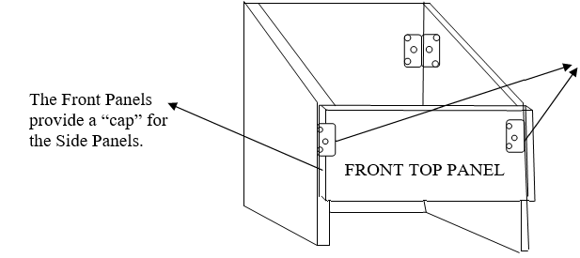
- Use (12) ½” Wood Screws to attach the Front Top Panel (1/2” plywood) to the Left & Right Sides (1/2” plywood) using (2) L-Brackets (such as (2) GA2 3 1/4" x 1 1/4" Gusset Angles) on the inside of the box.

The L-Brackets should be attached (10” from the ground) to the Sides and Front Top Panel of plywood on the INSIDE of the box.

- Attach the Top Lid to the Back of the worm bin box using the (2) 3-inch hinges and (12) ½” wood screws.

The Hinges should be attached to the OUTSIDE of the Back piece and on the INSIDE of the Top Lid IF you don’t want to see the hinge. If you don’t mind seeing the hinge, then you can attach it to the OUTSIDE of both the Back Piece & the Top Lid.
LEFT SIDE
TOP
LID

- Attach the Front Top piece to the Front Bottom piece using the (2) 2-inch H-hinges and (8) wood screws.

The 2” Hinges should be attached to the OUTSIDE of the FRONT TOP and FRONT BOTTOM so that the FRONT BOTTOM becomes a door that can be opened to pull out the clear plastic storage bin that holds the “liquid fertilizer” that drips into it from the worm bin(s) above.
TOP
LID

FRONT TOP

FRONT BOTTOM

OC Project Plan: Vermicompost Bin Construction Instructions

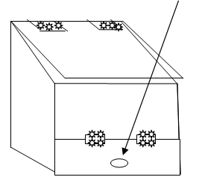
- Construction Instructions (cont.):

- Attach the Small Wooden Knob to the front of the Front Bottom piece so that you can lift the door open easily.

- Paint the bin with exterior wood sealant or paint to help it last longer.

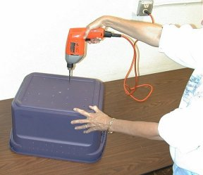

- Drill about twenty evenly spaced ¼-inch holes in the bottom of each bin. Concentrate the holes in the center of the bin since the edges of the bin
will rest on 2” x 4” posts (see photo on page 5). These holes will provide drainage and allow the worms to crawl into the second bin when you are ready to harvest the castings.

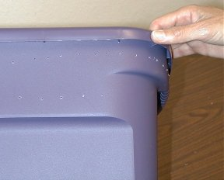

- Drill ventilation holes about 1 – 1 ½ inches apart on each side of the bin near the top edge using the 1/16-inch bit. Also drill about 30 small holes
in the top of one of the lids.

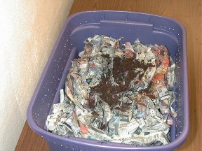
- Prepare bedding for the worms by shredding Newspaper into 1-inch strips. Worms need bedding that is moist but not soggy. Moisten the newspaper by soaking it in water and then squeezing out the excess water. Cover the bottom of the bin with moist shredded cardboard and then 3-4 inches of moist newspaper, fluffed up. If you have any old leaves or leaf litter, that can be added also. Throw in a handful of dirt for "grit" to help the worms digest their food.

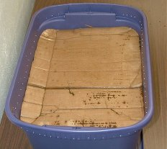
- Add the worms.

- Cut a piece of cardboard to fit over the bedding, and get it wet. Then
cover the bedding with the cardboard. (Worms love cardboard, and it breaks down within months.)

OC Project Plan: Vermicompost Bin Construction Instructions

- Construction Instructions (cont.):

EXTRA PHOTOS TO HELP YOU VISUALIZE THE CONSTRUCTION

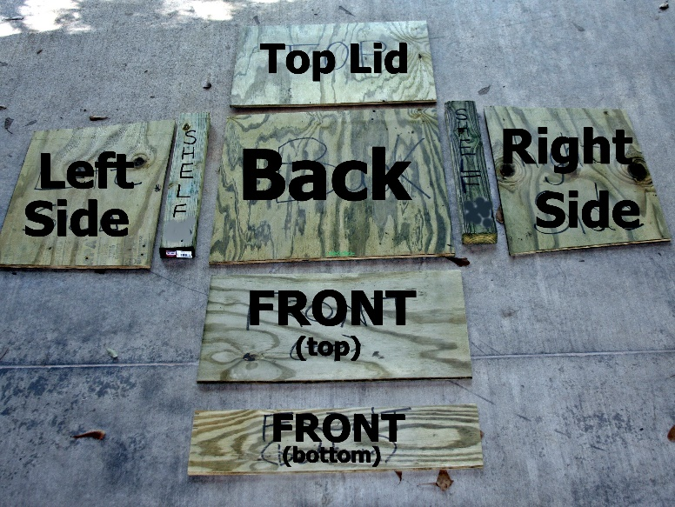  Worm Bin Box Lumber:  Laid Out & Labeled | 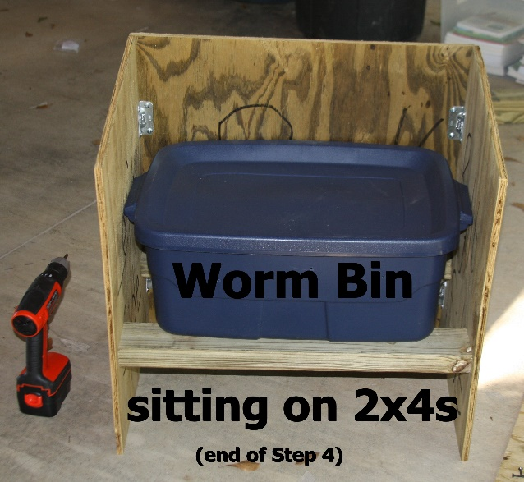  Worm Bin Box with (1) Worm Bin: How it should look after Step #6

