Welcome to our
Sunflower Garden
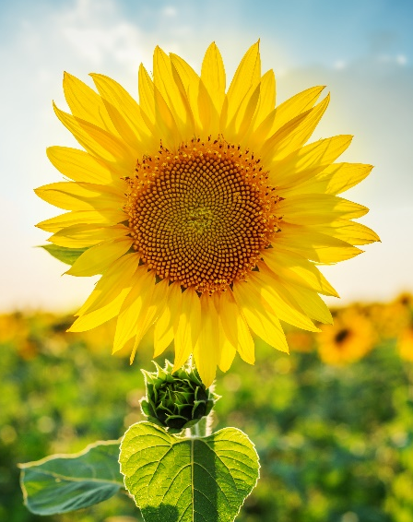
We grow sunflowers that produce seeds for our local birds to eat.
The sunflower is also a wonderful example of Fibonacci numbers in nature… 0, 1, 1, 2, 3, 5, 8, 13, 21, 34, 55, 89, etc… where the two previous numbers added together create the next number in the sequence.
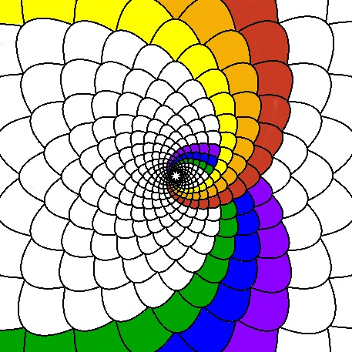
As you look more closely at the patterns the seeds and flower petals make, you’ll notice that they create symmetrical spirals. If you count the number of spirals going clockwise and the number of spirals going counter-clockwise then you will find that both are Fibonacci numbers.

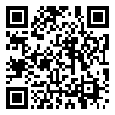
Scan this QR Code to learn more about Fibonacci!
Enjoy nature’s beauty!
Protect it from litter and vandalism!

