Outdoor Classroom Project Plan:
Construction Instructions for
SMALL INFORMATIONAL KIOSK

- Construction Tools & Supplies for Outdoor Classroom Build Day:
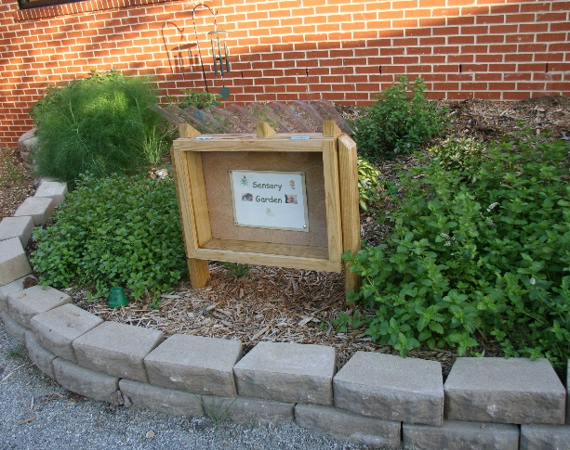
  - Phillips Screwdriver
  - Electric Drill w/ Phillips head or star-bit
  - Circular/ Jig Saw
  - Level
  - Measuring Tape
  - Post Hole Diggers

- Construction Instructions:

- First, purchase supplies and have them on-hand for the Outdoor Classroom Build Day.
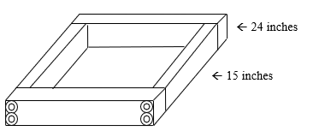
- Cut the plywood into a 24” x 18” rectangle.
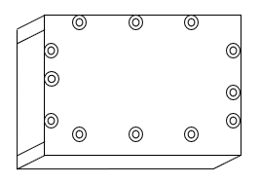
- Use (8) 2.5” self-drilling wood screws to attach the (2) 2”x 4”x 24” boards to the (2) 2” x 4” x 15” boards using your drill. Once the screws are drilled in it should look like a 4” deep box that is 24” wide and 18” tall. (See image on right)
- Use (12) 2.5” self-drilling wood screws to attach the plywood to the box. Drill the screws through the plywood into the 2”x4”s. (Optional: You can also use Wood Glue to help seal the plywood to the 2”x4”s.) Once the screws are drilled in it should look like a “shadow box” when you flip it over with the plywood on the bottom. (See image on right)
- Use (4) 2.5” self-drilling screws to attach the (2) 2”x 2” x 24” strips to the (2) 2”x 2” x 15” strips using your drill. Once the four screws are drilled in, it should look like a “picture frame.” (See image on right)
OC Project Plan: Small Informational Kiosk Construction Instructions

- Construction Instructions (cont.):
- (This is the hardest step, so consider asking your home improvement store to help you with this step.)
Place the acrylic Plexiglas on top of the “picture frame” you just created. Drill (6) holes one inch in from the edge of the acrylic Plexiglas using a 3/16” drill bit so that you can attach the plexiglass to the wooden frame. (See diagram below) You should have two holes on both of the 18” sides and two holes on one of the 24” sides – you will not drill holes in the fourth side yet because the hinges will be on the fourth side to connect the Plexiglas frame to the wooden box.
Note: DO NOT put a lot of pressure on Plexiglas as it can easily break.
- Place washers over each hole on top of Plexiglas and then gently screw in each self-drilling screw by hand using a Phillips-head screwdriver. (See images below)
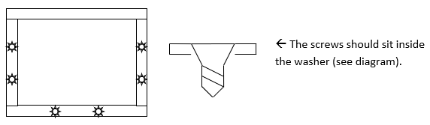
Note: DO NOT put a lot of pressure on Plexiglas as it can easily break.
18 inch side

24 inch side

- Place the (2) 2.5” hinges along the remaining 24” side of the Plexiglas frame (the side with no screws), and drill (3) small holes in the acrylic Plexiglas using a 3/16” drill bit for each of the holes in the hinges. Then attach the hinges using the screws included in the hinge packets. (See images below)
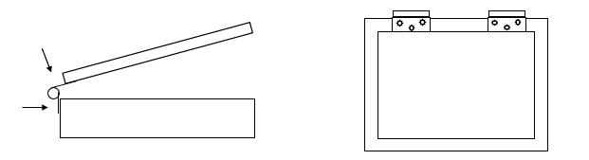

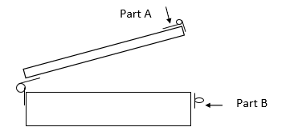
- Using the screws included the latch packet, attach the latch hinge to the front of the box (see “part A”) and then attach the latch clasp (see “part B”) to the bottom. (See image on right)
- Install Rubber Weatherseal around the interior junction of the frame and box. Add a slanted roof (if needed) to help weather-proof it as well.
- Cut cork board (if needed) and attach to plywood on inside of Kiosk with wood glue. Add “legs” to the side(s) or back so that it is the height you desire.
- Paint the kiosk with exterior wood sealant or paint to help it last longer.

