**Welcome to our Sensory Garden**



**Use all of your senses as you explore**

**our sensory garden and outdoor classroom!**

Gently feel the textures of the plants.

Can you smell the flowers?

What colors are the flowers?

What are the shapes of the leaves?

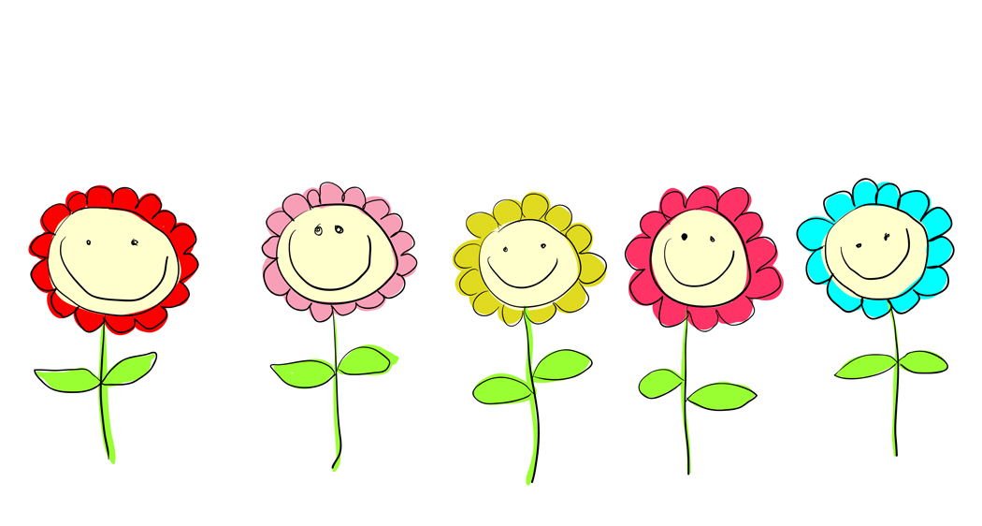

** Scan this QR Code to learn more about your senses.**

**Enjoy nature’s beauty!**

**Protect it from litter and vandalism!**