Welcome to our
Row Crops Garden

Farmland covers about 25% or ¼ of the state
of Alabama. Cotton is our largest row crop
and is grown in 59 of Alabama’s 67 counties.
Half of the peanuts produced in the U.S. are
grown in south Alabama.
Our farmers also grow corn, wheat, and soybeans.

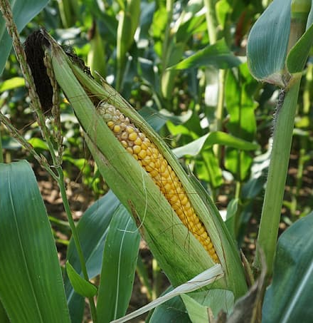
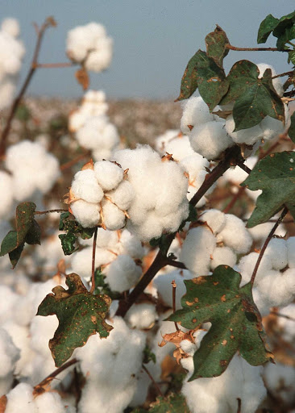
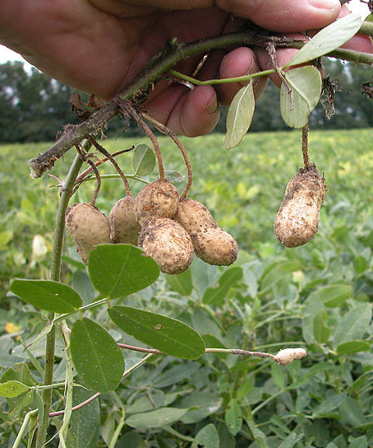

Scan this QR Code to learn more about row crops.
Enjoy nature’s beauty!
Protect it from litter and vandalism!

