Welcome to our
Pollinator Garden
Our pollinator garden includes flowers that
attract pollinators like ants, bees, beetles,
butterflies, moths, and wasps by providing
nectar for them.

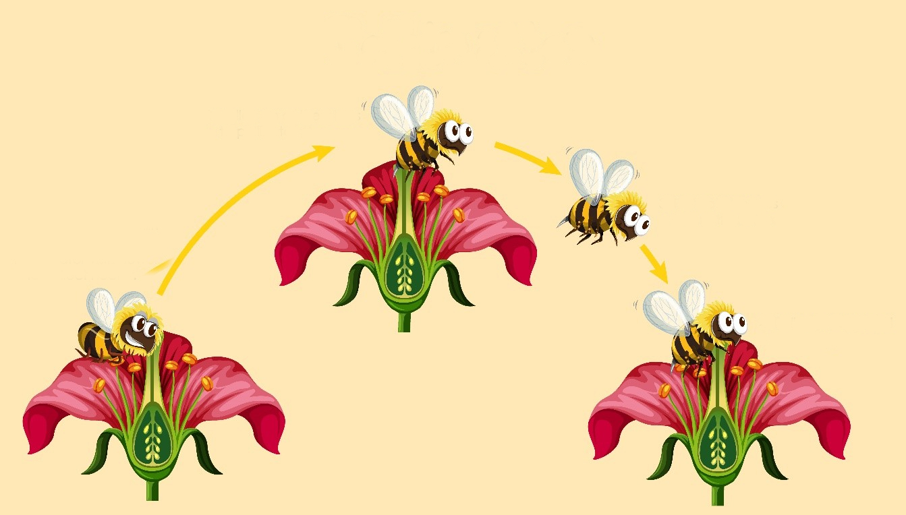
Pollen on the anthers stick to the Pollinator
Pollinator visits other flowers

Pollinator visits flower
Pollen is transferred to the stigma

Image: Freepik.com

We rely on pollinators and the plants they pollinate
for our clothes, drinks, food, and medicines.

Scan this QR Code to learn more about pollinators.
Enjoy nature’s beauty! Protect it from litter & vandalism!

