Plant Native Plants
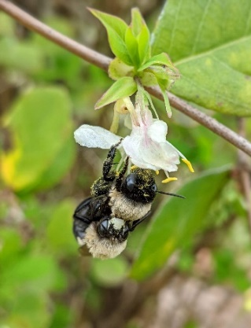
- Formed symbiotic relationships with native wildlife as they evolved together over millions of years.
- Provide valuable shelter and food sources like seeds and fruit for local songbirds and other native wildlife.
- Provide specific “host plant” species on which different butterfly species lay their eggs and that caterpillars eat.
- Provide nectar and pollen for bees and other pollinators.
- Require less water because they adapted to the local climate.
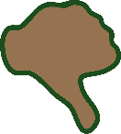
Remove Non-native Invasive Plants
- Not naturally found in the U.S. – introduced here by humans.
- Actively reproduce and invade our native plant communities.
- Out-compete our native for water, nutrients, and space.
- Reduce the number and diversity of native plant species which our native wildlife relies on for food and shelter.
- Cause our native plant and wildlife populations to decline.

Scan this QR Code to learn more about native plants.
Enjoy nature’s beauty!
Protect it from litter and vandalism!

