Outdoor Classroom Project Plan:
Materials List & Budget for
LOG DECOMPOSITION STATION

A Log Decomposition Station is easy to build with little to no expense. By developing a rotting log observation area, the students can observe decomposition over a long period of time and learn how various natural cycles such as the carbon and nitrogen cycles function in nature. By maintaining a rotting log learning station, students will learn about a vast array of decomposers (bacteria, fungi, arthropods and worms) as well as organisms that feed on the decomposers (salamanders, arthropods and worms).

- Habitat Requirements:
- (Best) A Shaded, moist area with forest litter covering the ground makes the best location as it will encourage a wider variety of organisms to colonize the area and provides them with their basic needs (food, water, and shelter) so that decomposition will take place at a faster rate. It is also helpful to use an area that is open enough so that students can easily gather around the logs and carefully roll them over for observation.
- (Better) A shaded area that has a cover of organic material such as leaves will work if you don’t have the before mentioned area. It will still attract decomposers, but to a lesser degree. Decomposing will also take place at a slower rate.
- (Good) An area that receives only morning sun, is moist and has ground litter cover is okay but will not attract nearly as many decomposers. You will also see less fungal activity, especially if it does not have the moisture.
- (Poor) An area that receives full sun will be the poorest location as many of the decomposers prefer cool, moist, and dark areas. Therefore, the rate at which decomposition takes place will be greatly reduced and you will lack biodiversity.

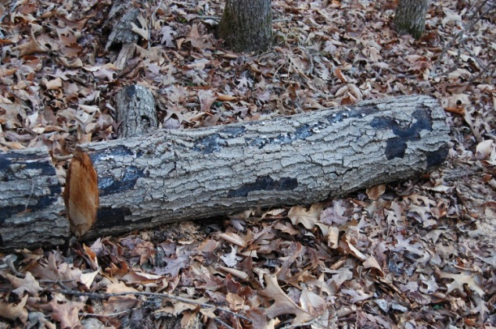
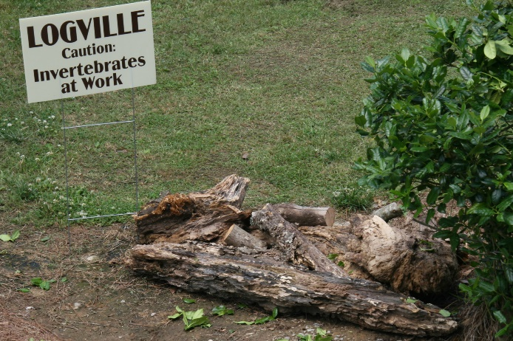
- Example Log Decomposition Stations:
Example Log Decomposition Station
Wrights Mill Road Elementary, Auburn City Schools
Example Log Decomposition Station & Sign
Falkville Elementary, Morgan County

OC Project Plan: Log Decomposition Station Materials List & Budget

- Estimated Cost:
- Example 4 ft x 6 ft Log Decomposition Station: $90
- Example 4 ft x 12 ft Log Decomposition Comparison Project: $90

- Materials & Supplies Lists with Estimated Budgets:
Example 4 ft x 6 ft Log Decomposition Station
Station | Materials & Supplies | Estimated Cost | Source of Materials | Final Cost
Sm. Log | (3) or more logs - at least 10” in diameter by 2-3 ft long | FREE | Donated or On Campus
Sm. Log | (3) large yard bags filled with fallen leaves | FREE | Donated or On Campus
Sm. Log | Educational Sign (explaining decomposition & decomposers) | $75 | Ask OC Consultant about https://www.alabamawildlife.org/oc-signs/
Sm. Log | (1) 6 ft. U-Post for Fence (for educational sign) @~$10.69 ea | $10 | Lowe’s Item #493054
Sm. Log | (1) Hillman 1/4-in x 1-1/2 in Zinc-Plated Coarse Thread Hex Bolt (2-count) @~$0.88 ea | $5 total | Lowe’s Item #137634
Sm. Log | (2) Hillman 1/4-in x 20 Zinc-Plated Steel Hex Nut @~$0.10 ea |  | Lowe’s Item #63301
Sm. Log | (2) Hillman 1/4-in Zinc-Plated Standard Flat Washer @~$0.15 ea |  | Lowe’s Item #63306
Total Estimated Cost: $90

OC Project Plan: Log Decomposition Station Materials List & Budget

- Materials & Supplies Lists with Estimated Budgets (cont.):
Example 4 ft x 12 ft Log Decomposition Comparison Project
Station | Materials & Supplies | Estimated Cost | Source of Materials | Final Cost
Lg. Log | (3) 3 hardwood logs (such as oak or sweetgum) at least 10” in diameter by 2-3 ft long | FREE | Donated or On Campus
Lg. Log | (3) softwood logs (such as pine Pine) at least 10” in diameter by 2-3 ft long | FREE | Donated or On Campus
Lg. Log | (6) large yard bags filled with fallen leaves | FREE | Donated or On Campus
Lg. Log | Educational Sign (explaining decomposition & decomposers) | $75 | Ask OC Consultant about https://www.alabamawildlife.org/oc-signs/
Lg. Log | (1) 6 ft. U-Post for Fence (for educational sign) @~$10.69 ea | $10 | Lowe’s Item #493054
Lg. Log | (1) Hillman 1/4-in x 1-1/2 in Zinc-Plated Coarse Thread Hex Bolt (2-count) @~$0.88 ea | $5 total | Lowe’s Item #137634
Lg. Log | (2) Hillman 1/4-in x 20 Zinc-Plated Steel Hex Nut @~$0.10 ea |  | Lowe’s Item #63301
Lg. Log | (2) Hillman 1/4-in Zinc-Plated Standard Flat Washer @~$0.15 ea |  | Lowe’s Item #63306
Total Estimated Cost: $90

