Outdoor Classroom Project Plan:
Construction Instructions for
LOG DECOMPOSITION STATION

- Construction Tools & Supplies for Outdoor Classroom Build Day:

- Chainsaw (to cut logs to length)
- Gloves for moving logs and spreading leaves
- (1) or (2) Shovel(s)
- (1) Wheelbarrow
- (1) Drill for attaching signs to posts

- Construction Instructions:

- Purchase/ gather supplies and have them on-hand for the Outdoor Classroom Build Day.
- Removed the grass from a 4 ft x 6 ft (or 4 ft x 12 ft) space so that only soil is remaining.
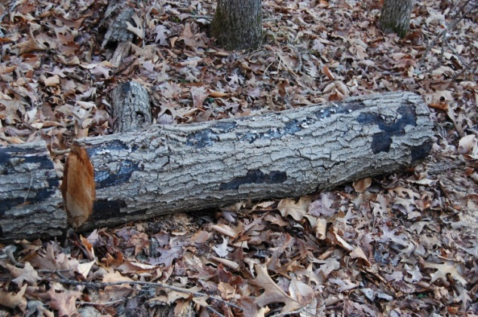
- Use the wheelbarrow to take the grass clumps to a pre-approved area for dumping the grass and soil.
- Spread the leaves or forest floor material in a two to three-inch layer in the exposed soil area where you are planning to place the logs.
- Place the logs on top of the leaves and dampen the area if it is dry. (You will want to moisten the area around once a week if it does not rain since moisture is important for decomposition to take place.) Place the logs far enough apart so that groups of students can gather around each log without getting in another group’s way.
- Dig a 1-ft deep hole near the garden for your education sign, place the 4”x4”x6’ post in the hole, use concrete to secure the post in the hole and around the base of the post to prevent water from collecting and rotting post. Attach educational sign to post.

