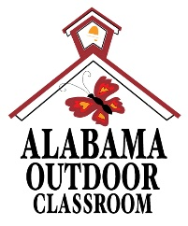
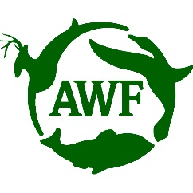
Example Outdoor Classroom
Learning Station Adoption Program
Spring 2025
You are signing up to Adopt this Learning Station for one semester.
Only one class can adopt one learning station each semester.
There are only enough tasks for one class per learning station.
You will receive a Learning Station Maintenance Folder with the adoption form, maintenance tips for the specific learning station, and details about the plants in the learning station including a leaf & flower shape ID chart.
- Sensory Garden (Kindergarten): ___________________________________
- Butterfly Garden (1st): ________________________________________
- Pollinator Garden (2nd): ________________________________________
- Frog & Toad Habitat (3rd): _____________________________________
- Songbird Station #1 (4th): _____________________________________
- Songbird Station #2 (4th): _____________________________________
- Songbird Garden (4th): _________________________________________
- Log Decomposition Station (5th):__________________________________
- Raised Bed #1:______________________________________________
- Raised Bed #2:______________________________________________
- Raised Bed #3:______________________________________________
- Raised Bed #4:______________________________________________
Additional information and educational activities related to the learning stations are available at www.AlabamaWildlife.org/outdoor-classroom-program.

