Outdoor Classroom Project Plan:
Materials List & Budget for
LARGE INFORMATIONAL KIOSK

The large Informational Kiosk is free standing and designed to provide a display area that is approximately 27” x 33” (inside measurements).
A large Information Kiosk can be used in many ways including:
- Welcome Center – at the entrance to your outdoor classroom site with an Outdoor Classroom Site Map and/or other information you want to share with students, teachers and visitors such as “What’s Growing on in the OC…”
- Classwork Display – where students can display their art work, photographs, poems or research on specific topics related to the learning stations throughout the year.

- Location Requirements:
- Place in close proximity to the entrance of the outdoor classroom.
- The legs needed to be set in the ground at a minimum depth of 2 feet for stability, so you will need to confirm that there are no utility lines found in the area where you plan to dig.

- Photos of a Completed Kiosk:
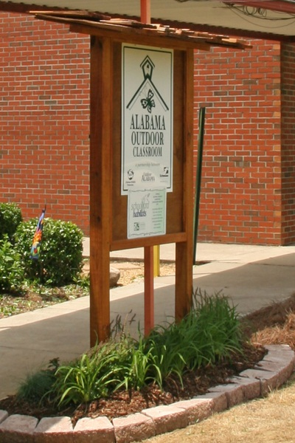
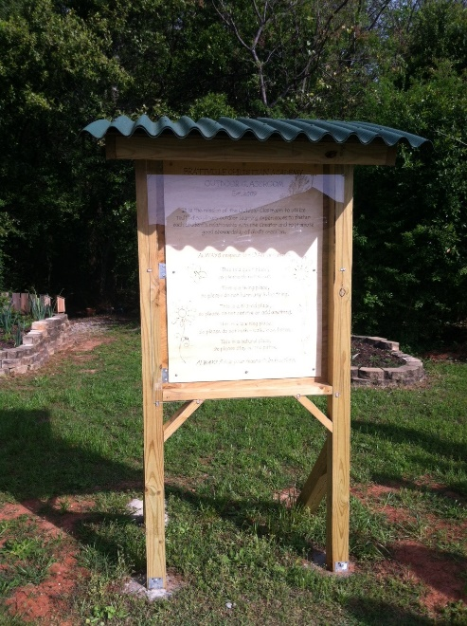

OC Project Plan: Large Information Kiosk Materials List & Budget

- Estimated Cost: $385
- Materials & Supplies with Estimated Budget:

Large Information Kiosk
(2.5’ x 4’): This wooden information board has a 2 ½ x 3’ box with an acrylic glass window, so that teachers/students can post “What’s Growing On…” each month.
Station | Materials & Supplies | Estimated Cost | Example Source | Final Cost
Lg Kiosk | (1) 0.08-in T x 30-in W x 36-in L Clear Sheet  @~$38.98 ea | $40 | Lowe’s Item #11233
Lg Kiosk | (4) 2-in x 4-in x 8-ft #2 Prime Wood Pressure Treated Lumber (two for (2) 8’ posts, one for (2) 30” cross pieces, one for (2) 4’ pieces to use as braces as quikrete dries) @~$5.38 ea | $25 total | Lowe’s Item #196087
Lg Kiosk | (4) 2-in x 2-in x 6-ft Square Unfinished Pine Board for frames @~$11.98 ea | $50 total | Lowe’s Item #810719
Lg Kiosk | (1) 23/32-in x 4-ft x 8-ft Treated Plywood  @~$46.78 ea | $45 | Lowe’s Item #195308
Lg Kiosk | (1) box #10 x 3-1/2-in Wood To Wood Deck Screws @~$9.98 ea | $10 | Lowe’s Item #9479
Lg Kiosk | (1) box #9 x 3-in Wood To Wood Deck Screws  @~$10.98 ea | $10 | Lowe’s Item #225847
Lg Kiosk | (2) 4-1/4-in Zinc T-shaped Door Hinge (should come with screws) @~$5.98 ea | $10 total | Lowe’s Item #64172
Lg Kiosk | (1) 3-1/2-in Steel-painted Swivel Hasps (to lock the kiosk) @~$6.38 ea | $5 | Lowe’s Item #308988
Lg Kiosk | (1) Gallon of Exterior Stain & Sealant | $40 | Ask Paint Store
Lg Kiosk | (1) 3” Paint Brush @ ~$16.98 ea | $20 | Lowe’s Item #42706
Lg Kiosk | (1) Paint Roller (base specifics on what type of paint you get) | $15 | Need to ask Paint Store
Lg Kiosk | (4) 50 lb bags of Quikrete Fast Setting Concrete Mix (two bags per hole x 2 holes) @ $6.71 ea | $25 total | Lowe’s Item #10437
Lg Kiosk | (1) 18” x 24” .80 Aluminum Sign with Rules for the Outdoor Classroom (optional) | $75 | Ask OC Consultant about https://www.alabamawildlife.org/oc-signs/
Lg Kiosk | (1) 6 ft. U-Post for Fence (for educational sign) @~$10.69 ea | $10 | Lowe’s Item #493054

OC Project Plan: Large Information Kiosk Materials List & Budget

- Materials & Supplies with Estimated Budget (continued):

Lg Kiosk | (1) Bag of 2 Hillman 1/4-in x 1-1/2-in Zinc-Plated Coarse Thread Hex Bolts @ ~$0.88 ea | $5 total | Lowe’s Item #137634
Lg Kiosk | (2) Hillman 1/4-in x 20 Zinc-Plated Steel Hex Nuts @ ~$0.10 ea |  | Lowe’s Item # 63301
Lg Kiosk | (2) Hillman 1/4-in Zinc-plated Standard Flat Washers @ ~$0.15 ea |  | Lowe’s Item # 63306
Total Estimated Cost: $385

