Outdoor Classroom Project Plan:
Construction Instructions for
LARGE INFORMATIONAL KIOSK

- Construction Tools & Supplies for Outdoor Classroom Build Day:
  - Hammer
  - Electric Drill w/ Phillips head or star-bit
  - Circular Saw
  - Level
  - Measuring Tape
  - Post Hole Digger

- Construction Instructions:

- First, purchase supplies and have them on-hand for the Outdoor Classroom Build Day.
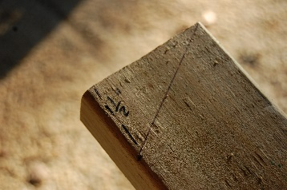
- Using the (2) 2”x4”x8’ treated lumber for posts, cut one end of each board so that it is slanted. The correct size of the slant can be accomplished by measuring 1.5” on one edge while using the end of the board on the other edge. (See the diagram and photo below.) This will allow you to attach the roof on top of the kiosk once it is constructed.
Cut here
1.5”
96”
- Cut the 2”x4”x6’ treated board into (2) 30” length boards to create (2) cross pieces that will be used to build the casing or opening for the kiosk.
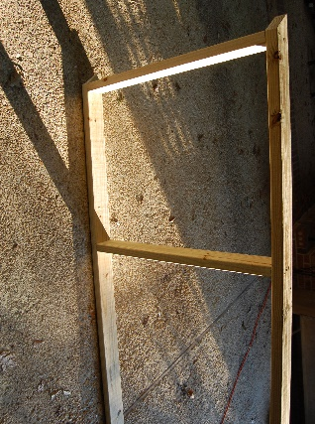
- Create a casing for the kiosk using the two 8 ft long posts from Step 2 and the two 30” pieces from Step 3. Attach the first 2”x4”x30” to the top portion of the two 2”x4”x8’s within 2” of the bottom of the slant on the 2”x4”x8’ by screwing (2) of the 3.5” wood screws through each post into the ends of the 2”x4”x30” piece placed horizontally between the posts. Measure along the inside of the posts down 36” from the top cross piece, and mark both posts. Attach the second 2”x4”x30” under the 36” mark using (4) more 3.5” wood screws to create a 30” x 36” opening for the display area. Be sure that your slanted ends of the posts are at the top of the kiosk so that you can attach the roof later.

30” cross pieces
3.5” screws

2”x4”x8’ posts
36” between cross pieces

OC Project Plan: Large Informational Kiosk Construction Instructions

- Construction Instructions (cont.):
- Cut one of the 2”x2”x6’ pieces into (2) 36” pieces in length and cut another 2”x2”x6’ piece into (2) 27” pieces in length. Screw the (2) 36” trim into the inside of the 8’ posts (using 3” screws) so that the 2” strips are flush with the front of the posts. Screw the (2) 27” trim into the inside the cross pieces (using 3” screws) so that the 2” strips are flush with the front of the cross pieces. These should create a “frame” for the acrylic sheet much like a picture frame. (See photo and diagram below.)
Top of slanted 2”x4”x8’ post (1 ½” higher)
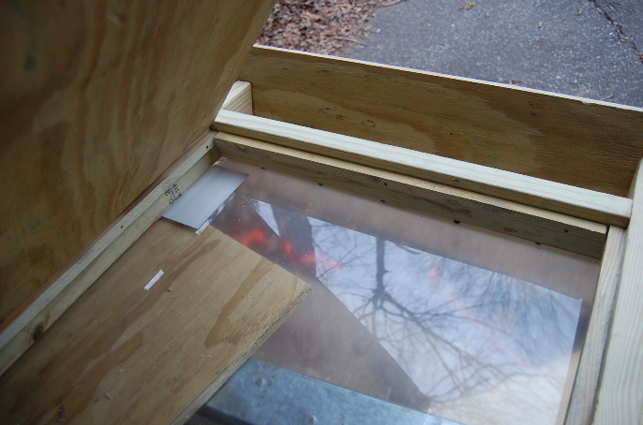
2”x4”x30” cross pieces
Bottom of slanted 2”x4”x8’

2”x2”x27”

2”x2”x36”
2” Frame for Acrylic Sheet

2”x4”x8’ post continues down

- Lay the kiosk face-down on the ground with the 2” frame closest to the ground. Gently place the acrylic sheet inside the opening against the 2” frame.
- Repeat Step 5 by cutting the remaining 2”x2”x6’ pieces into (2) 36” long and (2) 27” long. Gently place the 2”x2” strips on top of the acrylic sheet and screw in the 2” strips into the posts and cross pieces like you did in Step 5 so that the back of the acrylic sheet has a “picture frame” holding it in place.
- Cut the sheet of 3/4” treated plywood so that it measures 30” x 36”. Insert it into the back of the kiosk frame, letting it rest on the second 2” picture frame created in Step 7.
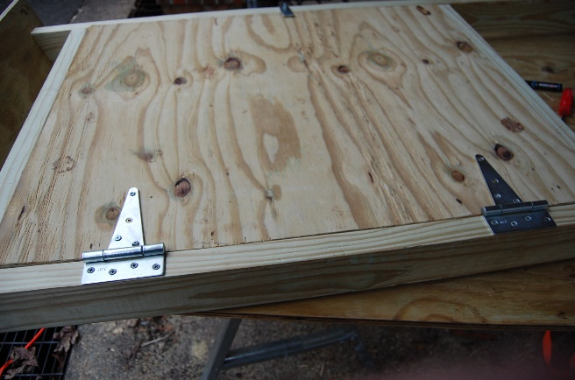
- Once it is in place, attach the T-hinges and the Safety Hasp. The two T-hinges should be attached 7” from the top of the plywood and 7” from the bottom edge of the plywood, so that you can open the back of the kiosk. The hasp should be located on the opposite edge from the T-hinges (at 17.25” or make it centered along that edge) to lock the kiosk.
4.5” T-hinges
3.5” Safety Hasp
OC Project Plan: Large Informational Kiosk Construction Instructions

- Construction Instructions (cont.):

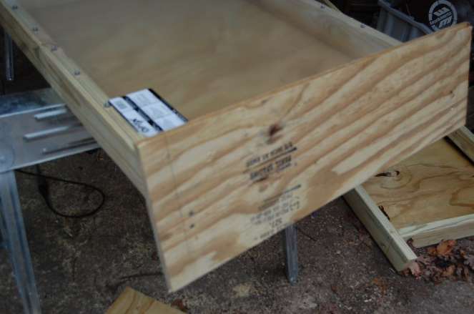
- Cut a 10”x36” piece of plywood from remaining piece of plywood and fasten it to the top of the kiosk using the 3.5” screws. (The roof will slant towards the front of the kiosk.) Cover this roof with shingles or some other roofing material.
- Take the kiosk to the outdoor classroom and dig two holes that are wide enough for the kiosk legs (about 6” in diameter) and deep enough (between 2-3 feet deep) depending on how high you want your kiosk to stand.
- Stand the kiosk up in the holes and use your level to make sure that it is straight. Nail one of the 2”x4”x4’ to each of the legs at a 45-degree angle to help hold the kiosk in position. Use one bag of Quikcrete per hole to hold your kiosk in place. Be sure to mound the Quikcrete around the bottom of the legs of the kiosk (above the grass) to prevent water collecting around the legs and causing rot.
- Paint the kiosk with exterior wood sealant or paint to help it last longer. If needed, you can add cork board to the inside of the kiosk. To add signs or educational material, open the back and make the necessary changes. Once you are finished, fasten the safety hasp on the back of the kiosk.

