Welcome to our Wet Weather Creek
Bienvenidos al arroyo de clima húmedo
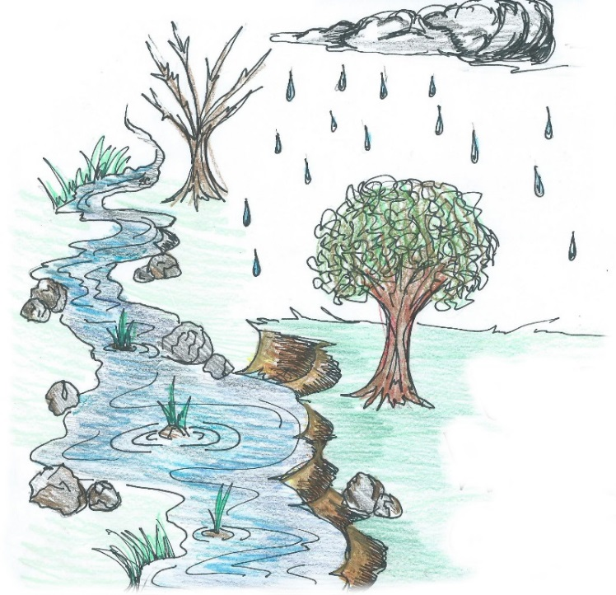

Did you know that when rain water is
not soaked up by the ground that the
stormwater flows into storm drains
and through drainage pipes that
deposit the water in our local
streams, lakes and rivers?

¿Sabía usted que cuando la tierra no absorbe
la lluvia, el agua es transportado por los
drenajes de tormentas a nuestros
arroyos, lagos y ríos?

Polluted rain water is our nation’s number one water quality problem. Our wet-weather creek collects stormwater run-off from rooftops, paved areas, sloped lawns and bare soil from our campus and the surrounding neighborhood. In 2016, we worked together to clean out the silt-filled creek, to add limestone rock along the creek bank to reduce erosion, and to plant aquatic plants along the creek that slow the flow of the stormwater run-off.

We hope you enjoy watching nature at work in our Outdoor Classroom!
Please help us protect it from litter and vandalism! Thank you!

This sign was provided by the James Clemens Spanish Club and Spanish Honor Society,
and the artwork was designed by Sylvia Cortés, Class of 2019.

