Welcome to our Songbird Habitat
Bienvenidos al hábitat del pájaro cantor

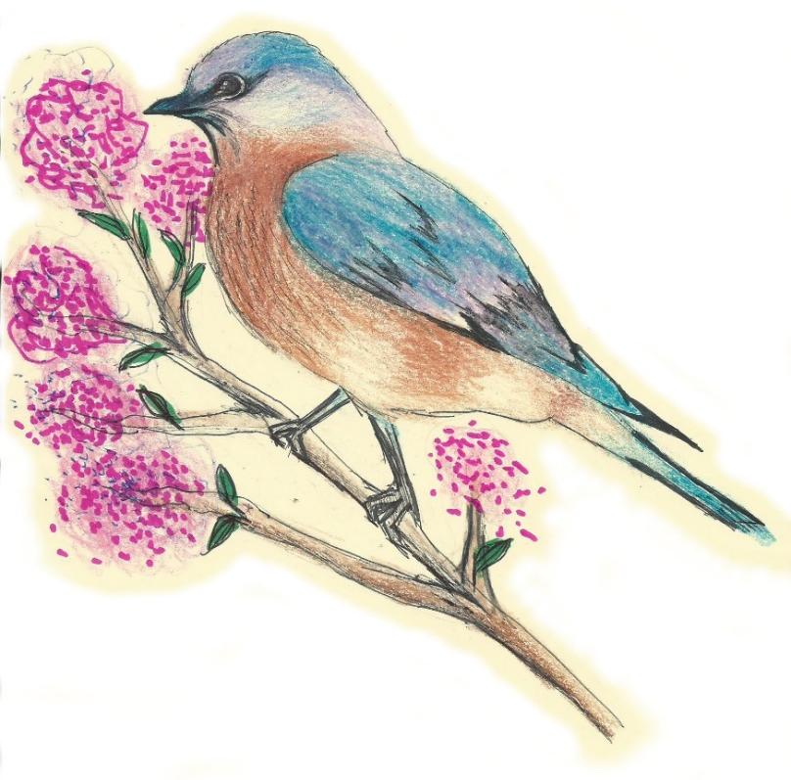
Since the 1950s, many songbird populations in the
Southeast have been in decline. The causes are
complex and include the loss of breeding and
wintering habitat, nests lost to cowbird and
European starling parasitism, and
predation by outdoor cats.

Desde los años 50, muchas poblaciones del
pájaro cantor de la región sudeste han sido
en decadencia. Las causas son complejas
e incluyen la pérdida de los hábitats de
cría e invernada, los nidos perdidos
debido al parasitismo del garrapatero
y del estornino europeo, y la
depredación por gatos al aire libre.

Our outdoor classroom provides a wide variety of habitat to help songbird populations. We planted a variety of native plants, bushes and trees that provide sources of food and shelter, and we have installed nesting boxes for the local cavity nesting birds such as the Eastern bluebird. In addition, our pond and creek provide a valuable source of water for drinking and bathing.

We hope you enjoy watching nature at work in our Outdoor Classroom!
Please help us protect it from litter and vandalism! Thank you!

This sign was provided by the James Clemens Spanish Club and Spanish Honor Society,
and the artwork was designed by Rebecca Thomas, Class of 2017.

