Use our Solar Power Charging Stations
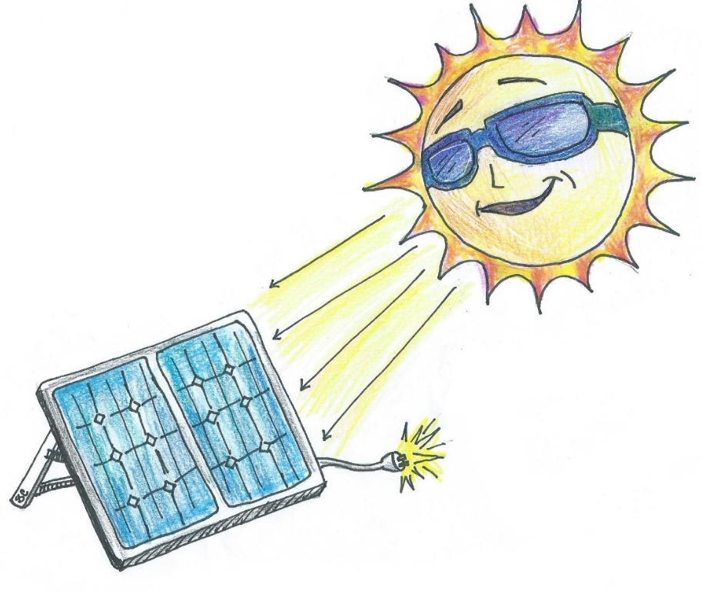
Usen los estaciones de cargar por energía solar

The sun can provide more energy in a single hour than
we (humans) use in an entire year. Our solar panels
use silicon, phosphorous and boron to convert the
sun’s light into a direct current of electricity
that you can use as a power source.

El sol puede proveer más energía en
sólo una hora que nosotros (humanos)
utilizamos en un año entero. Los
paneles solares usan silicio, fósforo
y boro para convertir la luz del sol
en un corriente directo que se puede
usar como un fuente de energía.

In 2017, our Engineering students created seven new solar-powered charging stations that will allow students to use electronic devices for longer periods of time as they collect data and record their observations in the outdoor classroom. In addition, the solar panels will help light the walking paths for students and the community.

We hope you enjoy watching nature at work in our Outdoor Classroom!
Please help us protect it from litter and vandalism! Thank you!

Support for this project came from a STEDTRAIN grant and Representative Mac McCutcheon.
This sign was provided by the James Clemens Spanish Club and Spanish Honor Society,
and the artwork was designed by Sylvia Cortés, Class of 2019.

