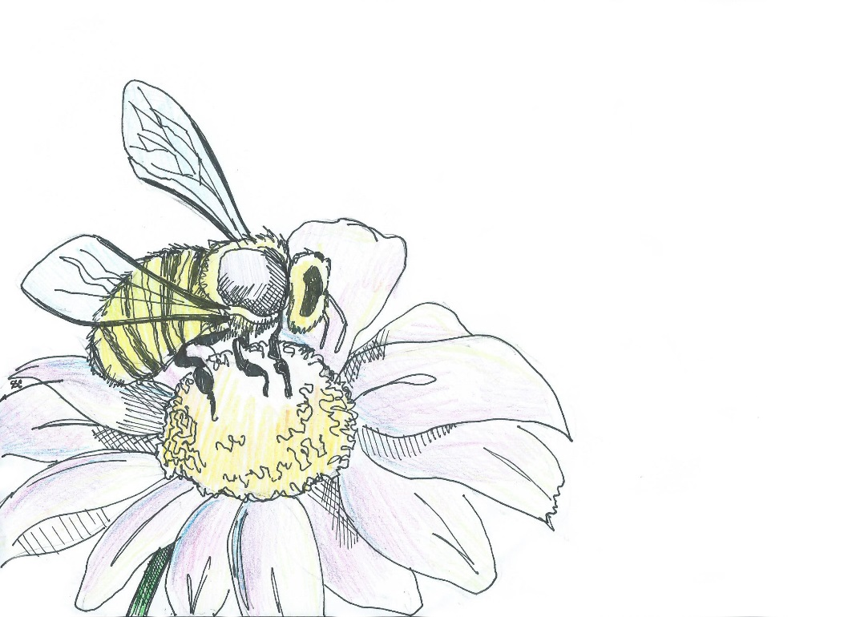
Welcome to our Pollinator Garden
Bienvenidos al jardín polinizador

Ninety percent of all plants need wildlife such as birds,
bees, beetles, flies, moths and butterflies for
pollination (the process of transferring pollen
from flower to flower) in order to start
seed and fruit production in flowers.

Noventa porcentaje de todas las plantas necesitan
fauna silvestre como los aves, abejas, escarabajos,
moscas, palomillas y mariposas para polinización (el
proceso de transferencia del polen de flor en flor)
para empezar la producción de las semillas
y frutas en las flores.

We have over 4,000 different native bee populations in the U.S. Our pollinator garden includes a wide variety of flowering plants and bushes to support local pollinators. Pollinators visit flowers to collect pollen and nectar as food or to use the flowers as shelter from inclement weather and predators. According to the U.S. Department of Agriculture, animals pollinate approximately 75 percent of the crops grown worldwide for our food, beverages, spices, and medicines. The fruits and seeds of flowering plants are also an important food source for wildlife as well.

We hope you enjoy watching nature at work in our Outdoor Classroom!
Please help us protect it from litter and vandalism! Thank you!

This sign was provided by the James Clemens Spanish Club and Spanish Honor Society,
and the artwork was designed by Sylvia Cortés, Class of 2019.

