Welcome to our Butterfly Garden
Bienvenidos al jardín de mariposas
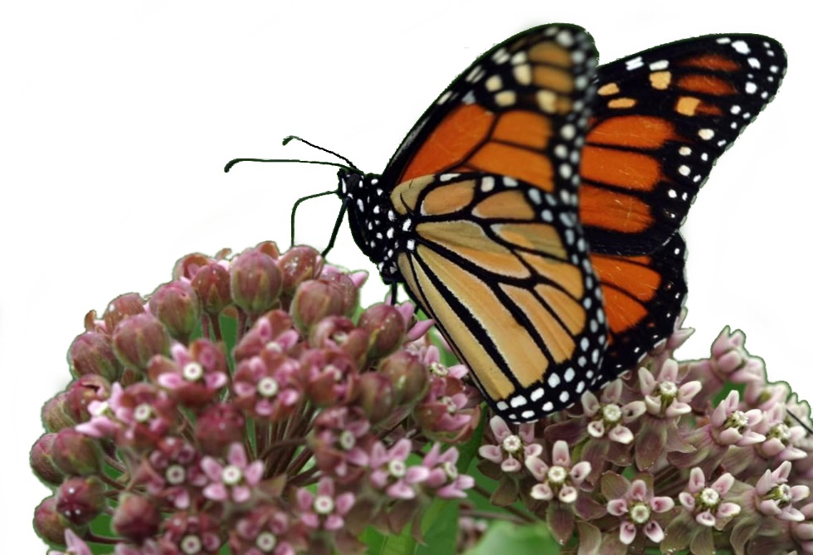
Butterflies play a vital role in ecosystems. They
are important indicators of the biodiversity
and health of an ecosystem due to their
sensitivity to even minor changes
in an environment.

Las mariposas son esenciales para los
ecosistemas. Ellas son indicadores
importantes de la biodiversidad y
salud de un ecosistema debido
a su sensibilidad a aún menores
cambios en un medio ambiente.

Butterflies are the most common pollinator for plants and crops behind bees, wasps and flies. They also provide a food source for wildlife including birds, lizards, frogs, and other insects. To provide habitat for butterflies, we planted native flowering plants that provide nectar for butterflies and “host plants” that provide food for their larvae (or caterpillars). If the host plant for a butterfly species is not readily available, this can cause a decline in that butterfly’s population. For example, one of the contributing factors in the decline of the monarch butterfly is the loss of its host plant—milkweed.

We hope you enjoy watching nature at work in our Outdoor Classroom!
Please help us protect it from litter and vandalism! Thank you!

This sign was provided by the James Clemens Spanish Club and Spanish Honor Society.

