Welcome to our Bog Garden
Bienvenidos al jardín de pantano

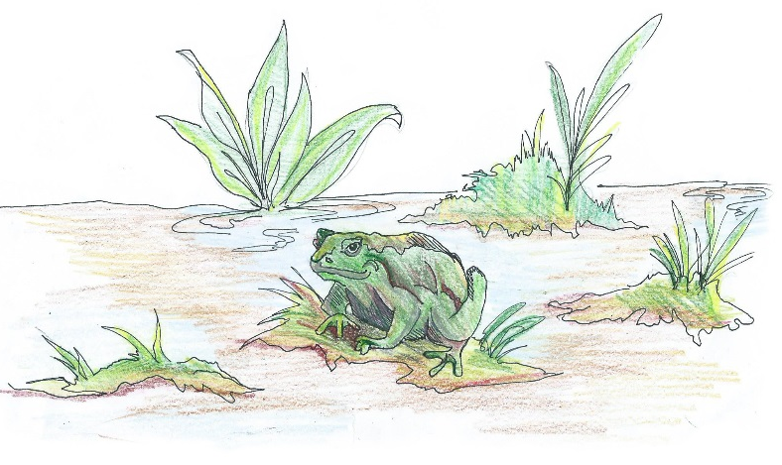
A bog is a type of wetland. Wetlands help regulate water levels, improve water quality by filtering out pollutants, reduce flood and storm damage and provide important habitats for fish and wildlife.

Un pantano es un tipo de humedal. Los humedales
ayudan a regular los niveles de agua, mejorar la
cualidad del agua por filtrar los contaminantes,
reducir el daño de los diluvios y tormentos
y proveer hábitats más importantes para
los peces y fauna silvestre.

A bog is a type of wetland in a low lying area where water collects, often times depositing dead, decaying plant matter. Because the plant remains cannot
easily decompose in the oxygen-poor, water-saturated soils, the soil becomes high in organic matter and quite acidic. Flora and fauna that thrive in a bog area must like a moist environment, but do not require standing water (like a pond, marsh or swamp) unless the bog area recently experienced heavy rains and has not yet drained. In some bog habitats you can find carnivorous, insect–eating plants such as pitcher plants. Our bog includes pitcher plants along with other plants that thrive in moist soil environments.

We hope you enjoy watching nature at work in our Outdoor Classroom!
Please help us protect it from litter and vandalism! Thank you!

Funds for this learning station came from an Alabama Wildlife Federation Outdoor Classroom Grant. This sign was provided by the James Clemens Spanish Club and Spanish Honor Society,
and the artwork was designed by Sylvia Cortés, Class of 2019.

