Welcome to our
George Washington Carver Garden

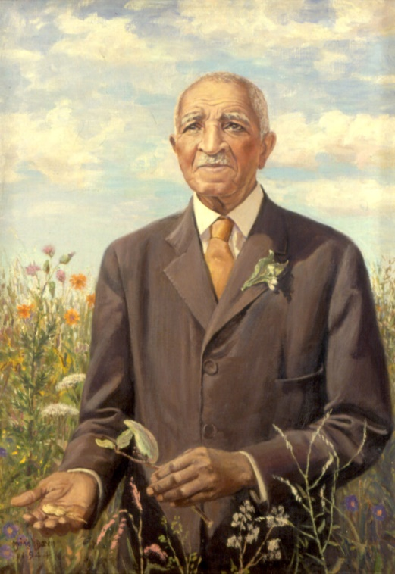
Dr. George Washington Carver was born a slave in 1864 on the farm of Moses and Susan Carver a year before slavery was abolished. Susan taught him how to read and write and introduced him to gardening. His interest in botany (the study of plants) lead him to become a professor at Tuskegee Institute in Alabama, where he became a famous agronomist (an expert in soil management and crop production). He spent much of his life teaching farmers how to grow peanuts and sweet potatoes and inventing hundreds of uses for them.

Scan this QR Code to learn more about Dr. Carver.
Enjoy nature’s beauty!
Protect it from litter and vandalism!

