Welcome to our
Fruit Orchard

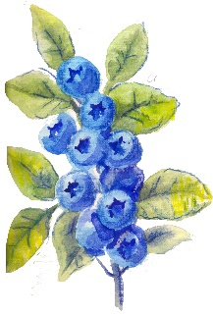
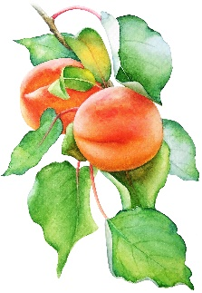
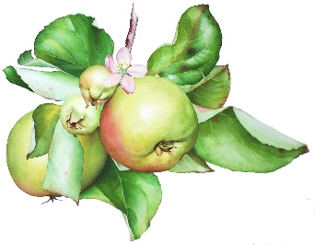
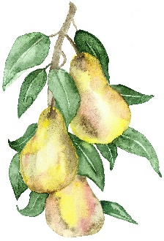

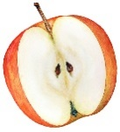
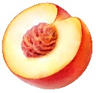
We grow apples, blueberries, peaches & pears
that are TASTY and HEALTHY!
Early European explorers introduced apple, peach and pear trees to Native Americans.
Blueberry bushes are a native species that
Native Americans used for medicine and food
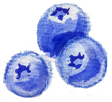
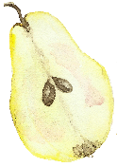
including a pudding recipe they shared with colonists during the first Thanksgiving meal.

Fruit Orchard Rules:
We only eat berries and fruit that our teacher gives us, and we share our berries and fruit with local wildlife.
Scan this QR Code to learn more about berries!
Enjoy nature’s beauty!
Protect it from litter and vandalism!

