Welcome to our
Frog & Toad Habitat

This small pond and bog provide food, water, and shelter for frogs and toads as well as their tadpoles.

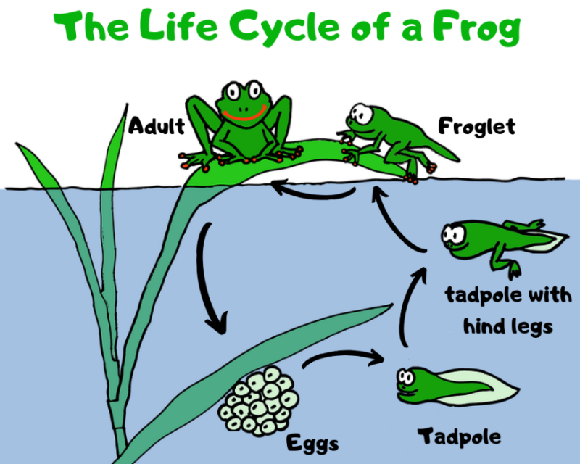
Tadpoles eat the plants and algae in the pond.

Frogs and toads eat the insects that are attracted to the pond and its vegetation.

Look for frogs and toads hiding in the plants in and around the pond or burrowed in the bog’s moist soil!

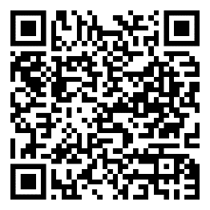
Scan this QR Code to learn more about frogs and toads.
Enjoy nature’s beauty!
Protect it from litter and vandalism!

