Welcome to our Pond

All living things need water to survive.

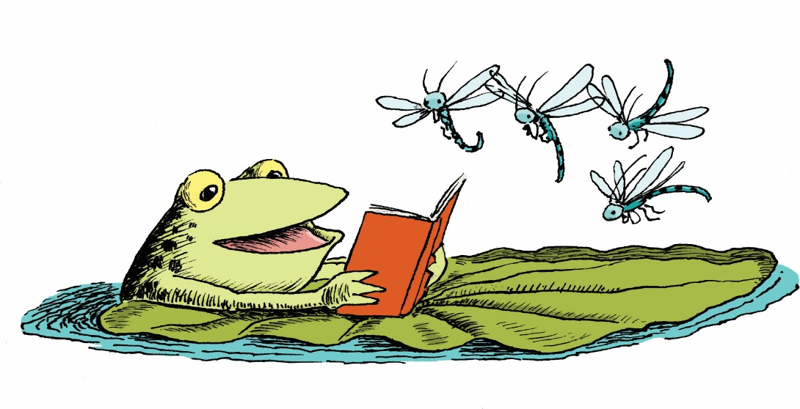
Our pond provides water for fish, birds, frogs,
and insects. Some animals like frogs and
dragonflies may lay their eggs in the pond.

We hope that through observing and studying
this pond from season to season we will all gain
a greater appreciation and knowledge about all
aquatic ecosystems large and small.

Scan this QR Code to learn more about ponds.
Enjoy nature’s beauty!
Protect it from litter and vandalism!

