Welcome to our
Decomposition Station
Nature’s way of Recycling...
Decomposition is the process of turning dead
material into nutrients that plants can use as food.

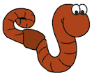
You can help “feed” our Decomposition Stations:
Vermicompost Bin
Red wiggler worms eat moist paper, egg shells,
and cardboard, and then produce castings (poop) for plants.
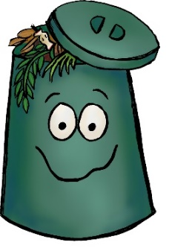
Compost Bin
Bacteria use oxygen and heat to breakdown materials
like dead leaves, flowers, sticks, and grass clippings.

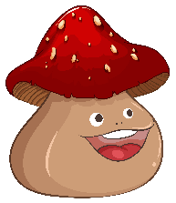
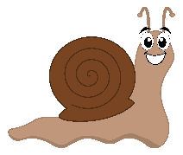
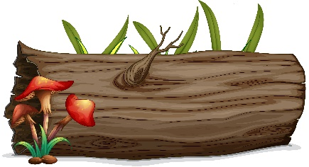
Log Hotel
“Decomposers” such as fungus (mushrooms)
and invertebrates (millipedes & snails)
help eat and break down the log into soil.

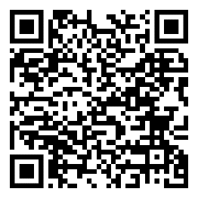
Scan this QR Code to learn more about decomposition!
Enjoy nature’s beauty!
Protect it from litter and vandalism!

