Outdoor Classroom Project Plan:
Materials List & Budget for
Cardinal Directions Sign

A cardinal directions sign includes a wooden post with (4) planks attached pointing in four different directions (north, east, south & west) with “North ,” “South ,” “East ,” and “West ” etched onto the planks. This is a helpful tool for students as they study weather patterns, the movement of the sun through the sky throughout the day and during different times of year, and the amount of sun and shade in the different areas of the outdoor classroom.
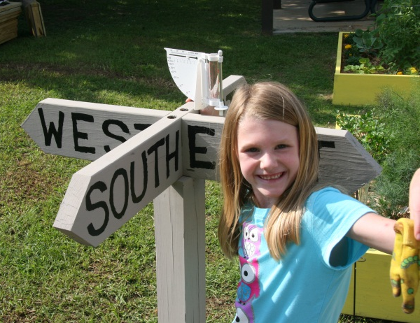
Optional Addition: Add (4) planks pointing in four different directions (north, east, south, or west). Then pick out four cities or landmarks that are in those same four different directions from your location, and etch the names of the locations along with the number of miles the locations can be found from your school. For example, if your school is in Huntsville, you could etch the following on the four planks: “Memphis (225 miles west) ”, “Washington D.C. (750 miles north) ”, “Montgomery (200 miles south) ” and “Atlantic Ocean (600 miles east) ”
- Location Suggestions for the Cardinal Directions Sign:
- Next to the Weather Station

- Example Cardinal Directions Signs:

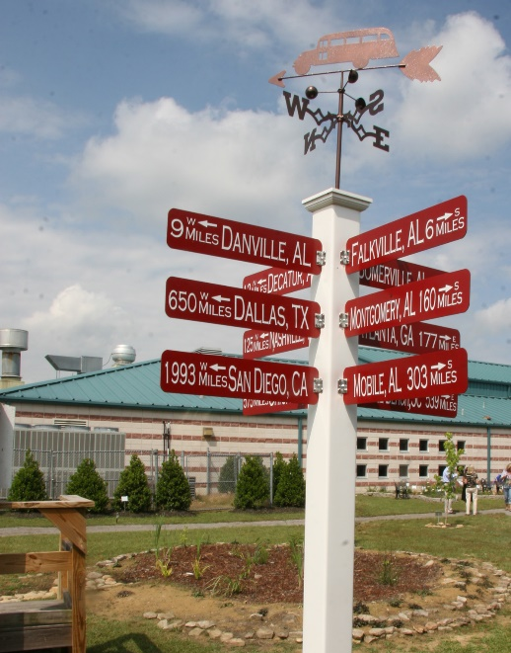
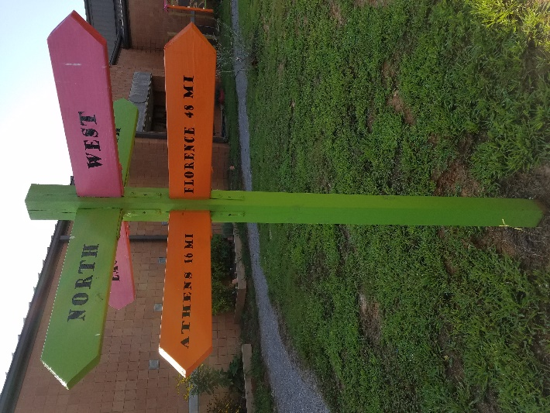

OC Project Plan: Example Cardinal Directions Sign Materials List & Budget
- Estimated Cost:
  - Cardinal Directions Sign w/ 4 wood planks: $240
  - Cardinal Directions Sign w/ 8 wood planks: $255
  - Cardinal Directions Sign w/ 4 metal planks: $265
  - Cardinal Directions Sign w/ 8 metal planks: $505
- Materials & Supplies with Estimated Budget
Example Cardinal Directions Sign
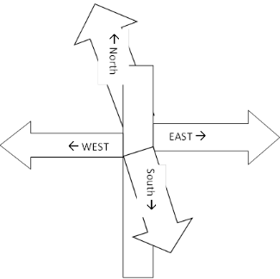
This wooden post has (4) planks attached pointing in four different directions (north, east, south & west) with “North ,” “South ,” “East ,” and “West ” etched onto the planks.
Optional Addition: Add (4) planks pointing in four different directions (north, east, south & west) with “Memphis (225 miles west) ”, “Washington D.C. (750 miles north) ”, “Montgomery (200 miles south) ” and “Atlantic Ocean (600 miles east) ”.
Letters on Sign need to be 4 inches tall to be seen from 40 ft away.
Station | Materials & Supplies | Estimated Cost | Example Source | Final Cost
Dir.Sign | (1) 4” x 4”x 8’ treated post @ ~$10.78 ea. | $10 | Lowe’s Item #552328
Dir.Sign | For Metal Cardinal Directions Signs: 6” H x 36”W .080 Aluminum Sign with Text on both sides @ $60 ea  (4) for North , East , South & West OR  (8) to include # of Miles N/E/S/W Landmark Name | $240-$480 total | Sign Company via OC Consultant
Dir.Sign | For Wood Cardinal Directions Signs: (1 or 2) Severe Weather 2” x 6” x 12’ #2 Prime Wood Pressure Treated Lumber @ ~$22.98 ea  Cut (1) into (4) 3 ft planks for cardinal directions only OR Cut (2) into (8) 3 ft planks to include mileage to landmarks | $15-25 total | Lowe’s Item #198476
Dir.Sign | For Wood Sign: (8-16) 1-in x 1-in x 2.75-in 18-Gauge G90 Galvanized Steel Angle (use two per plank) @ ~$0.72 ea | $10-15 | Lowe’s Item #1944324
Dir.Sign | (1) Box of (129) 2-in Wood To Wood Deck Screws (129) @ ~$9.98 ea | $10 | Lowe’s Item #7900
Dir.Sign | (1) 50 lb bag of Quikrete Fast Setting Concrete Mix  @~$6.71 ea | $5 | Lowe’s Item #10437
For Wood Cardinal Directions Sign:
Dir.Sign | (1) Gallon of Exterior Wood Paint Primer | $20 | Need to ask Paint Store

- Materials & Supplies with Estimated Budget (cont.)

Dir.Sign | (1) Gallon Exterior/Outdoor Wood Polyurethane (sealant) | $60 | Need to ask Paint Store
Dir.Sign | (1) Gallon Exterior Paint (pick a light color for base color) | $40 | Need to ask Paint Store
Dir.Sign | (1) Quart Exterior Paint (pick a dark color for lettering) | $25 | Need to ask Paint Store
Dir.Sign | (3) 3” Paint Brush (for painting base) @ ~$13.98 ea | $40 total | Lowe’s Item #1034365
Dir.Sign | Small paint brushes (for painting lettering) @ ~$4.98 ea | $5 | Lowe’s Item #105657
TOTAL ESTIMATED COST: $240-505

