Welcome to our
Butterfly Garden

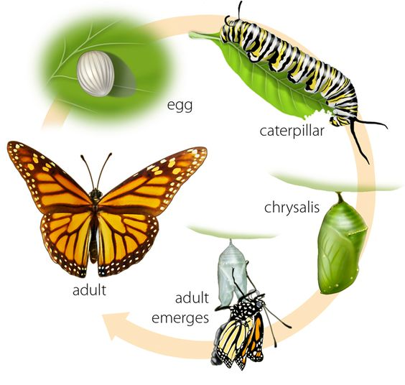
To provide habitat (a home) for butterflies, we planted flowering plants that provide nectar for butterflies and “host plants” that provide food for their larvae (or caterpillars).

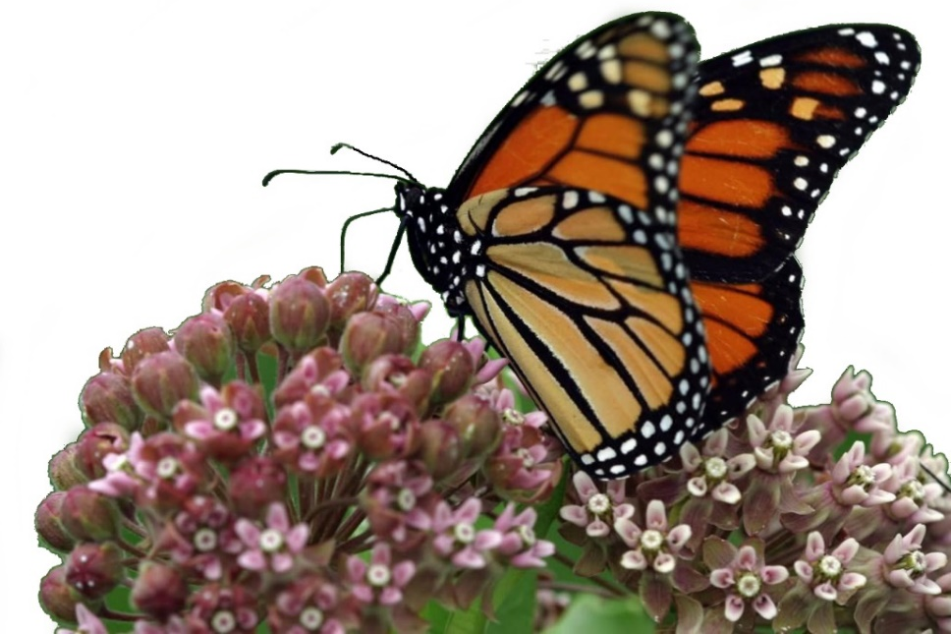
Butterflies are important!
They pollinate plants!

Scan this QR Code to learn more about butterflies.
Enjoy nature’s beauty!
Protect it from litter and vandalism!

