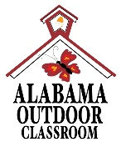
Outdoor Classroom Project Plan:
Materials List & Budget for
Box Turtle Habitat
Note: This outdoor learning station must be pre-approved by the Alabama Wildlife Federation and the Alabama Department of Conservation and Natural Resources (ADCNR) before it is built. If approved, ADCNR will provide a permit for the school to have two non-breeding box turtles for educational purposes.
An Eastern box turtle habitat is an enclosed habitat that provides water, food, cover, and an area for hibernation during winter months. In the wild, these turtles spend their time in woodland areas traversing the forest floor. They spend time basking in sunny areas, but they prefer shady, well-vegetated areas over all. They are omnivorous, eating everything from flowers and fungus to slugs and salamanders. Because the turtles are in an enclosure, the school is responsible for providing a balanced, nutritional diet for the turtles.

- Habitat Requirements:
- Two separate feeding areas (flat rocks) to minimize for food
- Basking area (such as a large flat rock) in full sun where turtles can warm their bodies
- A pond with drinkable water (that is cleaned by aquatic plants in the pond) that is large enough and deep enough for the turtles to completely submerge and soak their bodies AND that has some type of rocks or blocks in it as steps so the turtles can easily enter and leave the pond
- Plants such as hostas for cover and strawberry plants for supplemental food (in addition to what you feed them)
- Nesting area with sand (This is only to demonstrate to the students that turtles dig holes and lay their eggs in the ground. You should not have a pair of breeding turtles. If you have female turtles and you find eggs or baby turtles in the habitat, contact your AWF Outdoor Classroom Consultant.)
- Brumation (hibernation) area with at least three inches of loose soil and mulch (such as dead leaves) where turtles can completely burrow underground in the winter
- Small logs and rocks to create varied terrain to provide exercise for the turtles and to prevent their claws from growing too long
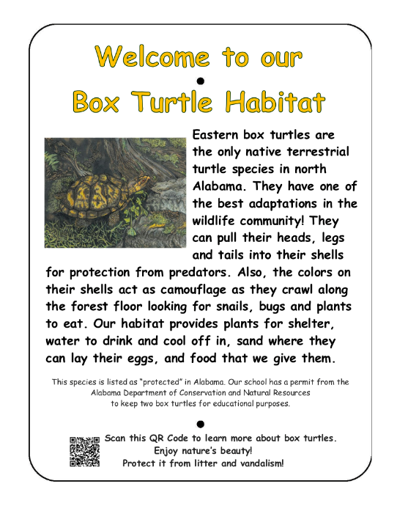
- A place where turtles can escape predators (such as a terracotta pot half-buried in the ground on its side)

- Example Box Turtle Habitat Picture & Educational Sign:
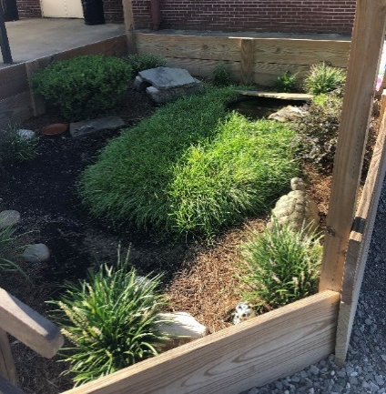
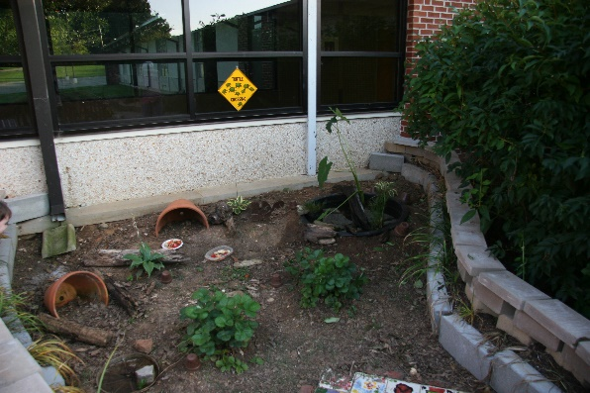
Outdoor Classroom Project Plan: Box Turtle Habitat
- Estimated Cost of Box Turtle Habitat: $495
- Materials & Supplies with Estimated Budget:
Box Turtle Habitat
8 ft W x 16 ft L x 20 in H enclosure with pond, plants, shelter, and feeding stations
Station | Materials & Supplies | Estimated Cost | Source of Materials | Final Cost
Turtle | (1) Can of Landscape Marking Spray Paint (to mark the perimeter of the enclosure, pond, etc.) @~$9.98 ea | $10 | Lowe’s Item #429750
Turtle | (4) 2” x 10” x 16’ Treated Lumber (for front & back) @~$28.08 ea | $115 total | Lowe’s Item #312277
Turtle | (4) 2” x 10” x 8’ Treated Lumber (for sides)  @~$10.98 ea | $45 total | Lowe’s Item #312274
Turtle | (1) 4” x 4” x 12’ Treated Lumber ((6) 24” braces) @~$18.38 ea | $20 | Lowe’s Item #312626
Turtle | (1) 1-Lb Box of 3” Ceramic Outdoor Deck Screws @~$9.98 ea | $10 | Lowe’s Item #9457
Turtle | (1) Large Mixing Tub 24-in W x 36-in L x 8-in D Drywall Mud Pan @~$18.28 ea | $20 | Lowe’s Item #1176703
Turtle | (1) Aquatic Plant (Horsetail, Lizard Tail, Arrow Arum, or Pickerelweed) | $10 | Nursery via OC Consultant
Turtle | (1) 50 Lb Bags of All-purpose Sand (for under pond & “nesting area”) @~$6.28 ea | $5 | Lowe’s Item #98545
Turtle | (1) 20 lb Bag of Brown Polished Pebbles Pebbles (along bottom of pond, top of potted aquatic plant) @~$32.45 ea | $30 | Lowe’s Item #1158217
Turtle | (3) 9” x 6” x 2” Patio Stones (stack to create steps in pond) @~$1.48 ea | $5 total | Lowe’s Item #477080
Turtle | (5) 12-18” Flat, Rectangular Natural Landscape Rocks (for feeding stations, basking station & cave) @~$6.18 ea | $30 total | Lowe’s Item #477064
Turtle | (1) 24” Terracotta Pot (create “cave” for protection from predators) @~$23.99 ea | $25 | Lowe’s Item #4349176
Turtle | (2) Hostas & (2) Evergreen Ferns (for cover) | $40 total | Nursery via OC Consultant
Turtle | (4) Food Source Plants (2 species, 2 individuals of each – see list below) | $20 total | Nursery via OC Consultant
Turtle | (2) 32-Quart (1CF) Bags of Evergreen Organic Potting Soil Mix @~$6.38 ea | $15 total | Lowe’s Item #380608
Turtle | (2) 2 CF Bags of Natural Dark Brown Pine Bark Mulch @~3.48 ea **do NOTget black mulch as it gets hot and kills plants** | $5 total | Lowe’s Item #92118
Outdoor Classroom Project Plan: Example Box Turtle Habitat
- Materials & Supplies with Estimated Budget (cont.):
Turtle | Small logs & rocks create varied terrain to help turtles exercise & help prevent their claws from growing too long | $0 | Get Donated
Turtle | (2) 50 Qt Bags of Leaf Litter/Mulch (for hibernation area and in “cave”) | $0 | Get Donated
Turtle | (1) Educational Sign | $75 | Ask OC Consultant about https://www.alabamawildlife.org/oc-signs/
Turtle | (1) 6 ft. U-Post for Fence (for educational sign) @~$10.69 ea | $10 | Lowe’s Item #493054
Turtle | (1) Hillman 1/4-in x 1-1/2 in Zinc-Plated Coarse Thread Hex Bolt (2-count) @~$0.88 ea | $5 total | Lowe’s Item #137634
Turtle | (2) Hillman 1/4-in x 20 Zinc-Plated Steel Hex Nut @~$0.10 ea |  | Lowe’s Item #63301
Turtle | (2) Hillman 1/4-in Zinc-Plated Standard Flat Washer @~$0.15 ea |  | Lowe’s Item #63306
Total Estimated Cost: $495
- Box Turtle Habitat Plant Suggestions:
Aquatic Plants
Horsetail | Lizard Tail | Arrow Arum | Pickerelweed
Food Plants
Clover | Strawberries | Lettuces/ Greens | Parsley
Alfalfa | Chickweed | Green Beans | Coreopsis

