EXAMPLE OUTDOOR CLASSROOM PROJECT PLAN:
Developing and Monitoring a Bluebird Nesting Trail
When it comes to birds, the eastern bluebird is one of the easiest birds to attract to a nesting box and is also very easy to identify due to its bright blue and orange coloration. A well placed bird house or houses (I don’t normally call them a bluebird house until a bluebird establishes residency since many other species of birds will also use these houses.) around a school can lead to a great learning opportunity for the students as well as help to increase the numbers of bluebirds in your area. There are numerous bird house plans on the internet that you can use including the one that the Alabama Cooperative Extension provides at http://www.aces.edu/pubs/docs/A/ANR-0687/ANR-0687.pdf and you will find various types of bird houses for sale at numerous locations such as garden centers, festivals, and home improvement stores. We also encourage people to purchase blue bird houses form the Alabama Industries for the Blind (AIB) as this helps to create jobs for Alabamians with disabilities. You may order them at http://aidb.org/aidb-items/ . You’ll just have to find the one that you think you like and give it a try.
If you and your class are really interested in learning about and helping to increase the population of bluebirds, you may want to establish a bluebird nesting and monitoring trail around your school’s campus. A trail can be as small as one nesting box or contain as many houses as you have time to monitor. The following information and accompanying monitoring pages and activity ideas will help you to establish such a trail and will let the students experience what it is like to be a field biologist.
- Suggestions for Establishing a Nesting Box Trail:
- Select an open area such as an open field, large lawn, golf courses, and gardens with scattered trees (used for perching near nest) and sparse ground cover
- Place the bird house so that the opening on the house faces a tree or bush that is 15’-25’ away. This gives the young something to fly towards when they make their first fledging flight.
- Place the nest box on a pole 4-6 feet above the ground instead of on a tree (you won’t be able to keep predators away if it is on a tree).
- Use a baffle around the post to keep squirrels, rat snakes and raccoons from raiding the nest.
- Place nesting boxes at a distance of around 100 yards apart. (Placing a bunch of houses close together will not increase the number of bluebirds that nest there since they are territorial during the nesting season.)
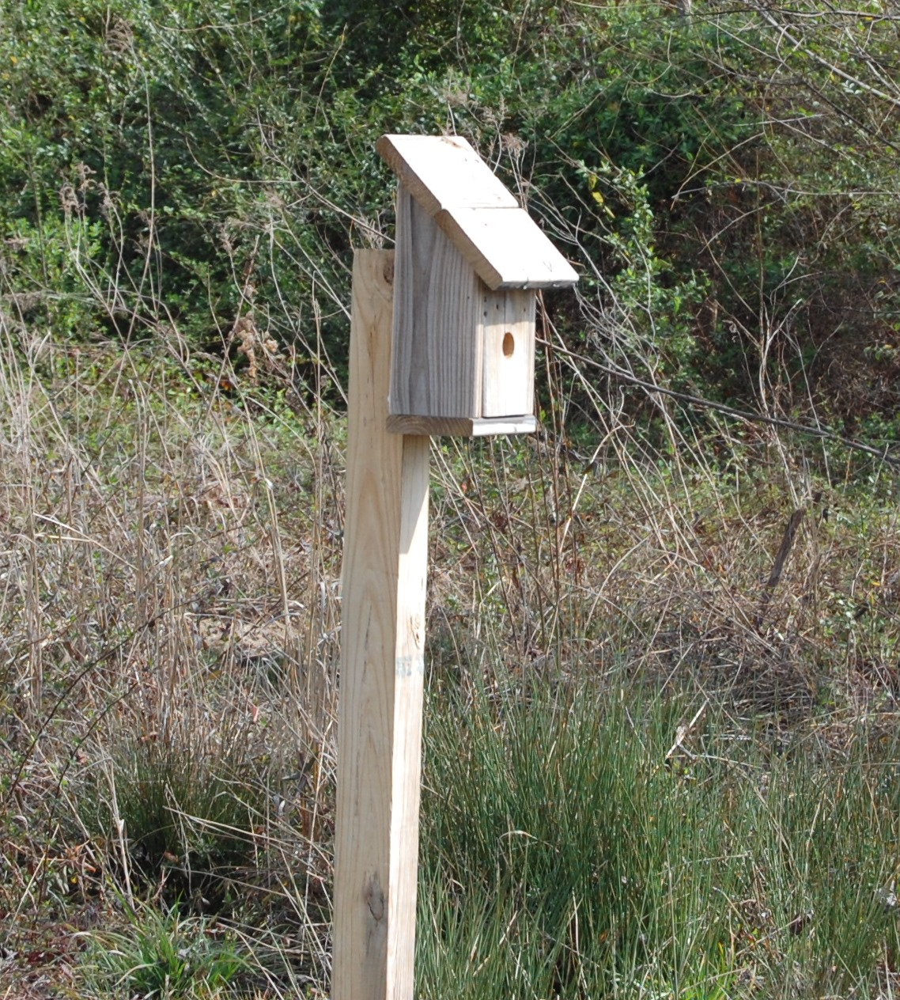
- Face the entrance hole from east to south for best results.
- You should try to have nesting boxes in place by mid-February as this is when they begin selecting nesting territory.
- When you first get started with a bluebird trail, keep the number of houses manageable so that you can check them at least once a week during nesting season (March through late summer). We would recommend up to 5 houses the first year until you feel you can handle more.
- If you are going to monitor several houses, develop a numbering system so that you can keep track of what is happening at each house.
- Dealing with Predators & Competitors:
- House Sparrows (English Sparrows) and Starlings will both compete for the nesting boxes. This is especially true around human dwellings such as barns, houses and school buildings. If the competitor is a starling, make the entry hole exactly 1” in diameter. The larger bodied starling will not be able to enter. The house sparrow is harder to keep away but you can help by not adding a perch (bluebirds don’t need them).
- Be aggressive in the removal of starling and house sparrow nests. Since both of these species are non-native invasive, they are not protected by federal or state law. It is best to remove their nests as soon as nest building is initiated. (You may need to do this daily!) It is not legal to remove any native bird species that decides to nest in the box.
- If you can’t stop the house sparrow or starling from nesting, remove the nest rather than let them be successful.
- Look out for blowfly larvae in the nest material, the larvae are parasitic and draw blood from the chicks. If the infestation is large enough, they will kill the young.
- Raccoons will climb to up to the nest boxes and remove eggs, chicks, and even the incubating adults. You can use a baffle on the pole to keep them from climbing and/or add a 5” overhand on the front of the box, over the entry hole. This will also deter the raccoon.
- Gray rat snakes will also climb up the pole and enter the nesting box. Once again a well-placed baffle below the box will help stop this predator.

- Compare & Contrast a Bluebird Nest and Other Bird Nests:
If by chance you have another species of bird nesting in the box other than a bluebird, enjoy (unless it is a starling or house sparrow) their presence! Here are some quick hints to help you identify the nest based on the nesting material used by the birds.
- Bluebird. Neatly constructed of grass, the 4-5 eggs are pale blue or occasionally white. If it has been over 15 days since eggs hatched and you find a well-flattened nest not disturbed, this indicates that the nestlings have fledged. Remove the old nest (only if there is no sign of a new nest being built) promptly because this will encourage bluebirds to nest again in that box.
- House Wren. The nest is large and made of twigs. The 6-8 eggs are white, speckled with brown.
- Tree Swallow. The nest is of woven grass, and lined with feathers. The 4-6 eggs are white.
- House Sparrow. A mixture of course grass, feathers, and trash make up these very large woven nests. Usually there are 5-6 gray-white eggs, speckled with brown.
- Chickadee. The nest is made of moss, plant down and lined with hair and animal fur. The 5-8 white eggs are speckled with reddish-brown.

Estimated Cost for Nesting Boxes (Set of 5) and Mounting Posts (Includes T-post, Metal ¾” Conduit or 4”x4” Treated Post):
Tools, Materials & Supplies:
- Tape measure
- Post Hole Digger/Fence Post Driver
- Bluebird Houses
- Shovel for pushing soil back in hole
- Screwdriver and screws

Itemized List for Blue Bird Nesting Box Trail (5 houses) EST. COST: $106.95-$137.40
Description of Materials & Supplies | Quantity | Estimated Cost | Source of Materials | Monetary/ Item  Donation
Bluebird House (either in kit form or preassembled) | 5 | $15.00x5=$75.00 | AIB or Other Source
Mounting Post  (You have several choices) | - 4”x4”x8’ treated post  - ¾”x10’ Metal Conduit  - 6’ T-Post | $6.97 each x 5=$34.85  $11.99 each x 5=$59.95  $3.98 each x 5=$19.90 | Hardware Store
Mounting Brackets (only needed for options 2 & 3 from Mounting Post) | ¾” 2-Hole Conduit Straps (2 per nest w/ ¾” conduit)  1.25 2-Hole Conduit Straps (2 per T-Post) | Pack of 10 = $2.45  Pack of 4 = $1.92 | Hardware

- Bluebird Nesting Box Mounting Diagram:
Mounting on ¾” Conduit
Mounting on 4”x4” Post
Mounting on 6’ T-post
Screws or Nails
1.25” Conduit Straps
¾” Conduit Straps
Blue Bird Box with Predator Guard
Predator Baffle (See directions)
Predator Baffle (See directions)

T-post’
¾” Conduit Pipe

2.5’ of T-post below ground

3’ of conduit below ground

3’ of treated post below ground level

Estimated Cost for Construction of 6” PVC Baffle:
Itemized List for Bluebird Nesting Box Baffles (5 houses) Estimated Cost: $102.98
Description of Materials & Supplies | Quantity | Estimated Cost | Source of Materials | Monetary/ Item  Donation
6”x10’ PVC Pipe | 1 piece cut into 2” lengths | $40.98 | Hardware Store
6” PVC End Caps | 2 per Baffle x 5=10 | $5.22x10= $52.20 | Hardware Store
.5”-1.25” Hose Repair Clamp | 2 per Baffle x 5=10 | .98x10=$9.80 | Hardware
Predator Baffle Attachment

Hose Repair Clamp

6” PVC End Caps – (You will need to drill a 3/4” hole in center of each end cap so that conduit can slide through it. A larger hole will need to be drilled if you use the T-post.)

2’ Piece of 6” PVC Pipe

Bluebird Nesting Trail Maintenance:
- Painting or staining is not required if the box is made from cedar or cypress. If it is made from pine (don’t use treated lumber), you may want to paint it to make it last longer.
- The boxes should be cleaned out after each brood or young leave the nest. This should be done immediately after they fledge since the adults will start a second or third brood within a couple of weeks.
- Wash the inside of the box with a 10% bleach/water solution.
- Check the box each spring for loose screws/nails, damaged areas and other repairs.

Bluebird Nesting Trail Monitoring:
- Check during nesting season – March through August.
- If possible, check the boxes in the afternoon, never at dusk or dawn.
- Check each box once or twice a week. When doing this, walk up to the side of the box, making soft sounds. Tap on the side of the box to warn the adult you are there and so they can fly off (they will return).
- Open the box and look inside so you can see the complete nest.
- Record anything pertinent such as type of bird nest, number of eggs or young if present and their general health appearance. Then close the box and walk away briskly (should only take a minute.)
- Stop monitoring when the chicks are 12-14 days old as you may cause them to leave the next too early.
- Don’t monitor on cold or wet days.
- Check out one of these sites for a great bluebird monitoring form:
  - Sialis - http://www.sialis.org/monitoring.htm
  - Virginia Bluebird Society - http://www.virginiabluebirds.org/about-bluebirds/monitoring-nest-boxes/

Bluebird Nesting Box Ideas:
- Math: Record data such as number of eggs/chicks and use the numbers in computing averages and other math concepts.
- Science: Study the life cycle of bluebirds and other species of birds
- Language Arts: Research different species of birds and write about them through poetry and creative writing.
- Art: Photograph and draw pictures of the bluebirds and other species of birds as they live around the outdoor classroom.
- Conservation: Learn about bluebirds and how this species has been impacted by human behavior. You may want to consider joining a local blue bird group and report the results.
- Literature Connections: The Bluebird Book: The Complete Guide to Attracting Bluebirds By Donald W. & Lillian Q. Stokes (ISBN-10:0316817457)
- Websites: The North American Bluebird Society (NABS) has a great picture based Factsheet that will be very helpful at: http://nabluebirdsociety.org/PDF/FAQ/NABS%20factsheet%20-%20Monitoring%20-%2024May12%20DRAFT.pdf . It shows pictures of the growth stages of the chicks until they fledge.

The Alabama Outdoor Classroom Program is a partnership between:
 | 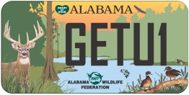
Alabama Cooperative  Extension System | Alabama Wildlife Federation | Alabama Department of  Conservation & Natural Resources

