Welcome to our
Berry Garden
We grow blueberries &
strawberries that are
TASTY and HEALTHY!
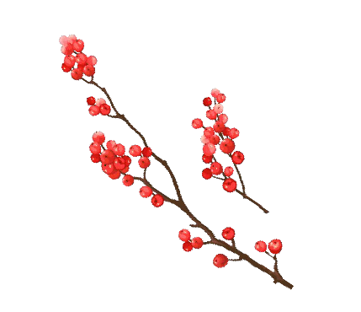
We also grow winterberry and American beautyberry for the
birds and other wildlife
that visit this habitat.

Berry Garden Rules:
- We only eat berries that our teacher gives us.
- We share the blueberries with the songbirds.
- We do NOT eat the winterberry or American beautyberry because wild berries may make us sick.

Scan this QR Code to learn more about growing berries.
Enjoy nature’s beauty!
Protect it from litter and vandalism!

