Welcome to our
Bat House

Bats are the only flying mammals in the world.
Just like humans, they have hair (fur), give birth to live young, and drink milk from mom as babies.

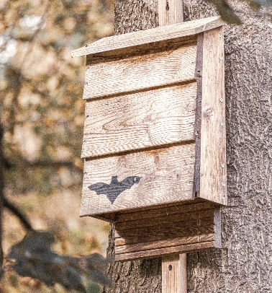
All 16 of Alabama’s bat species are
insectivores, eating mosquitoes and
pests that damage crops. Some can eat
several thousand insects in one night! We
built this bat house to provide a place
where native bats can roost (sleep).

Look for guano (bat poop) on the ground below the bat
house. It is dry and crumbly and has shiny insect parts
in it. This tells us whether or not bats have moved in!

Native species that may use our bat house:
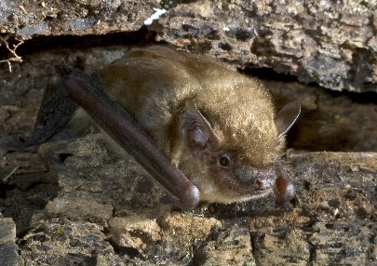
- Big Brown Bat (pictured)
- Evening Bat
- Northern Long-eared Myotis
- Tri-colored Bat

Scan this QR Code to learn more about bats.
Enjoy nature’s beauty!
Protect it from litter and vandalism!

