Alabama
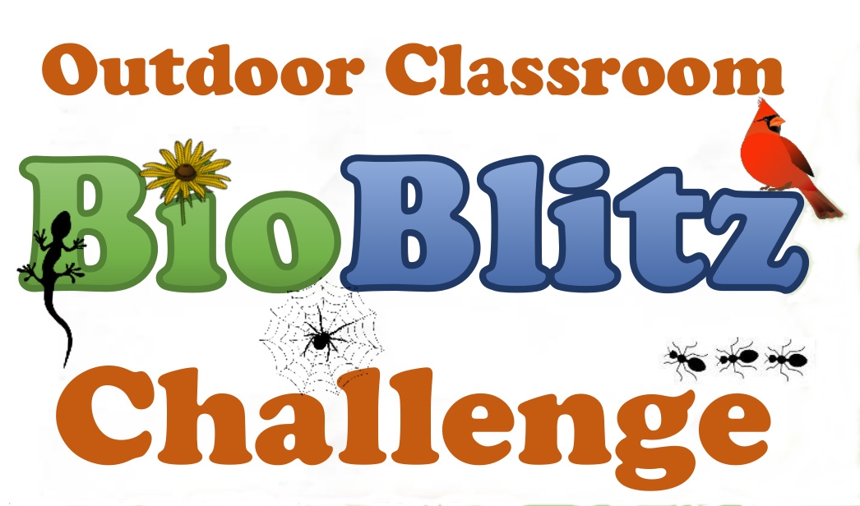

Citizen-Science Excellence Award

National Geographic Society, Alabama Wildlife Federation, Alabama Cooperative Extension System and <Name of School>
present this award honoring your participation in the
Alabama Outdoor Classroom BioBlitz Challenge

(Participant Name)

On this 5th day of September, 2017.

Teacher Signature: ________________________________________
