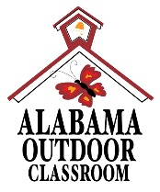 **BioBlitz**

**Certificate of Participation**

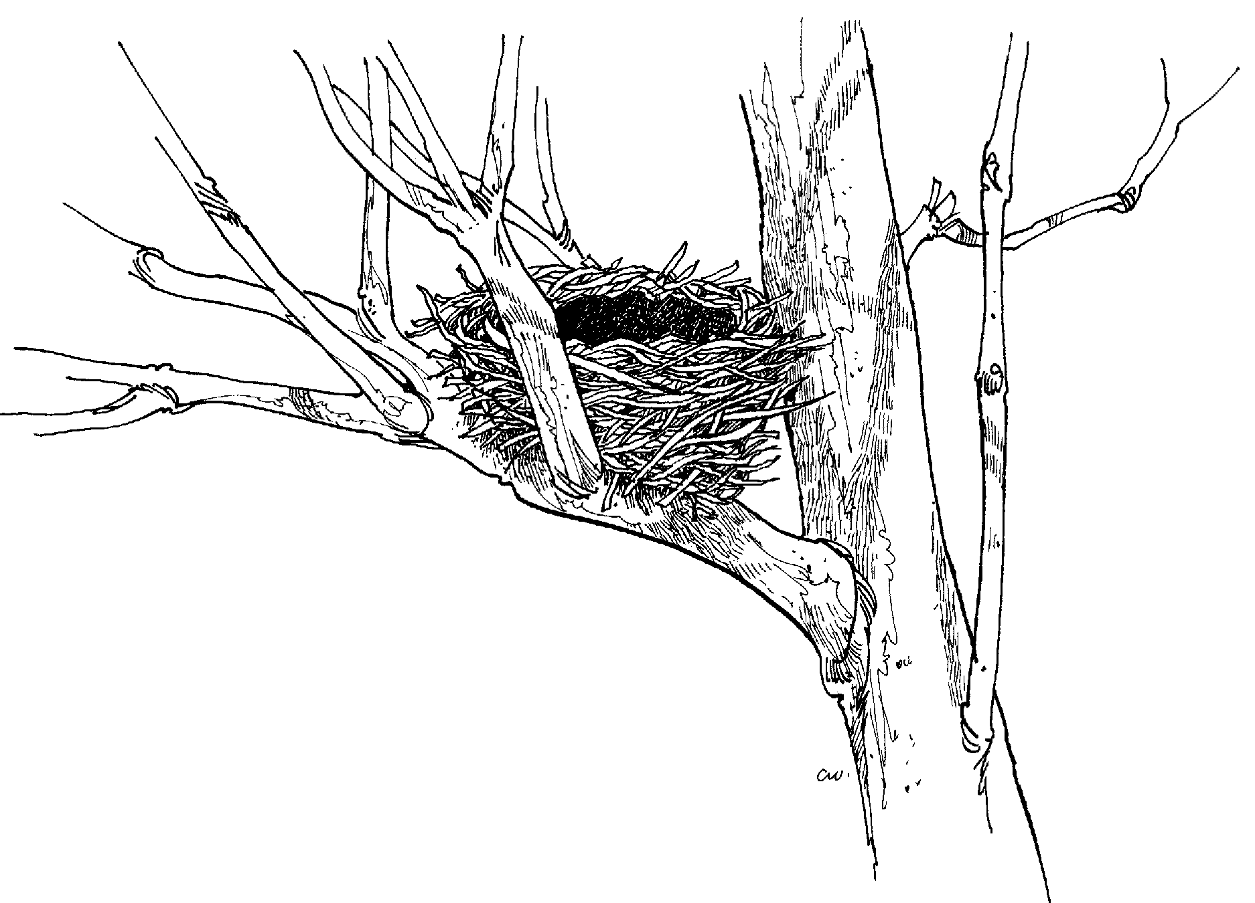 for

__________________

on September 5, 2017

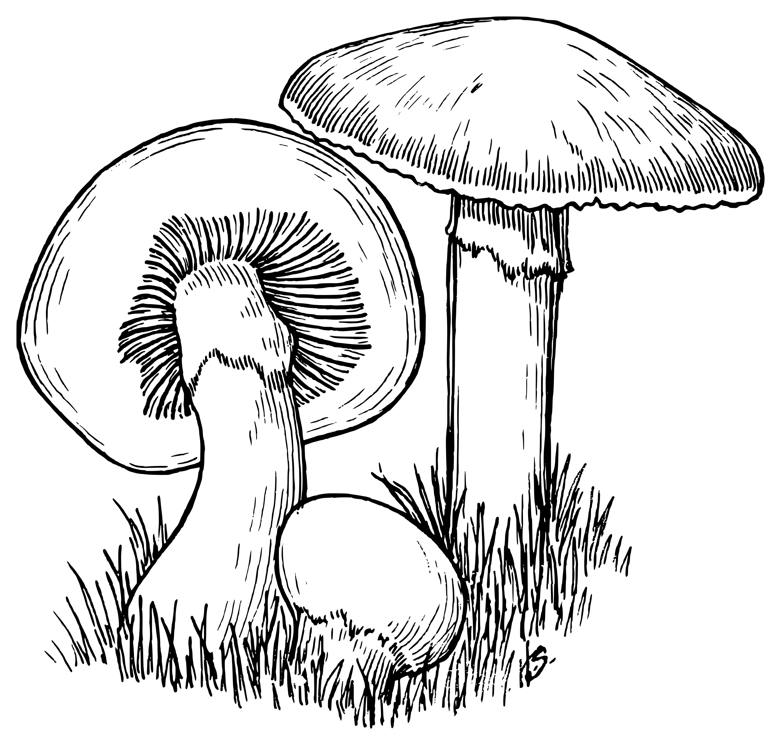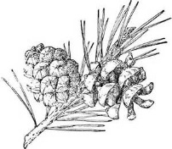for your assistance with finding and identifying the plants, animals, fungi and other organisms that live in your schoolyard and outdoor classroom.

 