QR Codes for Upper Grades Ecosystem Investigation Webpages
Learning Station/ Topic | URL | QR Code
Habitats
Bat House | https://www.alabamawildlife.org/learn-about-bats-upper/
Bee Habitat | https://www.alabamawildlife.org/learn-about-bees-upper/
Box Turtle Habitat | https://www.alabamawildlife.org/learn-about-box-turtles-and-their-habitat-upper/
Butterfly Garden | https://www.alabamawildlife.org/learn-about-butterflies-and-their-habitat-upper/
Decomposition Stations | https://www.alabamawildlife.org/learn-about-decomposers-and-their-habitat-upper/
Frog and Toad Habitat | https://www.alabamawildlife.org/learn-about-frogs-and-toads-and-their-habitat-upper/
Pollinator Garden | https://www.alabamawildlife.org/learn-about-pollinators-and-their-habitat-upper/
Songbird Garden | https://www.alabamawildlife.org/learn-about-songbirds-and-their-habitat-upper/
Other Learning Stations
Sunflower Garden/ Fibonacci | https://www.alabamawildlife.org/learn-about-fibonacci-sequence/
Pond | https://www.alabamawildlife.org/learn-about-ponds-upper/
Rain Garden | https://www.alabamawildlife.org/learn-about-rain-gardens-upper/
Sensory Garden | https://www.alabamawildlife.org/learn-about-senses-upper/
Weather Station | https://www.alabamawildlife.org/learn-about-weather-upper/ | 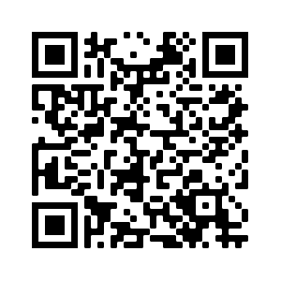
Woodland Wildflower Garden | https://www.alabamawildlife.org/learn-about-woodland-wildflowers-upper/
Topics
AL’s Biodiversity | https://www.alabamawildlife.org/learn-about-alabamas-biodiversity-upper/
AL’s Ecoregions | https://www.alabamawildlife.org/learn-about-alabamas-ecoregions-upper/
AL’s Waterways | https://www.alabamawildlife.org/learn-about-alabamas-waterways-upper/
Native Plants | https://www.alabamawildlife.org/why-plant-native/
Plant Anatomy | https://www.alabamawildlife.org/learn-about-plant-anatomy-upper/

