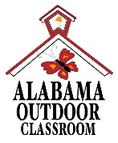
Outdoor Classroom Project Plan:
Materials List & Budget for
Butterfly Garden
A Butterfly Habitat should provide food, water, and shelter for a wide variety of butterflies and their larvae (or caterpillars). Butterflies will most often search flowering wildflowers, bushes, and trees for their main food source (nectar) using their tube-like “tongues” called a proboscis. However, some species will acquire the minerals and nutrients that they need by probing the ground around decomposing plants or animals or around animal excrement with their proboscises. Nectar, shallow puddles, and drops of rain or dew provide the water that butterflies need to survive. Different species of butterflies only lay their eggs on specific species of plants (referred to as “host plants”) and the caterpillars will only eat these plants before creating a chrysalis to go through metamorphosis into an adult butterfly. Butterflies typically take refuge from inclement weather or predators in bushes or trees.
- Habitat Requirements:
- Native flowering wildflowers, bushes, and trees that produce nectar
- Native “host plants” that caterpillars eat (see list below)
- Puddling stations for butterflies that prefer to get their nutrition from excrement covered in sand
- Bushes and trees for cover from inclement weather and predators
- Dark colored stones where butterflies can warm their bodies
- Full sun for 6-8 hours per day for optimal plant growth

- Example Pollinator Garden Pictures & Educational Sign:
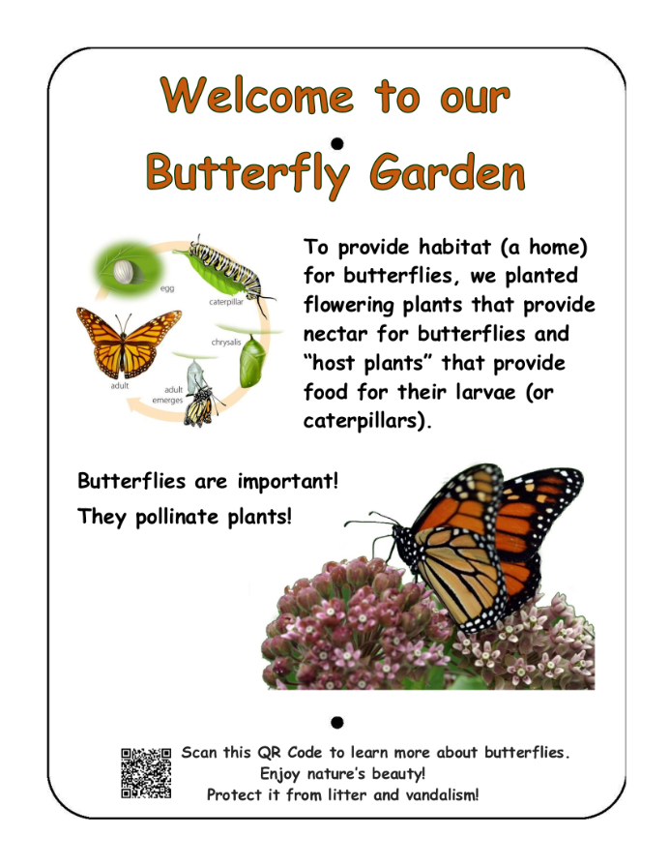
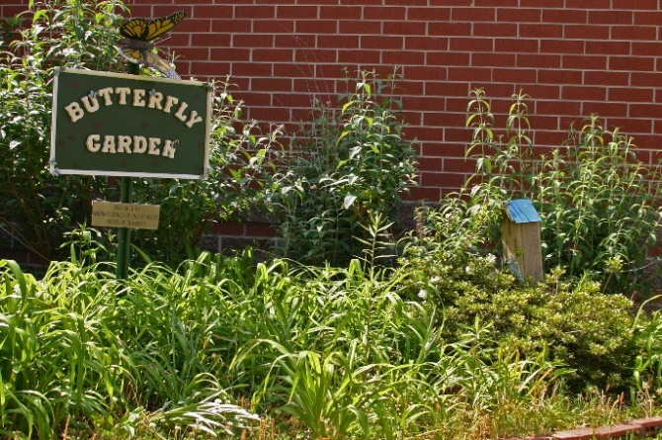

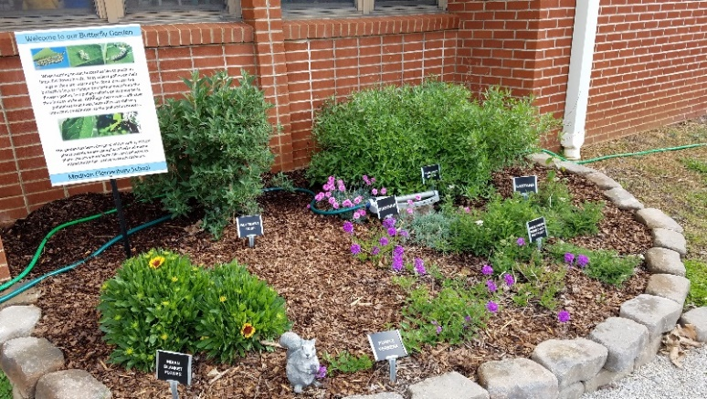
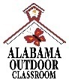
OC Project Plan: Example Butterfly Garden Materials List & Budget

- Estimated Cost:
- Example 3-sided garden against the school building (3’8” x 13’ 8”): $870-$905
- Example 4-sided garden away from the school building (4’8” x 13’8”): $990-$1,025

- Materials & Supplies with Estimated Budget:
Example 3-sided Butterfly Garden
(Actual Size: 3 ft 8 in (W) x 13 ft 8 in (L) x 6 in (D) 3-sided raised bed garden against school building ~19 CF)
Station | Materials & Supplies | Estimated Cost | Example Source | Final Cost
3-Bttrfly | (1) Can of Rust-Oleum Professional White Water-based Marking Paint (for laying out garden) @~$9.98 ea | $10 | Lowe’s Item #429750
3-Bttrfly | (40) 4” x 12” Retaining Wall Blocks (to create three sides of raised bed against school building) @~$2.88 ea | $115 total | Lowe’s Item #477088
3-Bttrfly | (1) 6’x50’ Sta-Green Professional Landscape Fabric (weed barrier) (16’ used for this garden) @~$33.98 ea | $35 | Lowe’s Item #510606
3-Bttrfly | (4) 32-Quart (1CF) Bags of Evergreen Organic Potting Soil Mix @~$6.38 ea (for garden) | $25 total | Lowe’s Item #380608
3-Bttrfly | (7) 1 CF/32 Qt Bags of Evergreen Organic Top Soil @~$2.18 each | $15 total | Lowe’s Item #648834
3-Bttrfly | (10) 1 CF Bags of Evergreen Organic Compost and Manure @~$3.68 ea (2 for garden, 1 per bush, 2 per tree) | $40 total | Lowe’s Item #380606
3-Bttrfly | (3) 2 CF Bags of Evergreen Organic Drainage and Aeration Soil Conditioner @~$4.58 ea | $15 total | Lowe’s Item #648829
3-Bttrfly | (2) Native Oaks, Dogwoods, or Tulip Poplars (*Optional - plant in or near OC as host plants & cover) @~$75 ea | *$150 total | Nursery via OC Consultant
3-Bttrfly | (2) Spicebushes or (2) Wax Myrtles (*Optional - plant as host plants near garden in OC if possible) @~$30 ea | *$60 total | Nursery via OC Consultant
3-Bttrfly | (2) Sweet Pepperbushes or (2) Butterfly Bushes (plant as nectar plants near garden) @~$30 ea | $60 total | Nursery via OC Consultant
3-Bttrfly | (8) Nectar Plants (2 different species, 4 plants of each species – see list below) @~$7 ea | $55 total | Nursery via OC Consultant
3-Bttrfly | (8) Host Plants (2 different species, 4 plants of each species – see list below) @~$7 ea | $55 total | Nursery via OC Consultant
3-Bttrfly | (1) Package of 40 6” Black Plastic Landscape Edging Pieces (18 to create (3) 3 ft dividers between the four plant species to make plant ID & weeding easier) @~$21.98 ea | $20 | Lowe’s Item# #379805

OC Project Plan: Example Butterfly Garden Materials List & Budget

- Materials & Supplies with Estimated Budget (cont.):
3-Bttrfly | (6) 2 CF Bags of Evergreen Natural Dark Brown Pine Bark Mulch (3 for garden, rest for trees/bushes) @~$3.48 ea **do NOT get black mulch as it gets hot and kills plants** | $20 total | Lowe’s Item #92118
3-Bttrfly | (2) 12-18” wide Terracotta Clay Plant Saucer (to create puddling stations) @~$14.48 ea | $30 total | Lowe’s Item #94459
3-Bttrfly | (1) .5 CF/50 Lb Bag of American Countryside All-purpose Sand (for puddling stations) @~$5.18 ea | $5 | Lowe’s Item #104898
3-Bttrfly | (1) Black Steel Garden Trellis (for passionflower vines) @~$16.48 ea | $15 | Lowe’s Item #397037
3-Bttrfly | (6-10) Plant ID Signs (one for each plant species) @~$6 ea | $35 - $60 total | https://www.alabamawildlife.org/oc-dig-into-plants/ for details
3-Bttrfly | (6-10) Biomarkers to hold Plant ID signs (13” stake with a 2” x 4” plate) @ ~$3 ea (includes S&H) | $20 - $30 total | AWF OC Consultant or https://mcgbiomarkers.com/shop/
3-Bttrfly | (1) 6 ft. U-Post for Fence (for educational sign) @~$10.69 ea | $10 | Lowe’s Item#: 493054
3-Bttrfly | Educational Sign (for the life cycle of butterflies) | $75 | Ask OC Consultant about https://www.alabamawildlife.org/oc-signs/
3-Bttrfly | (1) Hillman 1/4-in x 1-1/2 in Zinc-Plated Coarse Thread Hex Bolt (2-count) @~$0.88 ea | $5 total | Lowe’s Item #137634
3-Bttrfly | (2) Hillman 1/4-in x 20 Zinc-Plated Steel Hex Nut @~$0.10 ea |  | Lowe’s Item #63301
3-Bttrfly | (2) Hillman 1/4-in Zinc-Plated Standard Flat Washer @~$0.15 ea |  | Lowe’s Item #63306
Total Estimated Cost: $870-$905

OC Project Plan: Example Butterfly Garden Materials List & Budget

- Materials & Supplies with Estimated Budget (cont.)
Example 4-sided Butterfly Garden
(Actual Size: 4 ft 8 in (W) x 13 ft 8 in (L) x 6” (D) 4-sided raised bed garden ~20 CF)
Station | Materials & Supplies | Estimated Cost | Example Source | Final Cost
4-Bttrfly | (1) Can of Rust-Oleum Professional White Water-based Marking Paint (for laying out garden) @~$9.98 ea | $10 | Lowe’s Item# 429750
4-Bttrfly | (70) 4” x 12” Retaining Wall Blocks (to create four sides of raised bed garden) @~$2.88 ea | $200 total | Lowe’s Item# 477088
4-Bttrfly | (1) 6’x50’ Sta-Green Professional Landscape Fabric (weed barrier) (16’ used for this garden) @~$33.98 ea | $35 | Lowe’s Item# 510606
4-Bttrfly | (4) 32-Quart (1CF) Bags of Evergreen Organic Potting Soil Mix @~$6.38 ea (for garden) | $25 total | Lowe’s Item #380608
4-Bttrfly | (8) 1 CF/32 Qt Bags of Evergreen Organic Top Soil @~$2.18 each | $20 total | Lowe’s Item# 648834
4-Bttrfly | (10) 1 CF Bags of Evergreen Organic Compost and Manure @~$3.68 ea (2 for garden, 1 per bush, 2 per tree) | $40 total | Lowe’s Item #380606
4-Bttrfly | (3) 2 CF Bags of Evergreen Organic Drainage and Aeration Soil Conditioner @~$4.58 ea | $15 total | Lowe’s Item# 648829
4-Bttrfly | (2) Native Oaks, Dogwoods, or Tulip Poplars (*Optional - plant in or near OC as host plants & cover) @~$75 ea | *$150 total | Nursery via OC Consultant
4-Bttrfly | (2) Spicebushes or (2) Wax Myrtles (*Optional - plant as host plants near garden in OC if possible) @~$30 ea | *$60 total | Nursery via OC Consultant
4-Bttrfly | (2) Sweet Pepperbushes or (2) Butterfly Bushes (plant as nectar plants near garden) @~$30 ea | $60 total | Nursery via OC Consultant
4-Bttrfly | (10) Nectar Plants (2 different species with 5 of each species – see list below) @~$7 ea | $70 total | Nursery via OC Consultant
4-Bttrfly | (10) Host Plants (2 different species with 5 of each species – see list below) @~$7 ea | $70 total | Nursery via OC Consultant
4-Bttrfly | (1) Package of 40 6” Black Plastic Landscape Edging Pieces (18 to create (3) 3 ft dividers between the four plant species to make plant ID & weeding easier) @~$21.98 ea | $20 | Lowe’s Item# 379805
4-Bttrfly | (6) 2 CF Bags of Natural Dark Brown Pine Bark Mulch (3 for garden, rest for trees/bushes) @~$3.48 ea **do NOTget black mulch as it gets hot and kills plants** | $20 total | Lowe’s Item# 92118
4-Bttrfly | (2) 12-18” wide Terracotta Clay Plant Saucer (to create puddling stations) @~$14.48 ea | $30 total | Lowe’s Item# 94459

OC Project Plan: Example Butterfly Garden Materials List & Budget

- Materials & Supplies with Estimated Budget (cont.)
4-Bttrfly | (1) .5 CF/50 Lb Bag of American Countryside All-purpose Sand (for puddling stations) @~$5.18 ea | $5 | Lowe’s Item# 104898
4-Bttrfly | (1) Black Steel Garden Trellis (for passionflower vines) @~$16.48 ea | $15 | Lowe’s Item# 397037
4-Bttrfly | (6-10) Plant ID Signs (one for each plant species) @~$6 ea | $35 - $60 total | https://www.alabamawildlife.org/oc-dig-into-plants/ for details
4-Bttrfly | (6-10) Biomarkers to hold Plant ID signs (13” stake with a 2” x 4” plate) @ ~$3 ea (includes S&H) | $20 - $30 total | AWF OC Consultant or https://mcgbiomarkers.com/shop/
4-Bttrfly | (1) 6 ft. U-Post for Fence (for educational sign) @~$10.69 ea | $10 | Lowe’s Item# 493054
4-Bttrfly | Educational Sign (for the life cycle of butterflies) | $75 | Ask OC Consultant about https://www.alabamawildlife.org/oc-signs/
4-Bttrfly | (1) Hillman 1/4-in x 1-1/2 in Zinc-Plated Coarse Thread Hex Bolt (2-count) @~$0.88 ea | $5 total | Lowe’s Item# 137634
4-Bttrfly | (2) Hillman 1/4-in x 20 Zinc-Plated Steel Hex Nut @~$0.10 ea |  | Lowes Item# 63301
4-Bttrfly | (2) Hillman 1/4-in Zinc-Plated Standard Flat Washer @~$0.15 ea |  | Lowe’s Item# 63306
Total Estimated Cost: $990-$1,025

- Butterfly Habitat Plant Suggestions:

- These species are most commonly used in a butterfly garden. Customized plant identification signs with unique scannable QR Codes linked to webpages on AWF's website are available for these plant species. The webpages provide specific information about that plant species including a description of the plant, photos of the plant, maintenance tips, and the ecological benefits that species provides.

Nectar Plants | Nectar Plants | Nectar Plants | Host Plants for Caterpillars
Bee Balm | Indian Blanket | Narrowleaf Sunflower | Blue False Indigo
Black-eyed Susan | Joe-pye Weed | Purple Coneflower | Bronze Fennel
Cardinal Flower | Lanceleaf Tickseed | Red Sage | Butterfly Milkweed
Dense Blazing Star | Lavender | Rose Vervain | Common Yarrow
Foxglove Beardtongue | Miss Huff Lantana | Stokes Aster | Passionflower

- Visit the Alabama Butterfly Atlas website at http://alabama.butterflyatlas.usf.edu/ AND See the list below for more plant species suitable for the butterfly garden.

OC Project Plan: Example Butterfly Garden Materials List & Budget

- Butterfly Habitat Plant Suggestions (cont.):

Host Plants and Nectar Plants for Common Alabama Butterflies
Butterfly Species | Host Plant | Nectar Plant
Swallowtails
Pipevine Swallowtail | Pipevine | blueberry, blackberry, butterfly weed, butterfly bush, lilac, red bud, verbena
Black Swallowtail | parsley, dill, fennel, Queen Anne’s Lace, celery, carrots | red clover, butterfly weed, thistle
Spicebush  Swallowtail | spicebush | blueberry, blackberry, butterfly weed, butterfly bush, lilac, red bud, verbena
Giant Swallowtail | trees and shrubs of the citrus family, hop tree, prickly ash, rue | lantana, azalea, bougainvillea, goldenrod, butterfly bush, dianthus
Eastern Tiger  Swallowtail | sassafras, wild cherry, sweet bay, tulip tree, birch, ash, cottonwood, willow | wild cherry, butterfly bush, lilac, phlox, dianthus
Brush-footed Butterflies
Monarch | butterfly weed and other milkweeds | nectar from all milkweeds, lilac, clover, lantana, thistle, goldenrods, blazing stars, coreopsis, butterfly bush, and mints
Painted Lady | thistle, white yarrow, daisy, hollyhock, mallow | aster, cosmos, blazing stars, coreopsis, joe-pye weed, red clover, butterfly bush, zinnia, privet, butterfly weed
Viceroy | willows, poplars, cottonwoods, apple | aster, goldenrod, joe-pye weed, thistle, butterfly weed
Gulf Fritillary | passionflower vine | butterfly weed, black-eyed susan, thistle, verbena, vetch, joe-pye weed, passionflower vine, purple coneflower
Red Admiral | nettle | prefers tree sap and fermenting fruit, but will also nectar at daisy, aster, goldenrod, butterfly bush, red clover, gaillardia
Whites and Sulphurs
Cabbage White | cabbage, broccoli | mustards, clover, asters, mints
Clouded Sulphur | alphalpha, clover | flower nectar of many plants including butterfly bush, cosmos and gallardia
Gossamer-wing Butterflies
Red-banded  Hairstreak | wax myrtle, sumac, oak | yarrow, coreopsis, butterfly weed
Summer Azure | dogwood | most nectar producing flowers

OC Project Plan: Example Butterfly Garden Materials List & Budget

Host Plants and Nectar Plants for Common Alabama Butterflies (Cont.)
Butterfly Species | Host Plant | Nectar Plant
Skippers
Common  Checkered Skipper | globe mallows, mallow, hollyhock | aster, red clover, dianthus
Horace’s  Duskywing | red oak, willow oak, water oak, white  oak | goldenrod, peppermint

