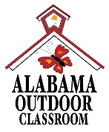
Outdoor Classroom Project Plan:
Materials List & Budget for
Butterfly, Butterfly Garden
A Butterfly Habitat should provide food, water, and shelter for a wide variety of butterflies and their larvae (or caterpillars). Butterflies will most often search flowering wildflowers, bushes, and trees for their main food source (nectar) using their tube-like “tongues” called a proboscis. However, some species will acquire the minerals and nutrients that they need by probing the ground around decomposing plants or animals or around animal excrement with their proboscises. Nectar, shallow puddles, and drops of rain or dew provide the water that butterflies need to survive. Different species of butterflies only lay their eggs on specific species of plants (referred to as “host plants”) and the caterpillars will only eat these plants before creating a chrysalis to go through metamorphosis into an adult butterfly. Butterflies typically take refuge from inclement weather or predators in bushes or trees.
- Habitat Requirements:
- Native flowering wildflowers, bushes, and trees that produce nectar
- Native “host plants” that caterpillars eat (see list on page 3 and 4)
- Puddling stations for butterflies that prefer to get their nutrition from excrement covered in sand
- Bushes and trees for cover from inclement weather and predators
- Dark colored stones where butterflies can warm their bodies
- Full sun for 6-8 hours per day for optimal plant growth

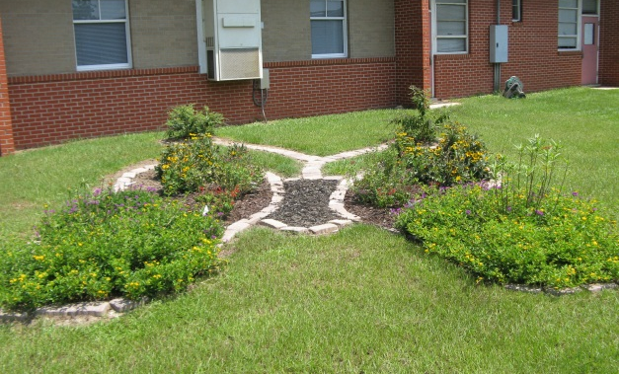
- Example Butterfly, Butterfly Garden Pictures & Educational Sign:
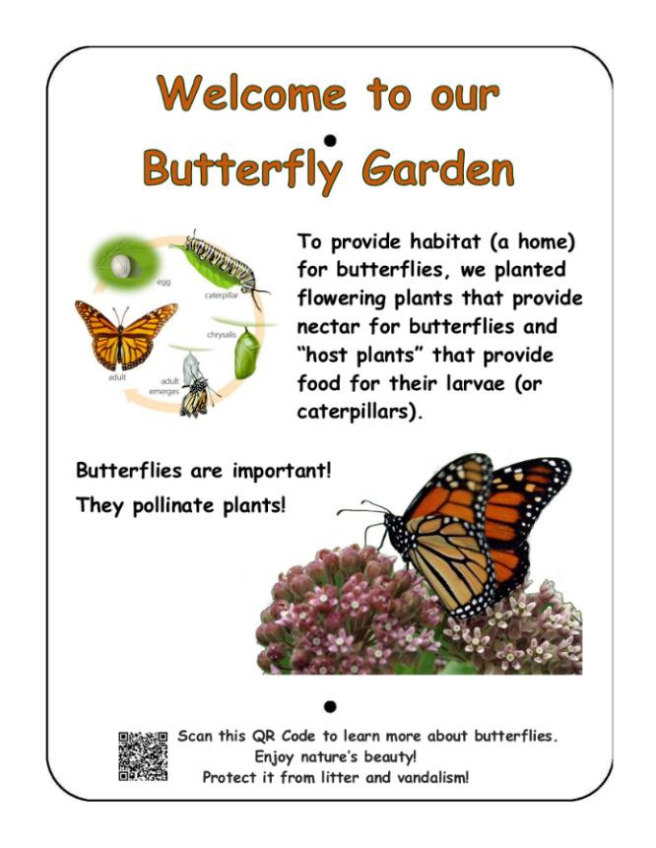

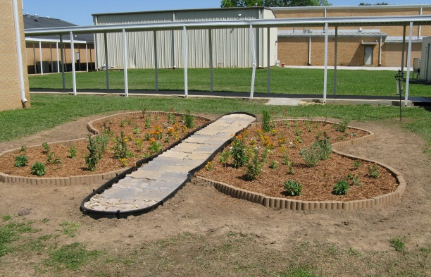
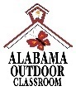
OC Project Plan: Example Butterfly, Butterfly Garden Materials List & Budget
- Estimated Cost: $1,140 – $1,190
- Materials & Supplies with Estimated Budget:
Example Butterfly, Butterfly Garden
4 individual “wing gardens” (~35 CF planting space total) with mulch “body bed” in between them. Notes made in budget for how to modify if you will use a sidewalk as your “body”.
Station | Materials & Supplies | Estimated Cost | Example Source | Final Cost
Bttrfly, Bttrfly | (1) Can of Rust-Oleum Professional White Water-based Marking Paint @ ~$10.98 ea | $10 | Lowe’s Item# 429750
Bttrfly, Bttrfly | (160) 11-in L x 4-in H x 6-in D Flagstone Concrete Retaining Wall Blocks (trapezoid-shaped to create rounded parts of wings) @ ~$2.88 ea | $460 total | Lowe’s Item# 477095
Bttrfly, Bttrfly | (1) EasyFlex No-Dig 20-ft Black Plastic Landscape Edging Roll (for rounded ends of butterfly body) *Exclude this if you are using a sidewalk as the body. ~$18.98 ea | $20 | Lowe’s Item# 1501486
Bttrfly, Bttrfly | (8) 32-Quart (1CF) Bags of Evergreen Organic Potting Soil Mix @~$6.38 ea | $50 total | Lowe’s Item# 380608
Bttrfly, Bttrfly | (14) 1 CF/32 Qt Bags of Evergreen Organic Top Soil @ ~$2.18 ea | $30 total | Lowe’s Item# 648834
Bttrfly, Bttrfly | (11) 1 CF Bags of Evergreen Organic Compost and Manure @~$3.68 ea (3 for garden, 1 per bush, 2 per tree) | $40 total | Lowe’s Item# 757958
Bttrfly, Bttrfly | (5) 2 CF Bag of Evergreen Organic Drainage and Aeration Soil Conditioner @ ~$4.58 ea | $25 total | Lowe’s Item# 648829
Bttrfly, Bttrfly | (1) Package of 40 6” Black Plastic Landscape Edging Pieces (create (2-4) 4 ft dividers) @ ~$21.98 ea | $20 | Lowe’s Item# 379805
Bttrfly, Bttrfly | (6) 2 CF Bags of Evergreen Natural Dark Brown Pine Bark Mulch (2 for garden, rest for trees/bushes) @~$3.48 ea **do NOT get black mulch as it gets hot and kills plants** | $20 total | Lowe’s Item# 92118
Bttrfly, Bttrfly | (2) Premium 2CF Black Hardwood Mulch (for body) *Exclude this if you are using a sidewalk as the body. @ ~$3.98 ea | $10 total | Lowe’s Item# 148349
Bttrfly, Bttrfly | (1) 6’x50’ Sta-Green Professional Landscape Fabric (weed barrier) (for gardens and body, only ) @ ~$33.98 ea | $35 | Lowe’s Item# 510606
Bttrfly, Bttrfly | (1) Black Steel Garden Trellis (ONLY IF you get passionflower vines) @~$16.48 ea | $0-15 | Lowe’s Item# 397037
Bttrfly, Bttrfly | (10) Belgard Overlay Paver 7.75-in L x 3.88-in W x 1.18-in H River Street Concrete Paver (for antennae) @~$0.58 ea | $5 total | Lowe’s Item# 3276557

OC Project Plan: Example Butterfly, Butterfly Garden Materials List & Budget
- Materials & Supplies with Estimated Budget (cont.):
Bttrfly, Bttrfly | (40) Host/ Nectar Plants from Nursery – see suggestions below (5” pots) @ ~$7 ea | $280 total | Nursery via OC Consultant
Bttrfly, Bttrfly | (2) Native Oaks, Dogwoods, or Tulip Poplars (*Optional - plant in or near OC as host plants & cover) @~$75 ea | $150 total | Nursery via OC Consultant
Bttrfly, Bttrfly | (2) Spicebushes or (2) Wax Myrtles (*Optional - plant as host plants near garden in OC if possible) @~$30 ea | $60 total | Nursery via OC Consultant
Bttrfly, Bttrfly | (2) Sweet Pepperbushes or (2) Butterfly Bushes (plant as nectar plants near garden) @~$30 ea | $60 total | Nursery via OC Consultant
Bttrfly, Bttrfly | (2) 12.2-in Terracotta Clay Plant Saucer (to create puddling stations) @~$14.48 ea | $30 total | Lowe’s Item# 94459
Bttrfly, Bttrfly | (1) .5 CF/50 Lb Bags of American Countryside All-purpose Sand (to create puddling stations) @ ~$5.18 ea | $5 total | Lowe’s Item# 104898
Bttrfly, Bttrfly | (4-8) Plant ID Signs (one for each plant species)  @~$6 ea | $25-50 total | https://www.alabamawildlife.org/oc-dig-into-plants/ for details
Bttrfly, Bttrfly | (4-8) Biomarkers to hold Plant ID signs (13” stake with a 2” x 4” plate) @ ~$3 ea (includes S&H) | $15 - $25 total | AWF OC Consultant or https://mcgbiomarkers.com/shop/
Bttrfly, Bttrfly | (1) 6 ft. U-Post for Fence (for educational sign) @~$10.69 ea | $10 | Lowe’s Item# 493054
Bttrfly, Bttrfly | Educational Sign (for the life cycle of butterflies) | $75 | Ask OC Consultant About  https://www.alabamawildlife.org/oc-signs/
Bttrfly, Bttrfly | (1) Hillman 1/4-in x 1-1/2-in Zinc-Plated Coarse Thread Hex Bolt (2-Count) @~$0.88 ea | $5 total | Lowe’s Item# 137634
Bttrfly, Bttrfly | (2) Hillman 1/4-in x 20 Zinc-Plated Steel Hex Nut @~$0.10 ea |  | Lowe’s Item# 63301
Bttrfly, Bttrfly | (2) Hillman 1/4-in Zinc-plated Standard Flat Washer @~$0.15 ea |  | Lowe’s Item# 63306
TOTAL ESTIMATED COST: $1,440 - $1,490
- Butterfly Habitat Plant Suggestions:
- These species are most commonly used in a butterfly garden. View customized plant identification signs with unique QR Codes that you can scan to open plant species’ webpages on AWF's website. The webpages provide specific information about that plant species including a description of the plant, the ecological benefits that species provides, maintenance tips, and photos of the plant including its leaves, flowers & seeds.

OC Project Plan: Example Butterfly, Butterfly Garden Materials List & Budget
- Butterfly Habitat Plant Suggestions continued:
Nectar Plants | Nectar Plants | Nectar Plants | Host Plants for Caterpillars
Bee Balm | Indian Blanket | Narrowleaf Sunflower | Blue False Indigo
Black-eyed Susan | Joe-pye Weed | Purple Coneflower | Bronze Fennel
Cardinal Flower | Lanceleaf Tickseed | Red Sage | Butterfly Milkweed
Dense Blazing Star | Lavender | Rose Vervain | Common Yarrow
Foxglove Beardtongue | Miss Huff Lantana | Stokes Aster | Passionflower
- Visit the Alabama Butterfly Atlas website at http://alabama.butterflyatlas.usf.edu/ AND see the list below (on page 4) for more plant species suitable for the butterfly garden.
Host Plants and Nectar Plants for Common Alabama Butterflies
Butterfly Species | Host Plant | Nectar Plant
Swallowtails
Pipevine Swallowtail | Pipevine | blueberry, blackberry, butterfly weed, butterfly bush, lilac, red bud, verbena
Black Swallowtail | parsley, dill, fennel, Queen Anne’s Lace, celery, carrots | red clover, butterfly weed, thistle
Spicebush  Swallowtail | spicebush | blueberry, blackberry, butterfly weed, butterfly bush, lilac, red bud, verbena
Giant Swallowtail | trees and shrubs of the citrus family, hop tree, prickly ash, rue | lantana, azalea, bougainvillea, goldenrod, butterfly bush, dianthus
Eastern Tiger  Swallowtail | sassafras, wild cherry, sweet bay, tulip tree, birch, ash, cottonwood, willow | wild cherry, butterfly bush, lilac, phlox, dianthus
Brush-footed Butterflies
Monarch | butterfly weed and other milkweeds | nectar from all milkweeds, lilac, clover, lantana, thistle, goldenrods, blazing stars, coreopsis, butterfly bush, and mints
Painted Lady | thistle, white yarrow, daisy, hollyhock, mallow | aster, cosmos, blazing stars, coreopsis, joe-pye weed, red clover, butterfly bush, zinnia, privet, butterfly weed
Viceroy | willows, poplars, cottonwoods, apple | aster, goldenrod, joe-pye weed, thistle, butterfly weed
Gulf Fritillary | passionflower vine | butterfly weed, black-eyed susan, thistle, verbena, vetch, joe-pye weed, passionflower vine, purple coneflower
Red Admiral | nettle | prefers tree sap and fermenting fruit, but will also nectar at daisy, aster, goldenrod, butterfly bush, red clover, gaillardia
Whites and Sulphurs
Cabbage White | cabbage, broccoli | mustards, clover, asters, mints
OC Project Plan: Example Butterfly, Butterfly Garden Materials List & Budget

Clouded Sulphur | alphalpha, clover | flower nectar of many plants including butterfly bush, cosmos and gallardia
Gossamer-wing Butterflies
Red-banded  Hairstreak | wax myrtle, sumac, oak | yarrow, coreopsis, butterfly weed
Summer Azure | dogwood | most nectar producing flowers
Skippers
Common  Checkered Skipper | globe mallows, mallow, hollyhock | aster, red clover, dianthus
Horace’s Duskywing | red oak, willow oak, water oak, white  oak | goldenrod, peppermint

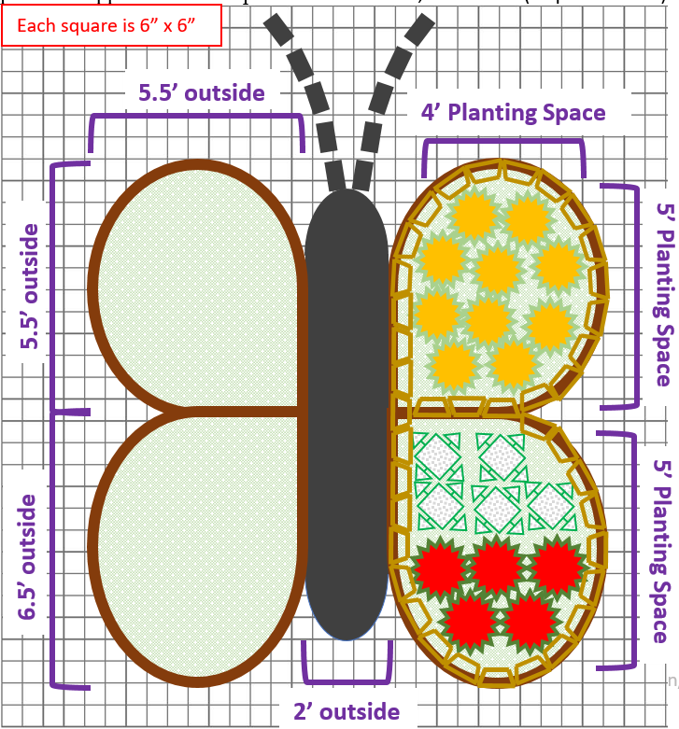
- Selecting Your Numbers of Plants: Diagram shows half of garden with blocks and plants just for simplicity. Middle section (the body) between the wings is filled with mulch or a sidewalk. Plants can be laid out several ways and left side should mimic right side:
- 1 species per bed (2 species total)
- 2 species per bed (4 species total)
- 1 species in upper bed and 2 species in lower bed, vice versa (6 species total)

Each square is 6” x 6”

