Outdoor Classroom Project Plan:
Construction Instructions for
Butterfly, Butterfly Garden
- Construction Tools:
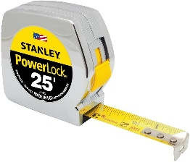
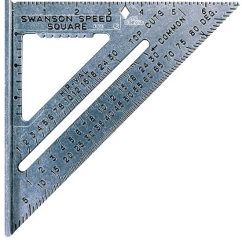
- (1) 20 ft Measuring Tape
Measuring Tape
- (1) Speed Square for measuring angles
Speed Square
- 24-inch I-beam Level
- (1-2) Wheelbarrows for moving grass clumps, soil & mulch
- (2-3) Sharp, Straight-edged Shovel & (2-3) Round-pointed Shovels
- (24-30) 1-gallon milk jugs (with tops cut off but handles remaining) for students to move excavated dirt, sand, soil, etc.
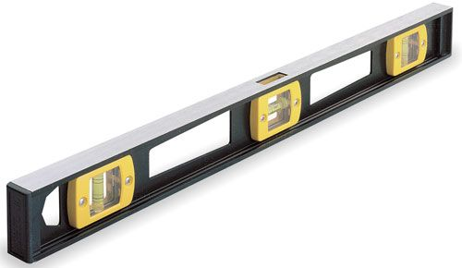
- (4-6) Hand-held Trowels (for stirring soil amendments together)
- Water hose for watering plants at the end of day
I-beam Level

- Construction Supplies:
- Twine (at least 160 ft)
- Garden Stakes or Flags
- (1) Can of Landscape Spray Paint
- Retaining Wall Blocks
- Weed Fabric
- Soil (or components to create amended soil such as soil conditioner, cow manure, potting soil, etc.)

- Construction Instructions:

- Select the area for the butterfly garden, and lay out a 12’x13’ grid using a measuring tape, stakes, and twine. Make each square within the grid equal to one square foot. (12” x 12”).
- Be sure your grid lines are straight and spaced evenly. Use a standard ruler if necessary to confirm that each square is 12”x12”. Check this at two or three spots along the body to ensure that it is the same width at the top, middle, and bottom
- Once the large grid is laid out on the ground, use a can of marking paint and graph 1 on page 2 to draw the outline of the butterfly over the grid lines (twine) and onto the ground. Note that 1 square on the graph represents one square on your grid. (Remember, you are creating a really big, exact copy of the butterfly drawing.)

Example Butterfly, Butterfly Garden Construction Instructions

- Construction Instructions continued:

Graph 2 – Points for measurement confirmation.
Graph 1 – Measurements for full butterfly.

- After drawing the butterfly onto your grid, you need to verify that your measurements are correct using graph 2 above. Confirm that the following measurements are correct.
  - The distance between the two red dots is 10’.
  - The distance between the green dots is 5.5’. This should be the same in the same spot on the other top wing.
  - The distance between the yellow dots is 2’.
  - The distance between the blue dots is 3’. This should be the same in the same spot where the other wings join as well.
  - The distance between the grey dots is 5.5’. This should be the same in the same spot on the other top wing.
  - The distance between the pink dots is 6.5’. This should be the same in the same spot on the other bottom wing.
- Once all of your measurements are confirmed accurate, dig and remove the grass in a path that is 1 inch deep and 8 inches wide along the INSIDE of the spray-painted garden perimeter to create a base on which to place the retaining wall blocks. Use your shovel/trowel to create a flat surface for the base to keep the retaining wall blocks level. If the area within your painted butterfly is not level you will want to dig it out as well to level it out.

Example Butterfly, Butterfly Garden Construction Instructions

- Construction Instructions continued:
- Lay the first layer of blocks down, as shown in Graph 3 on the right. Start with the blocks where the top and bottom wings meet (blue on the graph). Complete this layout on both the left and right side of the body.
- Use your I-beam level to make sure each block is level from side-to-side and front-to-back as you lay them down. Add a little dirt or sand and use your trowel to level the base surface if needed. Place the next block directly next to the first one, and use your level to make sure that the second block is level with the first block. Continue adding blocks until you have placed and leveled all of the first layer blocks.
- Place the landscape fabric (weed barrier) on the ground inside the garden area, push the fabric against the insides of the retaining wall blocks, and lay the edges of the fabric on top of the blocks so that the fabric will be sandwiched and held in place between the first and second layers of retaining wall blocks.
- Next, start laying the second layer of blocks, as shown in Graph 4 on the right. Start with the blocks where the top and bottom wings meet (blue on the graph). The second layer of retaining wall blocks should straddle the first layer to create more stable walls for your garden. See example below. Complete this layout on both the left and right side of the body.
Graph 3 – First layer of blocks.

- Once you have laid both layers of blocks with the weed fabric sandwiched between them, fill the garden with top soil, manure, potting soil, and soil conditioner. Use trowels to turn and mix the soils. Be careful when mixing as to not stab or tear the weed fabric under the soil on the ground.
- Install dividers made of the landscape edging inside the garden to create planting sections for different plant species. See planting section examples with dividers (black horizontal lines) on Graph 5 on page 4.
Example Butterfly, Butterfly Garden Construction Instructions
Graph 4 – Second layer of blocks.
- Construction Instructions continued:
- Plant the flowers, grouping each of the different species of plants together within each section. See planting layout options (based on the number of species you have selected) in Graph 5 below.

Graph 5 – Planting layout options.

- Add 1 inch of mulch around the plantings throughout the garden and water thoroughly.
- Place your plant ID signs with each species. Insert the educational sign post (u-post) in the ground near the garden and attached the educational sign to it using the nuts, bolts, and washers.
- Water all of the new plantings thoroughly.

