Critter Characteristics & Habitats:
Eastern Bluebird
Caution – Be careful not to harm any wildlife or their habitats.
Name: | ____________________ | Date:___________
Explore your outdoor classroom and look for an Eastern bluebird.
Use the Alabama Wildlife Federation’s Wonders of Wildlife
Eastern Bluebird webpage to help you answer the questions below.
- Draw a picture of the animal.

- What colors does it have?____________________________
black blue brown gray green orange purple red yellow white
- How many legs does it have?__________________________
zero two four six eight ten one hundred
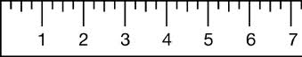
- Estimate how long (or tall) it is: ______feet _____inches
Alabama Wildlife Federation Outdoor Classroom Field Investigation Activity Sheet: Critter Characteristics & Habitats v2, pg 1 of 2
5. Put a checkmark next to the feature(s) it has.
- Fur | - Feathers | - Thin Wings | - Hard Covering
- Hard Shell | - Scales | - Smooth Skin | - Bristles

6. What type of animal is it?
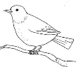  - bird | 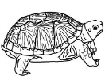  - reptile | 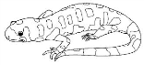  - amphibian | 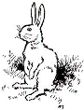  - mammal | - insect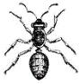 | 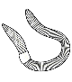  - other invertebrate
7. What type of “babies” does it have?
- Live baby (not in egg) that looks similar to parent (typically a mammal)
- Hard-shelled eggs with babies that look similar to parent (typically a bird or reptile)
- “Soft” tiny eggs in water with larvae that change (morph) into adult (amphibian or insect)
- “Soft” tiny eggs on plants or in soil with larvae that change (morph) into adult (insect)
8. What is the Latin name of this animal?
________________________________________________________
9. Where does this animal typically live? (you can choose more than one)
- grassland | - tundra | - desert | - woodland | - meadow | - wetland
- creek | - pond/lake | - river | - ocean | - other:______________
10. Where did you find it in the outdoor classroom?
- in the grass | - on the ground | - in the soil | - in a tree or bush | - in water  or a pond | - on a flower | - in nesting box
11. Describe its habitat needs including the specific food, water, shelter and places to raise its young it needs to survive:
___________________________________________________
___________________________________________________
___________________________________________________
Alabama Wildlife Federation Outdoor Classroom Field Investigation Activity Sheet: Critter Characteristics & Habitats v2, pg 2 of 2

