Critter Characteristics & Habitats
Caution – Be careful not to harm any wildlife or their habitats.
Name: | ______________________________________________________
Explore your outdoor classroom and look for an animal (wildlife). Complete the questions below to help you describe what type of animal it is and its habitat needs.
Use field identification guides like the National Audubon’s Field Guide to the Southeastern States, the
Alabama Wildlife Federation’s Wonders of Wildlife webpages, and the Outdoor Alabama’s Watchable Wildlife
webpages to help you answer the questions, if needed.
- Draw a picture of the animal.

- What color(s) is it?_________________________________
black blue brown gray green orange purple red yellow white
- How many legs does it have?__________________________
zero two four six eight ten one hundred
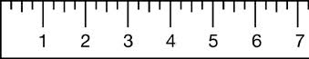
- Estimate how long (or tall) it is: ______feet _____inches
Alabama Wildlife Federation Outdoor Classroom Field Investigation Activity Sheet: Critter Characteristics & Habitats v1, pg 1 of 2
5. Put a checkmark next to the feature(s) it has.
- Fur | - Feathers | - Thin Wings | - Hard Covering
- Hard Shell | - Scales | - Smooth Skin | - Bristles

6. What type of animal did you find?
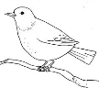  - bird | 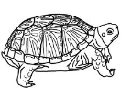  - reptile | 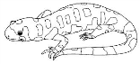  - amphibian | 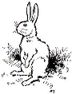  - mammal | - insect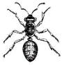 | 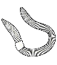  - other invertebrate
7. What type of “babies” does it have?
- Live baby (not in egg) that looks similar to parent (typically a mammal)
- Hard-shelled eggs with babies that look similar to parent (typically a bird or reptile)
- “Soft” tiny eggs in water with larvae that change (morph) into adult (amphibian or insect)
- “Soft” tiny eggs on plants or in soil with larvae that change (morph) into adult (insect)
8. What is the name of this animal?
________________________________________________________
9. Where does this animal typically live? (you can choose more than one)
- grassland | - tundra | - desert | - woodland | - meadow | - wetland
- creek | - pond/lake | - river | - ocean | - other:______________
10. Where did you find it in the outdoor classroom?
- in the grass | - on the ground | - in the soil | - in a tree or bush | - in water  or a pond | - on a flower
11. Describe its habitat needs including the specific food, water, shelter and places to raise its young it needs to survive:
___________________________________________________
Alabama Wildlife Federation Outdoor Classroom Field Investigation Activity Sheet: Critter Characteristics & Habitats v1, pg 2 of 2
___________________________________________________
___________________________________________________

